Student Representations for Addition Within 20
Student Representations | Description of Strategies
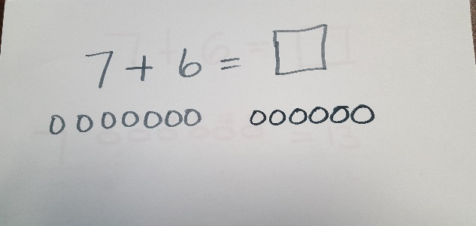 | These students are counting all.  The next step for them should be to use counting on strategies.
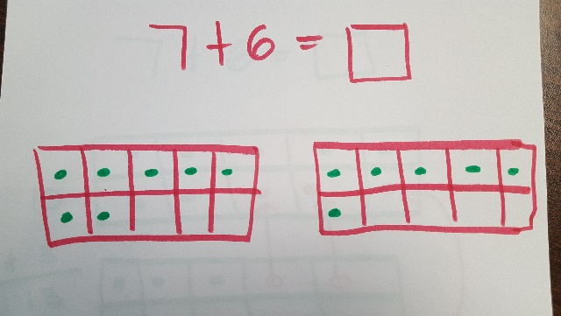

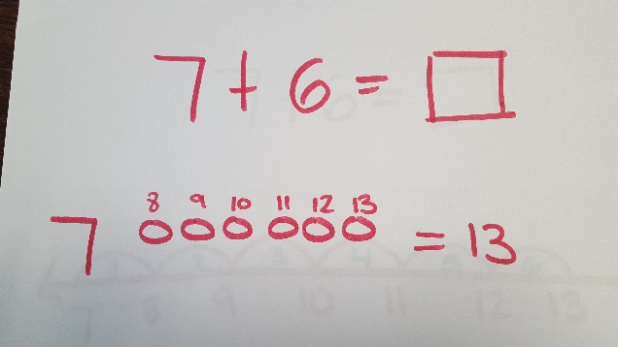 | These students are representing counting on.  As students are successful with the counting on strategy, they move on to other strategies based on number and operation relationships, including making ten, etc.
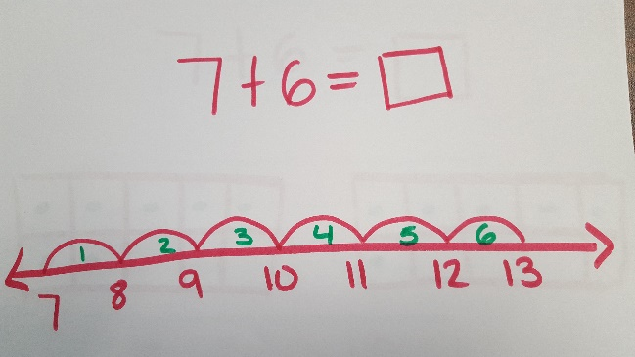

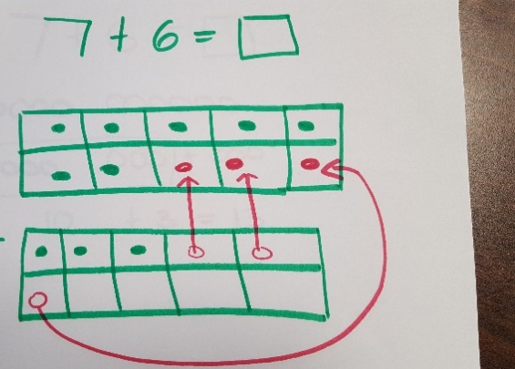 | These students are using the strategy of making a ten.  Next steps could include representing their work using numbers and equations as they decompose a number leading to a ten.
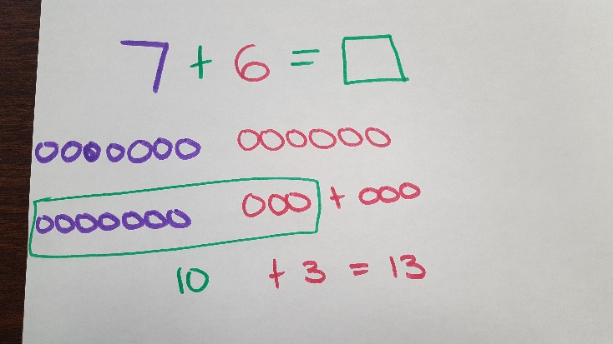

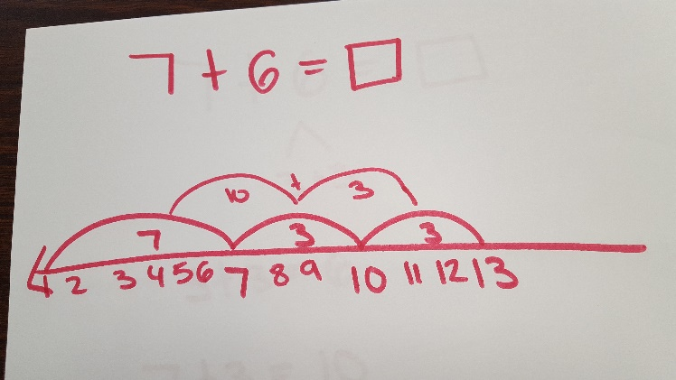

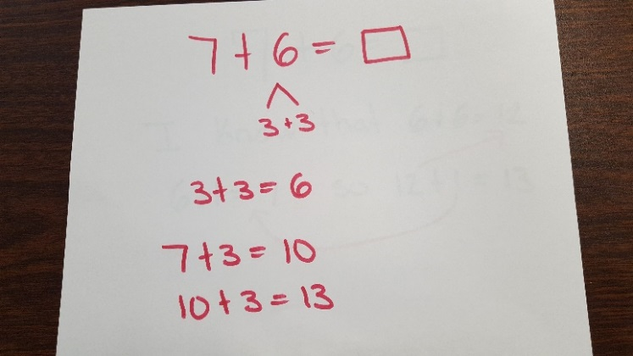 | This student is also making a ten, but is taking the next step of decomposing a number leading to a ten. This student is representing that work with numbers and equations.
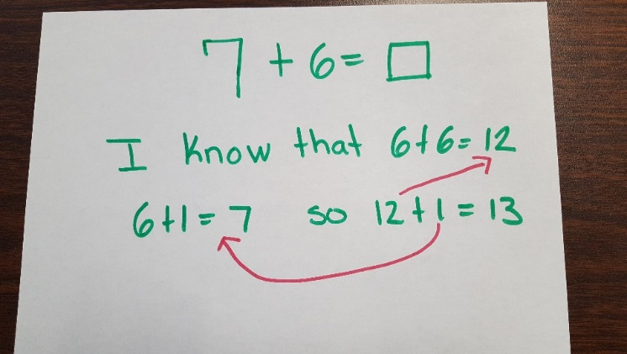 | This student is creating equivalent but simpler or known sums. The student applies her knowledge of doubles to solve a related but unknown problem. Making connections such as this is a goal for students by the end of first grade.

