Student Representations for Unknown Addend with an Equation
Student Representations | Description of Strategies
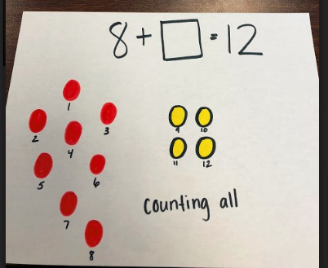 | This student is counting all the items and is seeing the total quantity.  The next steps could include encouraging the student to start using the strategy of counting on by beginning at a number other than 1.  Ask: Since you were given 8 to start, do you need to start counting at 1? What could you do instead?
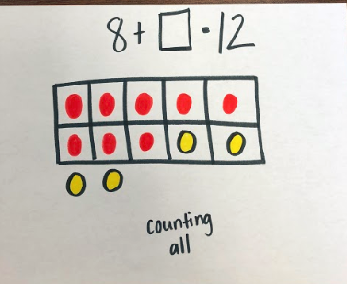 | This student is counting all the items and has organized them in a ten frame.  The next steps could include encouraging the student to start using the strategy of counting on by beginning with the 8 and only counting up to 12. A number line might be introduced for this purpose.
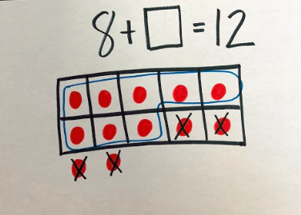 | This student is using the strategy counting back by starting at 12 and using a ten frame to subtract 4 (so that 8 remain). Observe to be sure the student does not get confused with which quantity is the unknown.  Ask: How did you know where to stop counting? What is the missing number in the equation?
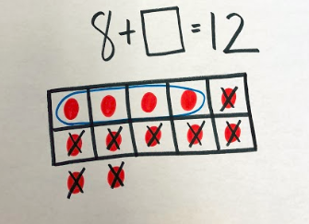 | This student is starting at 12 and counting back to subtract 8 until there are only 4 left.  Ask: What is the missing addend? Why does this strategy work?
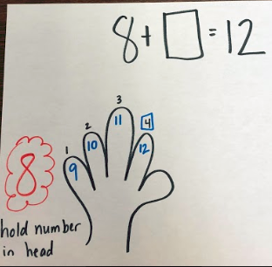 | This student started with the number 8 and counted on 4 more using their fingers to get to 12.  Next steps could include moving the student to other tools and using those tools to encourage him or her to think of relationships between numbers.  Ask: How could you show that thinking on a number line?
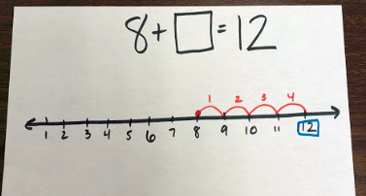 | This student used a number line to count on by starting at 8 and then jumping 4 individual jumps to get to 12. Next steps could include helping students see combinations and number relationships.  Ask: Could you use what you know about ten partners to jump differently on the number line?
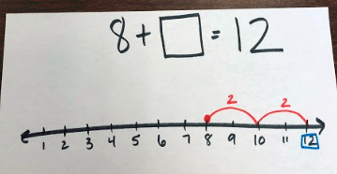 | This student is making a ten using a number line by making the jump of 2 from 8. The student then jumped 2 more to get to 12. Next steps could include encouraging the student to use mental strategies.  Ask: What is the missing addend in the equation? Could you solve this without using a model?
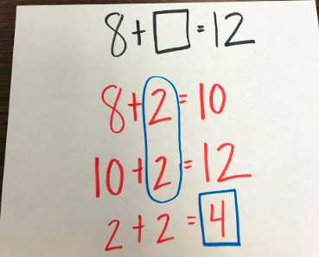 | This student used making a ten in an equation to find the missing number. While this is an efficient strategy, you could grow this student by encouraging a variety of strategies, such as the relationship between addition and subtraction.  Ask: How could you use a subtraction strategy to solve this addition problem?
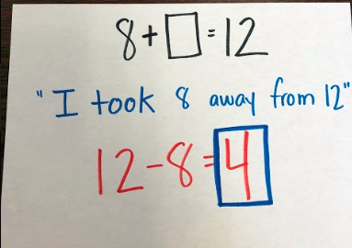 | This student is using the relationship between addition and subtraction to find the missing number. Next steps could include encouraging the student to show how he knew the answer was 4.  Ask: When you took 8 away from 12, how did you know what was left? What were you thinking? How could you show that?
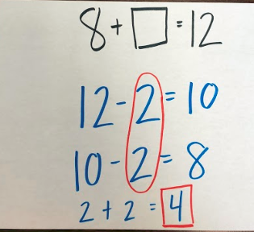 | This student is using the relationship between addition and subtraction combined with making a ten to find the missing number.

