Arrow Cards and Two-Digit Numbers
In this lesson, students will use arrow cards and other tools to explore and work with two-digit numbers.

NC Mathematics Standard:
Understand place value.
NC.1.NBT.2 Understand that the two digits of a two-digit number represent amounts of tens and ones.
- Unitize by making a ten from a collection of ten ones.
- Model the numbers from 11 to 19 as composed of a ten and one, two, three, four, five, six, seven, eight, or nine ones.
- Demonstrate that the numbers 10, 20, 30, 40, 50, 60, 70, 80, 90 refer to one, two, three, four, five, six, seven, eight, or nine tens, with 0 ones.

Additional/Supporting Standards:
Extend and recognize patterns in the counting sequence.
NC.1.NBT.1 Count to 150, starting at any number less than 150.
Understand place value.
NC.1.NBT.3 Compare two two-digit numbers based on the value of the tens and ones digits, recording the results of comparisons with the symbols >, =, and <.
Use place value understanding and properties of operations.
NC.1.NBT.5 Given a two-digit number, mentally find 10 more or 10 less than the number.

Standards for Mathematical Practice:
- Reason abstractly and quantitatively.
- Construct viable arguments and critique the reasoning of others.
- Use appropriate tools strategically.
- Look for make use of structure.

Student Outcomes:
- I can build a two-digit number using arrow cards.
- I can describe the value of a two-digit number based on the digits in the tens and ones places.

Math Language:
What words or phrases do I expect students to talk about during this lesson?
tens, ones, less, more, value

Materials:
- arrow cards, number cards (0-9), hundred boards, snap cubes, paper/journal, whiteboard (optional), dice, Place Value Mysteries sheets

Advance Preparation:
- Copy and prepare arrow cards and Place Value Mysteries sheet
- Gather materials

Launch
- Introduce the Task (10 minutes)
Use a set of arrow cards to demonstrate how to sort the cards in groups of ones and tens. Pair students together to sort a set of arrow cards in groups of ones and tens. After the cards are sorted, begin by asking the students to show specific one-digit numbers.
- Show me the number 1.
- Show me the number 4.
- Show me the number 7.

Ask students to show you specific two-digit numbers, one at a time:
- Show me the number 10.
- Show me 40.
- Show me 70.

For each number, ask:
    - How many tens are there in this number?
    - How many ones are there?

After students have shown one-digit and two-digit numbers, ask:
- How are the two numbers similar and different? (1 and 10, 4 and 40, 7 and 70).

Explore (30 minutes)
2. Part One: Building Two-Digit Numbers
Show students 5 cubes and have them show the number card to match the set.
Add a group of ten cubes that are connected and ask students to show the number card to match the set. Then ask: How many cubes do we have now?
Have students use the arrow cards (10 and 5) to show the number.

Show students 3 cubes and have them show the number card to match the set.
Add 2 groups of ten cubes that are connected and ask students to show the number card to match the sets. Then ask: How many cubes do we have now?
Have students use the arrow cards (20 and 3) to show the number.

Continue this activity with a few more numbers. If students seem to be doing well, give them the 2-digit number at once without starting with the ones and then adding the tens.

After you have done a few numbers as a class, have the students work in pairs. One student will say a two-digit number and the other student will create the number with both snapping cubes and Arrow Cards (tens and ones).

3. Part Two: What Is Ten More? (If appropriate for the time of year)
Bring the class back together and transition into this part of the activity. Give the students a two-digit number to make with arrow cards. Also, have students find the same number on their hundred board. Ask the students to use their hundred board to figure out 10 more than the number you gave them.

Have students share their responses and then make their new number with the Arrow Cards. Follow up by asking students:
- How many ones and tens are in the first number?
- How many ones and tens are in the new number?
- How is the new number different from the first number?

Have students work with a partner on this activity.
One partner can say a two-digit number or draw number cards (0-9) to generate a
two-digit number. The other partner should use the hundred board and arrow cards to identify and make the number that is ten more than the original number.

Students in first grade are required to find ten more and ten less mentally, so when students are ready, have them find the number using just the arrow cards without the support of the hundred board. To challenge students, have them find the number that is ten less than the original number. Once again, use the hundred board at first until students are ready to find the number mentally.

Discuss
- Discussion of Patterns on the Hundred Board (10 minutes)
After the above activity, the teacher brings the class back together to discuss the patterns on the hundred boards. The math talk that the teacher needs to hear is about the patterning on the hundred boards and what is happening to the tens place as the tens place is increasing (or decreasing) by one group of ten.

Possible questions to ask:
- In the number 43, what does the 4 represent?
- What does the 3 represent?
- What would 10 more than that number be?
- What would 10 less than that number be?

If time permits, continue to pose similar tasks for students. As students become more comfortable finding ten more (or ten less), then remove the support of the hundred board to have them work mentally.

Additional Activities (15-20 minutes)
For the time remaining in the lesson, give the students one of the following activities:
- Ordering Numbers
Have students pull arrow cards to generate two two-digit numbers. Students find both numbers on the hundred board and determine which is larger. Students should record their work in a math journal using math vocabulary (more and/or less).

- Get 100!
Have children draw a game board on paper or a whiteboard. The game board is a two-column chart. Label the left column “10s” and the right column “1s.” Model how to play the game with your students. The goal is to get as close to the number 100 without going over. The game can be played individually, in pairs, or teams.

Determine how you want students to record their numbers and share that with them (drawings, numbers, ten frame cards, choice). Roll a die or flip a number card. The students record the number that is chosen in either the 10s or 1s column. They do the same for the second number that is chosen and add the number onto their total. This continues for 6 rounds.

Provide students with a hundred board and snap cubes to help them with this game. The winner is the player that is closest to 100 without going over. Model playing a round. After playing one round ask students:
- What should we think about before determining whether to put numbers in the tens or ones column?

Allow students to play this game for a few rounds. Make sure they record their numbers in their journals or on a whiteboard. Students should have access to a hundred chart and snap cubes the entire time.

As students are playing observe and note:
- Are students able to accurately count on from a number?
- How do students use the hundred board or snap cubes to support their work?
- What explanations do students give about why they placed a number in a specific column?

Evaluation of Student Understanding
Informal Evaluation:
As students are working, observe and monitor if they are solving problems using place value understanding. Notice if students are:
- representing numbers correctly with the arrow cards
- using language of tens and ones
- using the hundred board to locate 10 more or 10 less
- correctly explaining the pattern of numbers when they add 10 more or 10 less
- quickly determining if the number needs to be placed in the 10s or 1s columns for the additional activity Get 100!

Formal Evaluation/Exit Ticket: (10 minutes)
You could use data from the additional activity Ordering Numbers as a formal evaluation. If you want an additional task, consider giving students a two-digit number and asking them to give you the number that is ten more and ten less. This can be also be used as the summative assessment.

Meeting the Needs of the Range of Learners
Intervention:
During the game, the teacher or student peer may help students represent the numbers with groupable materials and/or find the total of 10s and 1s. For the game Get 100!, the number 100 may be changed to a lower number.

Extension:
For students that are working at a higher level, encourage them to work without manipulatives to see if they can compute mentally. These students could find the higher mystery numbers on the Place Value Mysteries sheet found below. These could be cut into individual cards or left connected as a handout. Students could mark numbers on a hundred board to help them find the mystery number. Students may write Place Value Mysteries of their own following those examples. Here is an example: I am between 20 and 40. I have 3 tens. The sum of my digits is 7. Who am I?

Possible Misconceptions/Suggestions:
Possible Misconceptions | Suggestions
Students may reverse a number and confuse the tens place and ones place (e.g., stating that 32 is 2 tens and 3 ones). | Provide either snap cubes or ten frame cards to help students make sense of the idea that a ten is a group of ten ones.
Students may not be familiar or able to work with large numbers. | Do Place Value Mysteries with numbers less than 40.

Arrow Cards 00-90
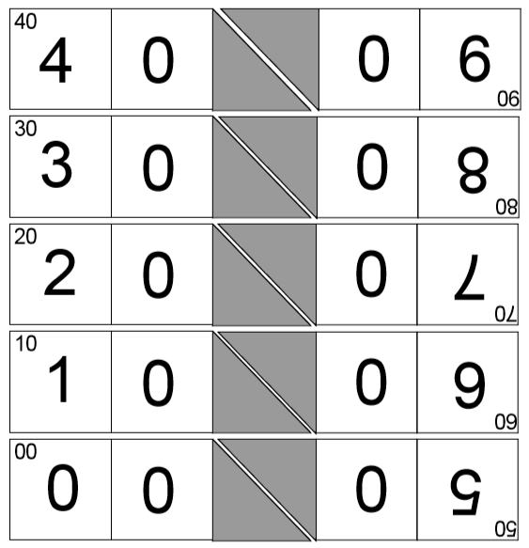

Arrow Cards 0-9
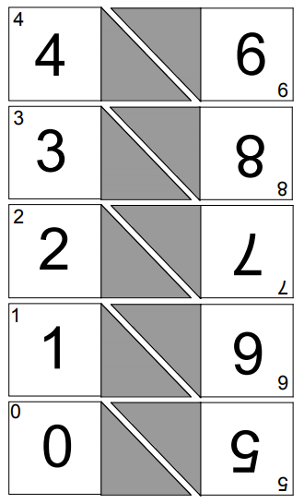
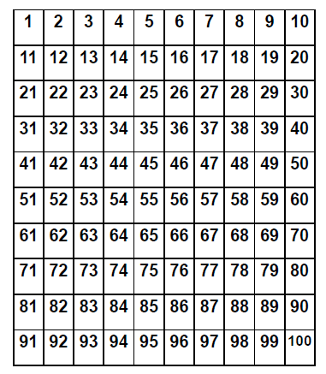
Hundred Board

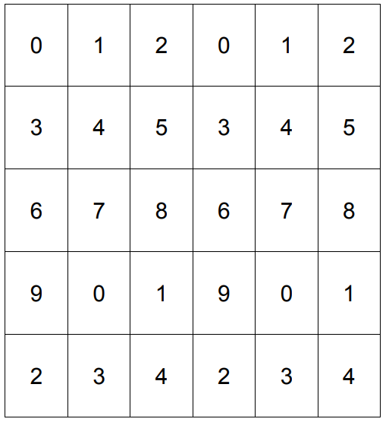
Number Cards (0-9)
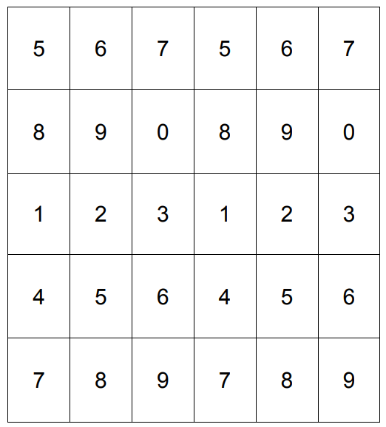

Place Value Mysteries

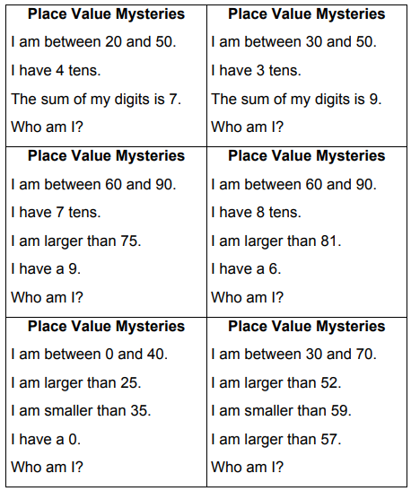

Place Value Mysteries (Set 2)

Place Value Mysteries  I am between 30 and 70.  I have 6 tens.  The sum of my digits is 7.  Who am I? | Place Value Mysteries  I am between 10 and 50.  I have 2 tens.  The sum of my digits is 9.  Who am I?
Place Value Mysteries  I am between 30 and 90.  I have 8 tens.  I am larger than 85.  I have 8 ones.  Who am I? | Place Value Mysteries  I am between 60 and 90.  I have 8 tens.  I am larger than 81.  I have a 6 ones.  Who am I?
Place Value Mysteries  I am between 0 and 40.  I am less than 25.  I am greater than 15.  I have a 0.  Who am I? | Place Value Mysteries  I am between 10 and 40.  I am larger than 23.  I am smaller than 29.  I am larger than 27.  Who am I?

