Place Value Ten Frame Cards
In this lesson, students use ten frame cards to compose numbers within 100.

NC Mathematics Standard:
Understand place value.
NC.1.NBT.2 Understand that the two digits of a two-digit number represent amounts of tens and ones.
• Unitize by making a ten from a collection of ten ones.
• Model the numbers from 11 to 19 as composed of a ten and one, two, three, four, five, six, seven, eight, or nine ones.
• Demonstrate that the numbers 10, 20, 30, 40, 50, 60, 70, 80, 90 refer to one, two, three, four, five, six, seven, eight, or nine tens, with 0 ones

Additional/Supporting Standards:
Extend and recognize patterns in the counting sequence.
NC.1.NBT.1 Count to 150, starting at any number less than 150.
Understand place value.
NC.1.NBT.3 Compare two two-digit numbers based on the value of the tens and ones digits, recording the results of comparisons with the symbols >, =, and <.

Standards for Mathematical Practice:
3. Construct viable arguments and critique the reasoning of others.
6. Attend to precision.
7. Look for make use of structure.

Student Outcomes:
- I can show given numbers with Ten Frame Cards and groupable manipulatives.
- Given a number, I can tell/show how much one more or one less is with Ten Frame Cards and groupable manipulatives.
- Given a number shown with Ten Frame Cards and groupable manipulatives, I can write the numbers in standard form.

Math Language:
What words or phrases do I expect students to talk about during this lesson?
place value, tens, ones, less, more, same as

Materials:
- ten frames, counters, ten frame cards for each pair of students, snap cubes, set of number cards (0-9), math journals or white boards and markers

Advance Preparation:
- Gather materials. Create and copy recording sheets for explore activities if desired.

Launch
1. Quick Images (10 minutes)
Use the Ten Frame Cards (attached) for this activity.
Tell students that you are going to “flash” a ten frame on the document camera (or large ten frames cards) and you want them to memorize the picture.
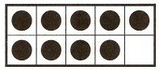

Show the picture to them for 3-5 seconds. After you have shown the card, have students make the same representation on their own ten frames. Show the card again for 3-5 seconds. Have them correct their representations if needed. Then show them the image and leave it up. Ask students questions such as:
How many counters are there?
Where are groups of counters that could help us count quickly?

Explore (35 minutes)
Early instruction should focus on numbers 0-50 before shifting the focus to work with numbers 0- 100.

There are 3 activities in this phase for students. After students have been introduced to these activities in whole group instruction, they can be repeated for more practice in centers.

2. Building Numbers with Ten Frames
Give each pair of students a set of Ten Frame Cards to use. Write a number for students to represent with their cards. Example: 38
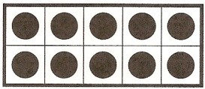
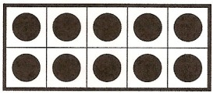
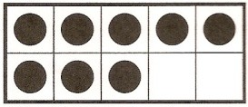

Ask questions after students have made the number 38 such as:
- What is the number?
- How many groups of tens are shown?
- How many ones are shown?
- How did you know to show that many tens/ones?

Give students a piece of paper that has the following recommended numbers on it.
Early instruction: 42, 29, 36, 48, 17
Later instruction: 82, 68, 71, 56, 92

Have students to work in pairs to make each of those numbers with their Ten Frame Cards and then record their work on a recording sheet or in their math journals. If students finish early, they can come up with their own numbers to build with their Ten Frame Cards.

As students are working observe to see:
- Do students accurately make the numbers with the Ten Frame Cards?
- How do students count the total?

3. More and Less with Two-Digit Numbers
Show a number with the Ten Frame Cards. Ask students to identify the value of the number. The students will then write the given number in the middle of white boards or on paper. Ask:
What two numbers will come before this number? Write them down.
What two numbers will come after this number? Write them down.

Example:
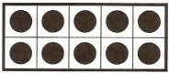
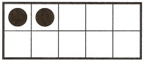

Students would write down 40 41 43 44

Provide students with a list of five numbers between 11 and 99. Have students build each number and then identify the two numbers before and the two numbers after those numbers. Students should record their work on a recording sheet or in their math journals.

4. Two-Digit Compare
Model or demonstrate this activity prior to playing.

Each pair of students needs a set of number cards (1-9) and either connecting cubes or Ten Frame Cards. Each student draws two number cards. The first card represents the tens place. The second card represents the ones place. Each student builds their number with either connecting cubes or Ten Frame Cards.

After building the numbers, students will compare the numbers in their math journals or on a recording sheet. Students will either use the words greater than, less than, or equal to or the symbols >, <, or = to compare (depending on the time of year). Example of recording sheet:
Player 1 | Comparison | Player 2
58 | Is less than | 72
81 | > | 60

As students are working, observe:
- Do students correctly represent the numbers?
- How do students count the numbers?
- Do students correctly use the words or >, < and = symbols?
- How do students explain their comparisons?

Discuss (10-12 minutes)
The discussion should reflect one or two of the different activities that students completed. Make connections between mathematics concepts and strategies. Begin the discussion by giving students an example and having them talk through it.

Example for Two-Digit Compare:
Play a quick round with a student by drawing cards and building the numbers. Ask the class: Who has the larger number? How do you know?

Additional Discussion Opportunity: Comparing 67 to 76
Show the numbers 67 and 76.
Ask students to explain how to build the numbers. After you build them, ask students: How are these numbers similar? How are these numbers different?

The goal of this discussion (Comparing 76 to 67) is to allow students to see that while the digits 7 and 6 are used in both numbers, the value of a number is largely influenced by the greatest place (the tens place) and then influenced by the ones place if the values of the tens place are equal.

Additional Activities (10-15 minutes)
For a follow-up activity, give students the activity sheet “Building Two-Digit Numbers” and/or have them work on other related activities.

As students are working, you can:
- Provide more intervention to struggling students
- Monitor students and ask questions about their mathematical thinking
- Observe and record notes as students work

Questions to ask and concepts to observe include:
    - How do you know that you have built the number correctly?
    - What does the value in this place mean (point to the tens place)?
    - How do you know which number is larger?

Evaluation of Student Understanding
Informal Evaluation:
While students are working there are ample opportunities to evaluate students’ performance.

Questions to assist student evaluation include:
- Do students correctly build a number?
- Can students accurately explain why they built the number correctly?
- How do you know which number is greater?

Formal Evaluation/Exit Ticket:
The “Building Two-Digit Numbers” activity sheet can be used to evaluate students’ understanding.

Meeting the Needs of the Range of Learners
Intervention:
If a student is struggling in representing numbers with Ten Frame Cards, model making more numbers with that student and/or a small group. Numbers 0-20 would be used along with double ten-frames. Pairing students to work with each other during centers/math tubs will help students that are struggling with showing numbers on Ten Frame Cards

Extension:
Students that can represent and explain the concept of tens/ones with lower numbers will
be asked to represent numbers of higher value. These students may need numbers higher than 100.

Possible Misconceptions/Suggestions:
Possible Misconceptions | Suggestions
Not realizing that a ten is a group of 10 ones | Continue to work with ten frames that have 10 individual counters or pictures on them and encourage students to talk about and work with the idea that 12 includes a full ten frame (1 group of 10) and 2 ones (leftovers).
Trouble writing the equations | Since equation writing is not a focus in Kindergarten, students may struggle making sense of the meaning of the addition and equals sign. Support students by having them talk about and think about the addition sign as “joined with” and the equal sign as “the same as.” For example, “15 is the same as 10 joined with 5.”

Ten Frame Cards
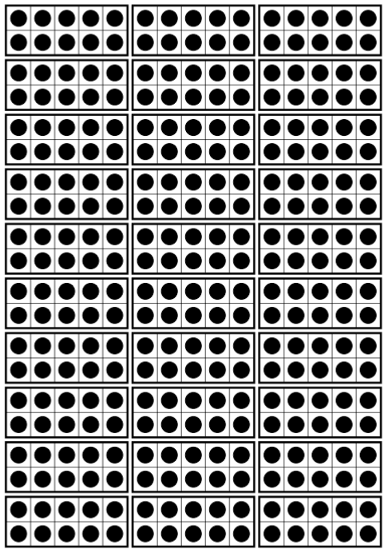
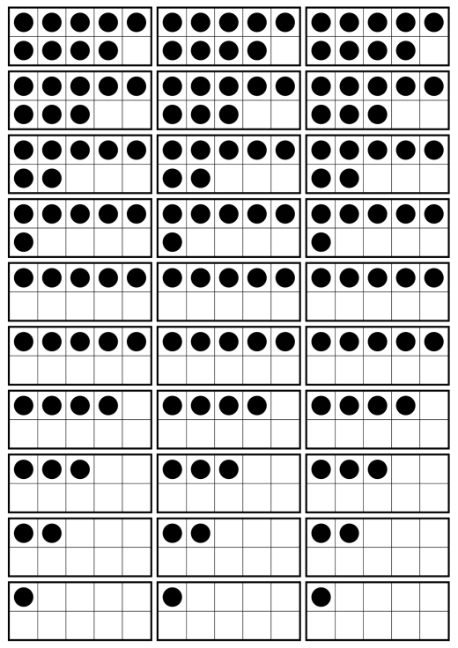
Primary Number Cards

0 | 1 | 2 | 0 | 1 | 2
3 | 4 | 5 | 3 | 4 | 5
6 | 7 | 8 | 6 | 7 | 8
9 | 0 | 1 | 9 | 0 | 1
2 | 3 | 4 | 2 | 3 | 4

5 | 6 | 7 | 5 | 6 | 7
8 | 9 | 0 | 8 | 9 | 0
1 | 2 | 3 | 1 | 2 | 3
4 | 5 | 6 | 4 | 5 | 6
7 | 8 | 9 | 7 | 8 | 9

Building Two-Digit Numbers Activity Sheet
