Two-Digit Numbers with Ten Frames
In this lesson, students use ten frames to represent and compare two-digit numbers.

NC Mathematics Standard:
Understand place value.
NC.1.NBT.2 Understand that the two digits of a two-digit number represent amounts of tens and ones.
• Unitize by making a ten from a collection of ten ones.
• Model the numbers from 11 to 19 as composed of a ten and one, two, three, four, five, six, seven, eight, or nine ones.
• Demonstrate that the numbers 10, 20, 30, 40, 50, 60, 70, 80, 90 refer to one, two, three, four, five, six, seven, eight, or nine tens, with 0 ones.

Additional/Supporting Standard:
Extend and recognize patterns in the counting sequence.
NC.1.NBT.1 Count to 150, starting at any number less than 150.
Understand place value.
NC.1.NBT.3 Compare two two-digit numbers based on the value of the tens and ones digits, recording the results of comparisons with the symbols >, =, and <.

Standards for Mathematical Practice:
3. Construct viable arguments and critique the reasoning of others.
6. Attend to precision.
7. Look for make use of structure.

Student Outcomes:
- I can represent two-digit numbers.
- I can compare two-digit numbers.

Math Language:
What words or phrases do I expect students to talk about during this lesson?
Less, more, ones, tens

Materials:
- number cards (0-9), ten frame cards, ten frames, counters, 100 boards for support (optional)

Advance Preparation:
- Gather materials

Launch
1. Two-Digit Numbers with Ten Frames (10 minutes)
Call on a student to pick a number card from a stack of 0-9 number cards (attached). The number generated will be the number of ones in your number. The student should fill a ten frame with the number that is generated.

The student should then pick another card to represent the number of tens. For each ten, the student should grab a complete ten frame card (attached). Name the number represented.

Repeat this a few times with different students.

Explore
2. Two-Digit Compare with Ten Frames (15-20 minutes)

Directions:
- Students will play with partners.
- Provide each student with a set of ten frame cards, a ten frame, and counters.
- Students will select 2 number cards. They will use those 2 digits to make a two-digit number and then use the ten frame cards to represent tens and counters to represent ones on a blank ten frame.
- Students will write down the numbers in their math journals.
- Whoever has the highest number wins a point.

As you observe, ask students:
- How many tens do we have?
- How many ones do we have?
- How many do we have on all the ten frames?

If students are struggling, encourage them to skip count by 10s before adding on the 1s. A hundred board may be a useful tool to have them work with.

Discuss (10 minutes)
3. Bring the class together to discuss the game. Suggested questions:
- What happened during the game?
- What strategy did you use to find your number?
- How does the game help you with place value?

If time permits, have two students play a round in front of the class and ask:
- What strategy did they use to find your number?
- How do we know which number is larger?
- Does the number of tens or the number of ones determine which number is larger?

Additional Activities (if needed)
The exit ticket idea below or similar tasks can be used to give students more opportunities to work with representing and comparing two-digit numbers.

Evaluation of Student Understanding
Informal Evaluation:
During the activities and discussion ask students:
- How do we know which number is larger?
- Does the number of tens or the number of ones determine which number is larger? Explain.

Formal Evaluation/Exit Ticket:
Generate two one-digit numbers for the class (using a spinner, cards, etc.). Have students use the ten frame cards to make a two-digit number out of the 2 digits. For example, 3 and 5 could be 35 or 53. Students write about the number of tens and ones in their math journals and represent the number with pictures of ten frames. As students are working, observe to see if they can correctly make a two-digit number. If time permits have them do this with 2 or 3 numbers.

Meeting the Needs of the Range of Learners
Intervention:
Repeat this lesson in a small group with struggling students. Work with smaller numbers within 50, before moving to a higher number range.

Extension:
If students are successful with Two-Digit Compare with Ten Frames, these students may need numbers higher than 100.

Possible Misconceptions/Suggestions:
Possible Misconceptions | Suggestions
Not realizing that a ten is a group of 10 ones | Consider having students work with teen numbers. Help them see the teen number 17 as 17 cubes that can be grouped into a group of 10 with 7 leftovers as well as 17 on a double ten frame which would be 1 full ten frame and another ten frame with 7 on it.

Ten Frame

Ten Frame

Ten Frame Cards 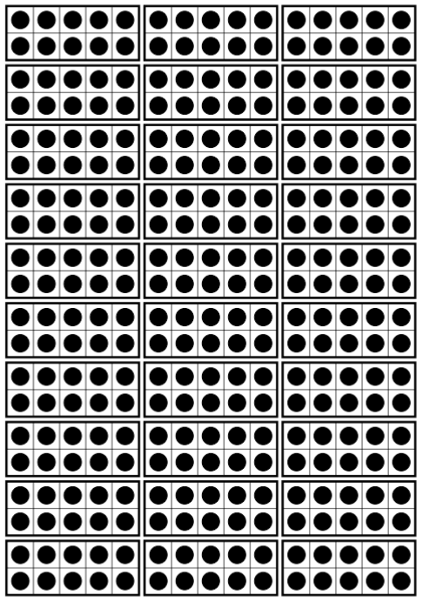
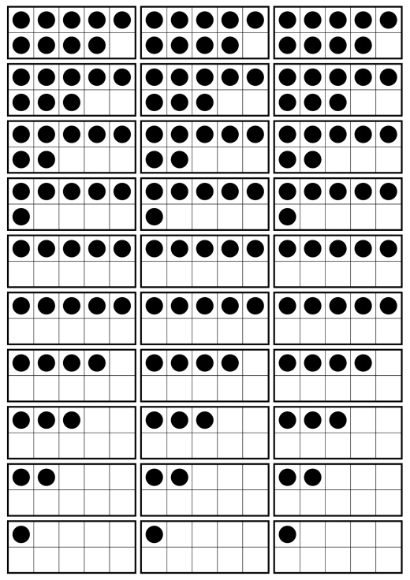Primary Number Cards

0 | 1 | 2 | 0 | 1 | 2
3 | 4 | 5 | 3 | 4 | 5
6 | 7 | 8 | 6 | 7 | 8
9 | 0 | 1 | 9 | 0 | 1
2 | 3 | 4 | 2 | 3 | 4

5 | 6 | 7 | 5 | 6 | 7
8 | 9 | 0 | 8 | 9 | 0
1 | 2 | 3 | 1 | 2 | 3
4 | 5 | 6 | 4 | 5 | 6
7 | 8 | 9 | 7 | 8 | 9

