NC.1.NBT.3
Molly and John Disagree
Domain | Number and Operations in Base Ten
Cluster | Understanding place value.
Standard | NC.1.NBT.3 Compare two two-digit numbers based on the value of the tens and ones digits, recording the results of comparisons with the symbols >,=,<.
Materials | SF and pencil
Task | Provide materials to the student. Read the problem to the student: Molly says set A is greater than set B. John says set B is greater than set A. Who is correct? Explain how you know. Show your thinking with pictures, numbers, or words.  A.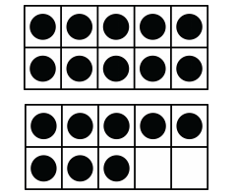 B.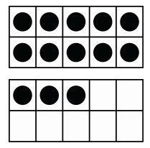  _______________ is correct because ___________ is greater than __________.  (student name) (#) (#)  Explain how you know.

Continuum of Understanding
Not Yet Proficient | Response includes 0-1 of the descriptors in “Meets Expectations” | Correctly Identified:  - Set A as 18  - Set B as 13  - Molly as being correct  - 18 is greater than 13  - Both have one ten, 8 ones is greater than 3 ones (place value is referenced)
Progressing | Response includes 2 of the descriptors in “Meets Expectations”
Meets Expectations | Response includes all of the descriptors in “Meets Expectations”  - Identifies who is correct: Molly  - Correctly states that 18 is greater than 13  - Clearly explains how they know Molly is correct by referencing place value

Standards for Mathematical Practice
1. Makes sense and perseveres in solving problems.
2. Reasons abstractly and quantitatively.
3. Constructs viable arguments and critiques the reasoning of others.
4. Models with mathematics.
5. Uses appropriate tools strategically.
6. Attends to precision.
7. Looks for and makes use of structure.
8. Looks for and expresses regularity in repeated reasoning.

Molly says set A is greater than set B. John says set B is greater than set A. Who is correct? Explain how you know.

A. B.
Show your thinking with pictures, numbers, or words.

___________________ is correct because _________ is greater than _________.
(student name) (#) (#)

Explain how you know?

