Cluster 3 Images:
Understanding Equality and Place Value to Compare Numbers
Topic | Comparing Numbers with Sentence Frames
Description | Students compare two-digit numbers in this cluster without an emphasis on using the symbols for greater than, less than, and equal to (the same value as). Instead, the language should be the focus as students compare based on meanings of the tens and ones digits.  In addition to tools such as balance scales, students may use sentence frames to help explain how they know a number is greater than, less than, or the same value as another number.
Images | 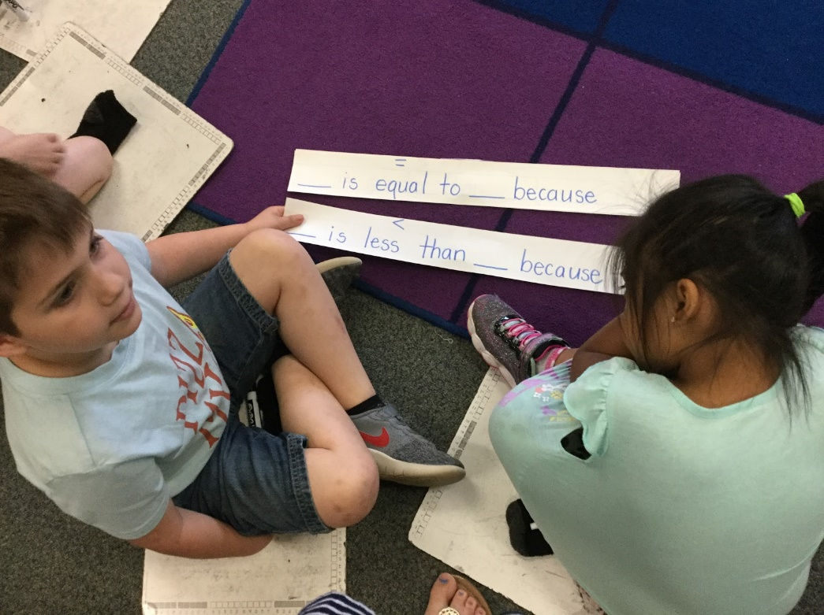  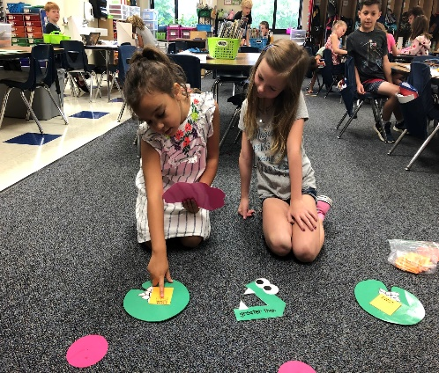  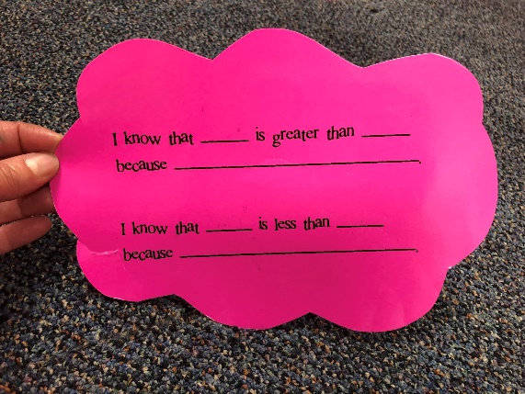
Topic | Place Value Charts
Description | Students move beyond 20 to explore place value within 100. After many experiences with making sets of tens and some more, students will begin to make connections among representations including the symbolic number and the number of tens and ones (example: 47 is forty-seven is 4 tens and 7 ones).  Appropriate models are groupable, proportional models such as ten sticks of cubes, rekenreks, groups of ten objects banded together or grouped in a cup, or red/yellow chips on tens frames. Students begin to see 10 as ten ones and a group of ten. This concept is known is unitizing.
Images | 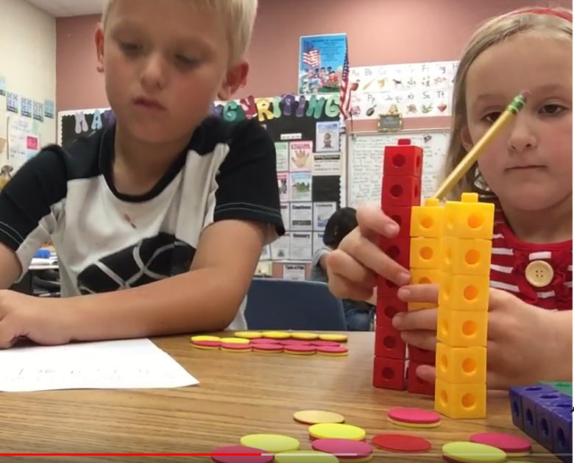  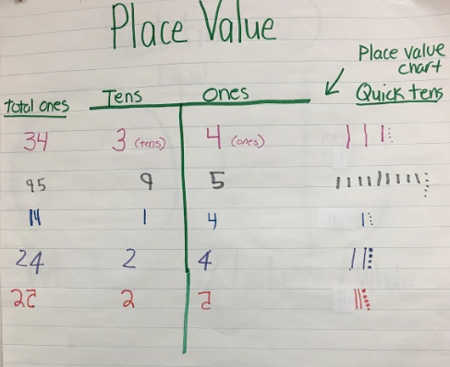
Topic | Comparing with Data and Word Problems
Description | This cluster builds on Cluster 1 as students continue to pose questions, collect data, and analyze the results. This gives a context for comparing quantities in two categories. Compare-difference unknown word problems are also introduced. Students should use models to directly compare quantities represented in the problem.
Images | 