The intended purpose of this document is to provide teachers with a tool to determine student understanding and suggest instructional moves that may help guide a student forward in their learning. It is not an exhaustive list of strategies.

Describing Numbers Using Place Value

Using pictures or words, explain if these numbers are the same or different.
41 14
NUMBER AND OPERATIONS IN BASE TEN
Understand place value.
NC.1.NBT.2 Understand that the two digits of a two-digit number represent amounts of tens and ones.
• Unitize by making a ten from a collection of ten ones.
• Model the numbers from 11 to 19 as composed of a ten and one, two, three, four, five, six, seven, eight, or nine ones.
• Demonstrate that the numbers 10, 20, 30, 40, 50, 60, 70, 80, 90 refer to one, two, three, four, five, six, seven, eight, or nine tens, with 0 ones.

Not Yet Proficient | - Using numbers 11-19, present a set of counters to students and a ten frame. Have students fill the ten frame. Ask: How many counters do we have? Did we have more than ten? How do you know? How many groups of ten do we have? How many leftovers do we have?  - Ask student to group a pile of manipulatives into a ten frame and describe it using the words tens and ones. (ex. 12 is 1 ten 2 ones)  - Building Teen Numbers  Learners need teen number cards, a double ten frame, and counters or cubes. Learners pull a teen number card and build the number on the ten frame with counters/cubes.  - Changing Teen Numbers  Learners need teen number cards, a double ten frame, and counters/cubes. Learners pull a teen number card and build it on the ten frame with counters/cubes. Learners pull another teen number card and change the number of counters/cubes to match their new number. Lesson: Ten Frames (11-19)
Progressing | - Ask student to model the numbers 24 and 42. Have the student orally explain the difference between the two numbers. Students should state that 42 is greater because it has more tens. Provide ample experiences for students to build numbers with ten frame cards.  - Ask student to write a statement about the two numbers (ex. 42 is greater than 24 because it has 4 tens).  - Lesson: Place Value and Arrow Cards Part 1 and Part 2
Meets Expectations | - Provide experiences for students to explore multiple representations using tens and ones (Example: 37 is 3 tens and 7 ones; 2 tens and 17 ones; 1 ten and 27 ones; 37 ones).  - Lesson: Greater Than, Less than Cover Up  Note 1: Students should be given ample opportunities to compose and decompose tens before they are introduced to “pre-grouped” tens (ex. base ten blocks) that require trading.  Note 2: Non-proportional materials (ex. coins) should not be used.

Teen Number Cards

10  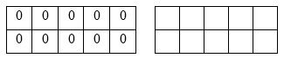 | 11  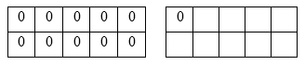 | 12  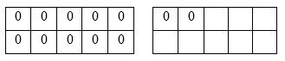
13  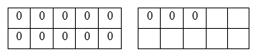 | 14  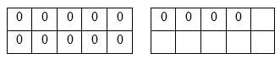 | 15  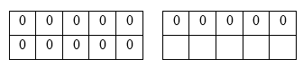
16  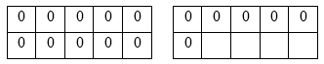 | 17  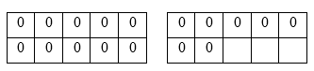 | 18  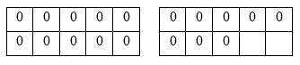
19
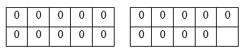

Double Ten Frame

The intended purpose of this document is to provide teachers with a tool to determine student understanding and suggest instructional moves that may help guide a student forward in their learning. It is not an exhaustive list of strategies.

Problem Type: Compare/Difference Unknown

Katie has 9 stuffed animals. Maya has 6 stuffed animals. How many fewer stuffed animals does Maya have than Katie?

Johnny had 5 cards. Madison had 13 cards. How many more cards did Madison have than Johnny?

OPERATIONS AND ALGEBRAIC THINKING
Represent and solve problems.
NC.1.OA.1 Represent and solve addition and subtraction word problems, within 20, with unknowns, by using objects, drawings, and equations with a symbol for the unknown number to represent the problem, when solving:
• Add to/Take from-Change Unknown
• Put together/Take Apart-Addend Unknown
• Compare-Difference Unknown

Add and subtract within 20.
NC.1.OA.6 Add and subtract, within 20, using strategies such as:
• Counting on
• Making ten
• Decomposing a number leading to a ten
• Using the relationship between addition and subtraction
• Using a number line
• Creating equivalent but simpler or known sums

Not Yet Proficient | - Show the student two towers (8 and 5). Ask: Which tower has fewer cubes? How do you know? How many fewer?  - Check to see if the student understands the word fewer. Show the student a tower of 8 cubes and ask: Can you build a tower that has fewer cubes?  - Assess to see if the student understands that this is a Compare Problem. Ask: How many stuffed animals does Katie have? How many stuffed animals does Maya have? How would you find the difference between Katie’s amount and Maya’s amount?  - Model the two amounts with cubes and compare the two towers. Label the towers with the names Katie and Maya. Ask: Who had fewer? How many fewer?
Progressing | - If the student attempts to join the 9 and the 6, ask the student: Can you retell the story and explain what the two numbers represent? Did Katie and Maya put their stuffed animals together? What do we want to know about the amount of stuffed animals they have?  - If the student recognizes the structure of the problem, but makes a computation error, support the student in using an accessible strategy. For example, start at 6 and count on. Make a line of 6 and a line of 9, and ask students: How many more are there in this line (pointing to the line of 9)?  - If students need manipulatives to support computation, provide them with opportunities to use manipulatives and then record their work on paper for the problem situation.  - If the student is unable to write the correct equation, have the student model the situation with the cubes as you notate the equation. Ask the student: Why would I write 9 – 6 = ? What does the 9 represent? What does the 6 represent? What does the “?” stand for? Then switch roles and the teacher models with cubes as the student writes the equation.
Meets Expectations | - Give students equations and ask them to write Compare Difference Unknown story problems that match the equation.  - Encourage students to explain why both these strategies work: adding up from 6 to 9 or subtracting from 9 to 6.

