**Compare these two numbers using the words**

***is greater than***or ***is less than***or ***is equal to***

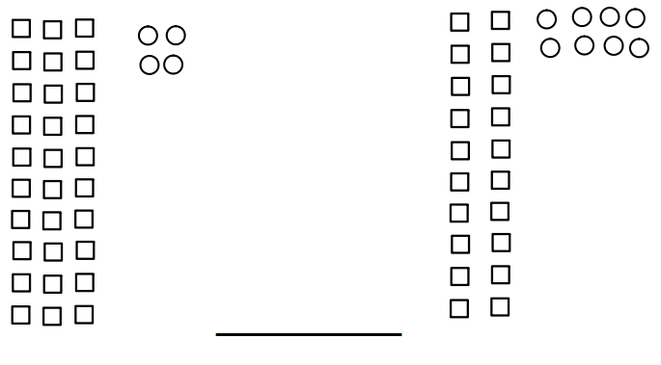

**Compare these two numbers using the words**

***is greater than***or ***is less than***or ***is equal to***

**47      __________________________  4 tens and 7 ones**

**Do these two drawings have the same value?** **Yes or No**

**Why or why not?**

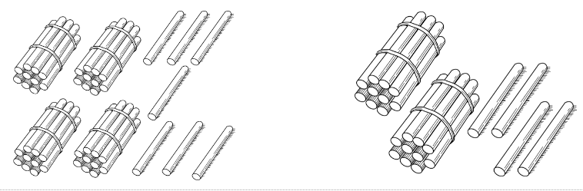

**Compare these two numbers using the words**

***is greater than***or ***is less than***or ***is equal to***

**7 tens 2 ones ____________________   7 ones 2 tens**

**Sam says that the numbers below have the same value.  Do you agree or disagree? Yes or No**

**Explain your thinking in pictures, numbers, or words.**

 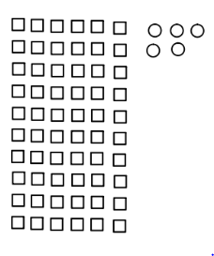

**Tim has 17 pennies.  Kim has 27 pennies.**

**Complete the sentence frame.**

**_________________ has more pennies than _________________.**

**Tom and Susan collect dinosaur stickers.  Tom has 12 dinosaur stickers. Susan has 15 dinosaur stickers.  Complete the sentence frames.**

**The number _______ is fewer than_______.**

**This means that __________________ collected fewer stickers than __________________.**

**A bowl of fruit has 13 strawberries and 15 grapes.  Were there fewer strawberries than grapes in the bowl?       Yes or No**

**Explain your thinking using pictures, numbers or words.**

**Compare these two numbers using the words**

***is greater than***or ***is less than***or ***is equal to***

**42      __________________________  45**

**Explain how you know.**

**John thinks the number 17 and 71 are the same number.  Do you agree or disagree? Agree or Disagree**

**Explain your thinking with pictures, numbers, or words.**