Student Representation for Comparing Two 2-digit numbers
Student Representations | Description of Strategies
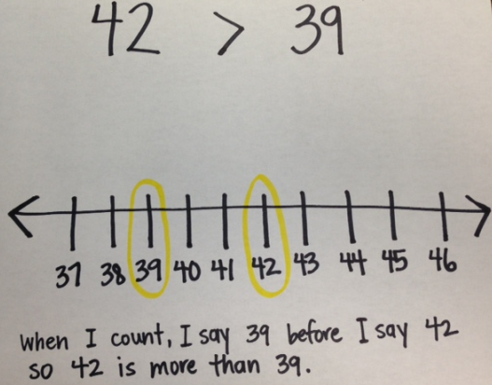 | The student is relying on the counting sequence to compare. The next step could be moving toward thinking of the numbers as a quantity then comparing the two quantities.  Ask: How can you represent the number 42? Begin with concrete objects the student can count out. Repeat with the number 39 then ask: Now how can we determine which is more and which is less?
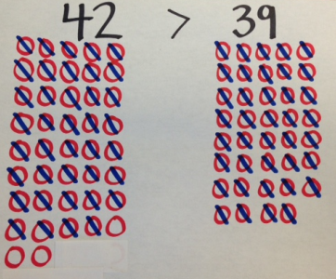 | The student is thinking of the numbers as representing quantities and is also comparing. The comparison focuses on individual objects. You may ask the student: Was it difficult to keep track of how many objects you crossed out? How could you do it differently so that it might be easier [more efficient]?  The next step could be unitizing objects or thinking in groups of ten. You could use objects that can be grouped or stacked, such as cubes. Have student show the quantities with groups of ten and some more then compare.
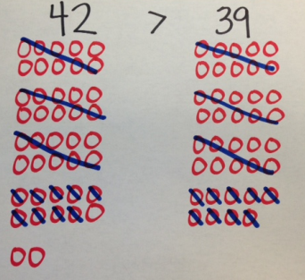 | The student is representing quantities and thinking in groups of ten but is still comparing by crossing out matching groups or sets.  The next step could be to move toward place value understanding by thinking of tens and some more, or ones. This can be done using groupable objects, filling ten frames, and/or using ten frame cards to represent numbers.
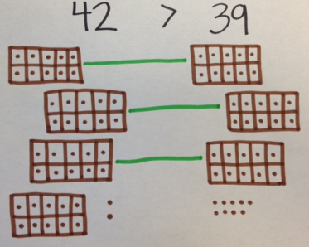  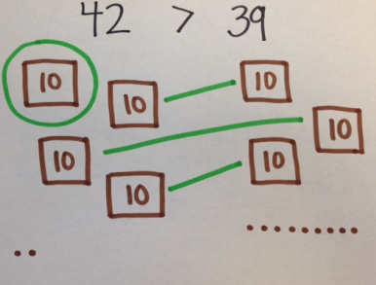 | This thinking shows the student understands numbers are made up of tens and “leftovers,” or ones. The student is still matching groups to compare and seems to be on the verge of seeing there are more tens in one number than the other. Ask: What were you thinking as you compared these two numbers? Then use the response and the student’s drawing to help the student see that there are 4 groups of ten (or 4 tens) in the number 42 but only 3 groups of ten (or 3 tens) in the number 39.  Notice how the student approaches the ones when comparing. A misconception could be that the student realizes there are more ones with 39 than with 42. This could create confusion, so remind the student of the groups of ten, specifically how there are more tens in 42. You may need to separate the last group of 10 from 42 into individual ones so there ends up being 12 ones and not just two if the student continues to struggle to understand.
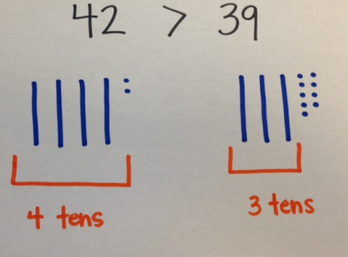 | The student is using place value understanding to compare the numbers. The student sees the quantities as tens and ones. This meets the expectation for comparing two 2-digit numbers in first grade.  If you would like to continue to grow the student in this area, you could encourage more detailed explanations (see below).
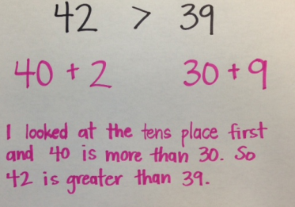 | This sample is more abstract, but the clear written explanation could also match the previous sample drawing. It is not necessary for first graders to reach this stage of thinking, but it is a natural next step if the student needs to be challenged when comparing numbers.

