Mathematicians Work Together
This is lesson two in a series of six lessons focused around developing a mathematical community at the beginning of the school year. The primary goal is for students to begin establishing norms for how students work together during math class throughout the whole year. A secondary goal is to estimate length.

NC Mathematics Standards:
Measure and Estimate Lengths.
NC.2.MD.3 Estimate lengths using standard units of inches, feet, yards, centimeters, and meters.

Standards for Mathematical Practice:
1. Make sense of problems and persevere in solving them.
4. Model with mathematics.
6. Attend to precision.

Student Outcomes:
- I can work with a partner to complete a math task.
- I can use blocks to build a tower that is about 1 foot tall.

Math Language:
- mathematician
- the same height as
- estimate
- foot

Materials:
- laptop, access to internet, speakers
- building blocks, Unifix cubes, base-ten blocks, or other materials for stacking
- photos of people working together (found at the end of this plan)
- poster paper, markers
- ruler (1 foot long ruler per 2 students)
- writing paper or math journal
- pencil
- materials for “Math Partners” or “Working Together in Math” anchor chart

Advance Preparation:
- Preview Wonder Grove: Work Together as a Team video.
- Print or be ready to project pictures of people working together (Pictures are at the end of this file).
- Be ready to create a Math Partners or Working Together in Math chart of expectations. (Future lessons throughout the year might involve working as a small group or team rather than in pairs.)

Launch:
- Introduce the task.
- Say: Mathematicians solve problems. During our daily math time, we will work as mathematicians to solve problems with objects, shapes and numbers. Many times mathematicians work together when solving problems. Also, before solving a problem, mathematicians might estimate what they think the solution should be.
- Show pictures of people working together. Ask: What do you notice in these pictures? What do you see that tells you the partners are doing a great job working together?
- Watch Wonder Grove: Work Together as a Team. Have students look for ways the students work together during the video.

knees to knees
- After viewing the video, say: Maria had trouble building a tower. Talk to your neighbors about ways the friends worked together to help Maria. Remember, when we talk to our partners, we look at each other and listen. We may decide who shares first. I say something, then my partner says something. We keep taking turns until the teacher gives a signal. (Model with a student.)
- Have students share their ideas with the class. As students share, generate a “Math partners…” or a “Working Together in Math” chart (see right). This chart may be displayed and added to throughout the school year.

Sample
Chart:
Only
record
ideas
students
share.
Math partners…
Listen
Take turns
Talk quietly
Explain their thinking
Are helpful
Encourage each other

- Introduce today’s task.
- Before introducing today’s math task, arrange students in pairs. Ask partners to come and get their building blocks. Allow 2-3 minutes of free exploration time.
- Bring students back together (away from the blocks).
- Explain task. Say: Today’s math task is that partners will work together to build a tower, just like Maria did with her friends. Your tower will have to be a certain height. One tool for measuring height is a ruler. Does anyone know how long a ruler is? (12 inches or 1 foot) This ruler is 1 foot in length. It’s a tool we can use to measure how many feet tall a tower stands.
- We said before that mathematicians often estimate an answer before they work to solve a problem. What does it mean to estimate? (To guess, but to do a bit more than that, to guess in a reasonable way, an educated guess, a guess that you think is close to the answer)
- You and your partner will build a free-standing block tower that is about 1 foot tall. (Teacher needs to clarify what is meant by free-standing.) You will need to work together to estimate when your tower has reached a height of 1 foot. Which way would I hold my ruler to measure 1 foot tall? (Demonstrate) Once your tower is built, you will need to get a ruler to measure your tower’s height. If your tower is not 1 foot tall, return the ruler to the front, change your tower, then get the ruler to measure again. As you work, be sure to remember the things mathematicians do when they work together.

Explore:
- Allow 10-15 minutes for partners to build their towers. This exploration time is useful for observing and collecting formative data on students’ current level of understanding, and to take note of how students are working with a partner.

Observation | Questions to Ask
They are each building their own tower, rather than working together. | Students may not have had a lot of previous experiences working with partners, and need help getting started.  - How many towers did Maria and her friends build when they were working together?  - What can you do to start building one tower together (take turns adding blocks)?
Partners are disagreeing or one is doing all the work. | Refer to the “Math Partners” chart.  - What is one thing you and your partner can do so that both of you are building the tower (take turns adding blocks, talk about where the blocks should go, etc.).
Partners are successfully building a tower together. | - How did you work together to decide how to start building your tower?  - Did you run into any problems or have to make any changes when building your tower?

- As each pair of students finishes their tower, observe how they use their ruler to measure the height. Ensure they are measuring vertically.
- Once a team has estimated, measured, corrected, and measured again, or repeated that process until they are satisfied with their tower, ask them to work together to write and/or draw reflections about how they worked together as partners. What did you do well? What could you have done better? What would you do differently next time?
- Engage students in a “Gallery Walk” of each group’s towers in which each student has an opportunity to view and consider the other towers. You may decide to lead the students through the walk whole class if they are not familiar with the process. Some questions might include: What was your partnership thinking when you designed this tower? Were there times that you had to help each other or stop and start again? What thinking can you see in this group’s tower? How is this tower like your own or others? How is this tower different from your own or others? Is this tower about 1 foot tall? How can you prove whether it is or isn’t?
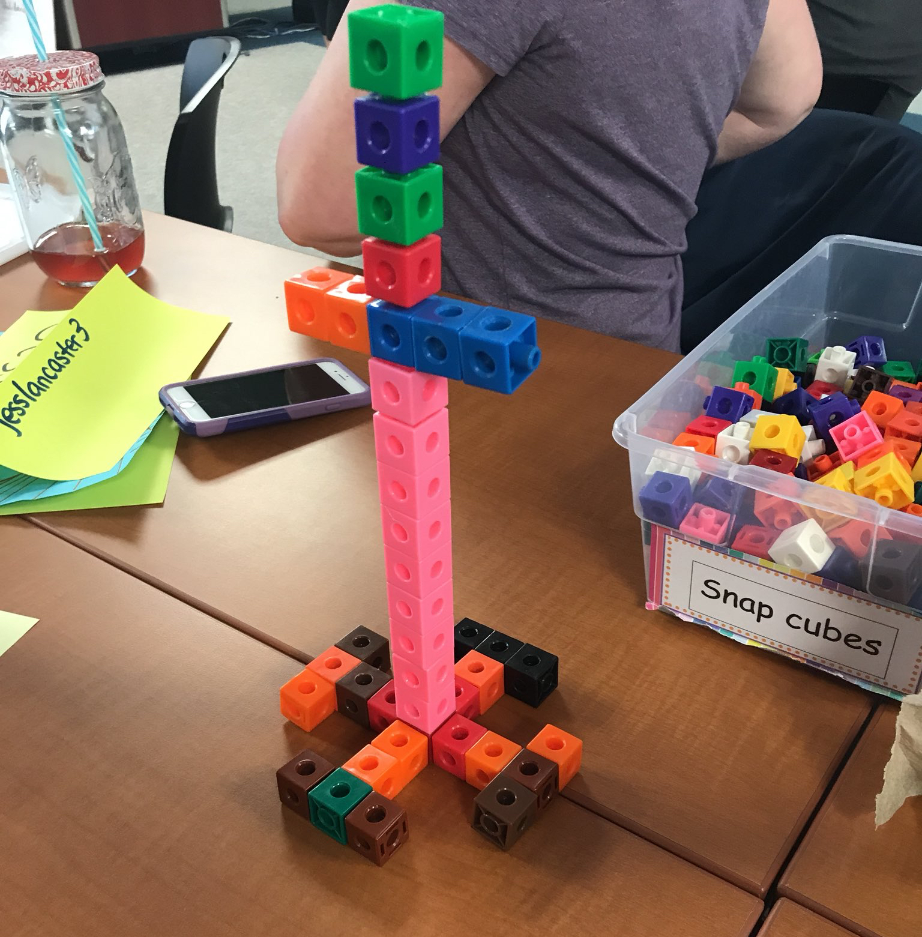

Discuss:
- Bring students together on the carpet or other gathering area (or move away from any blocks or towers that are still out).
  - Remind students that they were mathematicians, and they worked with their partner to build a tower.
  - Discuss successes and room for improvements in partner work referencing and adding to the anchor chart as needed.

Sample Questions | Possible Responses  (in order of least to most sophisticated)
- How did your estimate of 1 foot, your tower, compare to the actual 1 foot? | - It was shorter.  - It was taller.  - It was 1 foot.
- How many partners had towers that were under/over 1 foot? | - (Show of hands)
- Share with us one way your partner was helpful to you while you worked together.  - Refer back to the anchor chart and ask students to think about things they did when working on their towers. | - Answers will vary or the teacher may share an observation of partners being helpful to each other.  - Answers will vary.
- Partner Reflections | - Allow partners who had time for reflections to share their writing and/or drawings.

- Say: We all are mathematicians when we are working on mathematical problems. Today, we learned how to work with a partner to solve a math task. Today and every day, we will be mathematicians and keep talking about math, looking for math in our world, and using math to solve problems.

Evaluation of Student Understanding:
Informal Evaluation:
- Students may not have a solid notion of the length of 1 foot. The goal is not that they accurately estimate the height of 1 foot, but that they work with a partner.

Meeting the Needs of the Range of Learners:
Interventions:
- As this was an introductory lesson, it is not expected that students have prior knowledge of the units feet and yards or of estimating lengths. Working well with a partner is an even more important goal at this early moment in the school year.
Extensions:
- Throughout the school day, find opportunities to look for objects with an estimated length of 1 foot. Play I Spy…
- Create another task that involves cup stacking (build a tower using cups) if blocks were originally used. This task might ask students to build a tower that is 1 yard or 3 feet tall. (16 oz plastic cups work well. Note: It takes 36 cups to make a 3 foot pyramid tower. See picture examples below.)

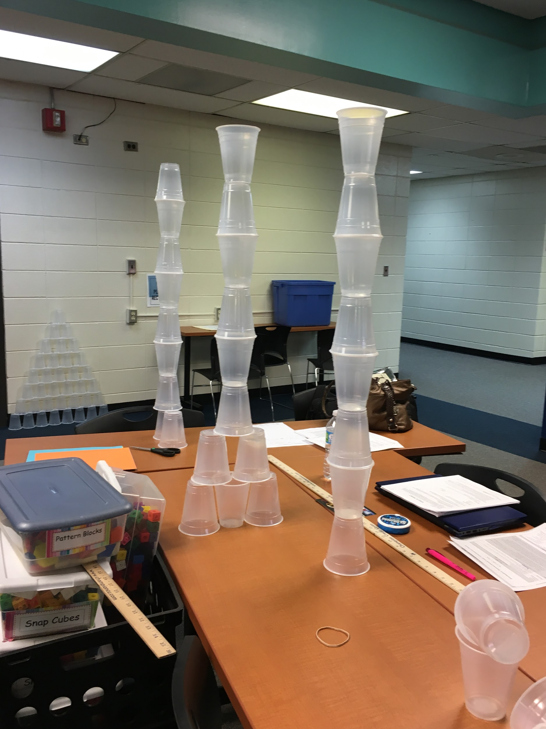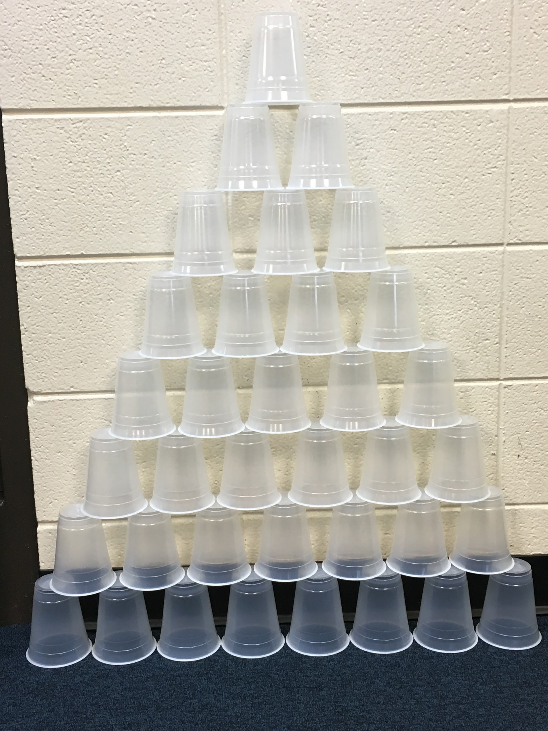

Possible Errors  and Misconceptions | Suggestions
Student does not want to estimate initially or the second or third time, but just wants to measure. | Encourage the student by reiterating that getting the tower height “close” is good enough! Do not make the rulers available too soon and hold them after each measurement.  You could also allow a student to estimate where the ruler reaches on their own height, if that reference helps them better engage with the task.

Special Notes:
- This was an introductory lesson, with the intended goal of learning how to work on a math task/activity with a partner. Therefore, students should not be held accountable for not measuring correctly. By the end of the school year, after having many experiences with measurement and measuring tools, students will be able to better estimate and measure.

Examples of People Working Together
