Mystery Animal
In this lesson, students will sort items into groups. They will use
counting to analyze the organized items and answer the question “How many?”

NC Mathematics Standards:
Classify objects and count the number of objects in each category.
NC.K.MD.3 Classify objects into given categories; count the numbers of objects in each category and sort the categories by count.

Supporting Standards:
Count to tell the number of objects.
NC.K.CC.4 Understand the relationship between numbers and quantities.
- When counting objects, say the number names in the standard order, pairing each object with one and only one number name and each number name with one and only one object (one-to-one correspondence).
- Recognize that the last number named tells the number of objects counted regardless of their arrangement (cardinality).
- State the number of objects in a group, of up to 5 objects, without counting the objects (perceptual subitizing).
NC.K.CC.5 Count to answer “How many?” in the following situations:
- Given a number from 1–20 10, count out that many objects.
- Given up to 20 10 objects, name the next successive number when an object is added, recognizing the quantity is one more/greater.
- Given 20 10 objects arranged in a line, a rectangular array, and a circle, identify how many.
- Given 10 5 objects in a scattered arrangement, identify how many

Standards for Mathematical Practice:
4. Model with mathematics
5. Attend to precision

Student Outcomes:
- I can organized items into groups.
- I can count to answer “How many?”

Math Language:

- Count
- Numbers 1-10
- How many?
- Set
- Group
- Category

Materials:
- Copies of the Mystery Animal picture (page 5)
- Computer, projector, speakers, internet access
- Duck! Rabbit! video by Chronicle Books
- Yellow, brown, and blue crayons or markers
- Yellow, red, and blue manipulatives
- Baggies – one baggy for each group of 3-4 students

Advance Preparation:
- Be ready to play the video Duck! Rabbit! by Chronicle Books
- Print a class set of the mystery animal picture.
- Have yellow, red, and blue manipulatives and baggies near front of room.

Launch:
- Explain: Mathematicians make conjectures as they work. This means they make guesses about what they think will happen or what they think is correct. Sometimes mathematicians’ conjectures/guesses are right, sometimes they are wrong, and sometimes there isn’t a right or wrong answer. In today’s lesson, you will make a conjecture/guess. For this guess, there isn’t a right or wrong answer.
- Activate prior knowledge. Say:
  - In today’s lesson, we will make a conjecture about a mystery animal. We will look at a picture and guess what the mystery animal is.
  - We know people have hands, feet, and hair. What are some features an animal can have? Discuss with a partner.
  - Now, let’s talk to our partners about some specific animals. What are some features a bear has? A duck? A snake? A rabbit?
  - When you see the picture of the mystery animal, use its features to help you decide what animal it is.
- Make conjectures about the mystery animal:
  - Display the mystery animal picture. Say: Silently look at this picture. Without talking, make a conjecture about what animal this is. Don’t tell anyone!
  - Distribute a mystery animal picture to each student. Prompt students to record their conjectures on the line below the picture. Students may use inventive spelling, or dictate to the teacher. Once finished, students may share with partners.
  - Click to reveal video of the book Duck! Rabbit! Pause video so it does not play.
  - Say: There is a book all about this mystery animal. It is called Duck! Rabbit! The characters try to decide if this is a duck or rabbit. What other animals could it be?
  - Prompt students to color the picture based on the animal they originally saw:
- Duck – yellow
- Rabbit – red
- Other animal – blue
  - Play video of Duck! Rabbit! As video plays, collect students’ colored pictures. Display the pictures in a scattered, unorganized arrangement on the board.
- Introduce task:
  - Draw attention to the pictures on the board. Say: Here are our conjectures about the mystery animal.
  - Say: Tell your partner what you notice. Have a few students share.
  - Say: Tell your partner what you wonder. Have a few students share.
NOTE: While partners talk, count out yellow, red, and blue manipulatives to match the class’ conjectures. Place in a baggy. Repeat this for each baggy until there are enough baggies for groups of 3-4 students.
  - Explain task: Right now, our conjectures/guesses look messy. They’re mixed up and not organized. Today you will work in a team to organize our class’ conjectures into groups. When you finish organizing, your team will answer the question: What do you know about our class by looking at these groups?
  - Call on a few students to restate the task to the whole group, making certain all students have made sense of the task.
  - Distribute baggies of yellow, red, and blue manipulatives. Explain that the colored manipulatives represent our classmates’ guesses on the board. Remind students what each color represents. Students may also look at the board as a reminder.

Explore:
- Allow 8-10 minutes for groups to organize the manipulatives and discuss the answer to the question: What do you know about our class by looking at the groups?
- While students work, ask questions to advance their thinking.

Observation | Questions to Ask
Students have difficulty getting started. | - What type of animal does the yellow manipulative represent? Blue manipulative? Red manipulative?  - What is the first thing the class is supposed to do?  - The manipulatives are all mixed up! How can we group them?
Students have difficulty organizing the manipulatives into groups. | - The manipulatives are all mixed up! How can we group them?  - How can we put together the items that are the same?
Students organize the manipulatives into groups, but have difficulty answering the question, “What do you know about our class by looking at the groups?” | - Which color do we have a lot of (or a little of)?  - What animal does that color represent?  - How many are there?  - What does this tell you about students in our class?
Students have difficulty tracking while counting. | - How can we arrange the manipulatives so counting will be easier? (example: in a straight line)  - How can we move the manipulatives as we count to help keep track? (examples: move and count, slide and count)  - How can we touch or point to make counting easier?
Students quickly and easily group and count each set. | - What do you know about our class by looking at the groups?  - Are you able to find the total number of students in our class by looking at this information?  - Did more students think the mystery animal was a duck or rabbit? How do you know?

- As students work, select a few students to share during the “Discuss” section of the lesson. Determine the sequence in which students will share (e.g., least to most sophisticated observations/answers).

Discuss:
- Bring students together to share their solutions (e.g., on carpet).
- Draw attention to the pictures on the board. Review what each color represents.
- Say: The first part of the task was to organize our conjectures. Tell me how I can organize these pictures on the board. Organize the pictures as students direct.
- Say: ______ will you remind us of the question we were asked to discuss?
- Have selected students share what they know about the class from looking at the pictures. As students share, ask questions such as:
- After looking at the different groups, what do you know about our class?
- How many students thought the animal was a duck? Rabbit? Different animal?
- What did you do to make counting easy? (point and count, touch and count, move and count using manipulatives, or other tracking strategy)
- Which group had a lot? A little? How do you know? (At this point in the school year, students are not expected to use words such as more/less/same amount as.)

Evaluation of Student Understanding:
Informal Evaluation:
- Students organize manipulatives into groups.
- Students use counting strategies (e.g., touch and count, slide and count, point and count) to determine the total amount in each group.
- Students use mathematics to describe the sorted groups (e.g., 4 students thought the mystery animal was a rabbit).

Meeting the Needs of the Range of Learners:
Interventions:
- If students have difficulty using colored manipulatives to represent the animals, an alternative is to use yellow, red, and blue copies of the mystery animal image.
- Use observational data from the “Explore” portion of today’s lesson to plan differentiated, small group instruction, as well as to guide planning for future lessons.

Extensions:
- Solve additional problems related to the book Duck! Rabbit! For example:

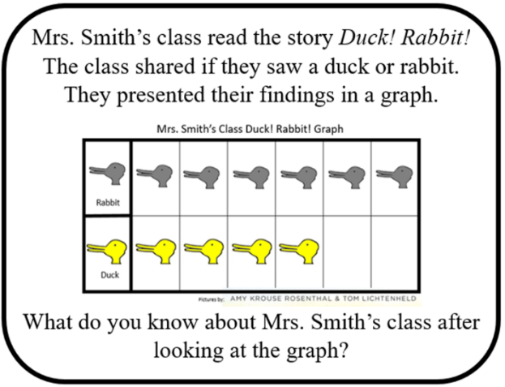

Mystery Animal Images

