Mathematicians Learn From Mistakes
This is lesson five in a series of six lessons focused around developing a mathematical community at the beginning of the school year. While this lesson addresses standard NC.2.G.1, the primary goal is for students to recognize that mathematicians use their mistakes as opportunities to learn.

NC Mathematics Standards:
Geometry
Reason with shapes and their attributes.
NC.2.G.1 Recognize and draw triangles, quadrilaterals, pentagons, and hexagons, having specified attributes; recognize and describe attributes of rectangular prisms and cubes.

Standards for Mathematical Practice:
1. Make sense of problems and persevere in solving them.
3. Construct viable arguments and critique the reasoning of others.
7. Look for and make use of structure.

Student Outcomes:
- I can learn from my mistakes.
- I can notice how objects are classified into a group.

Math Language:

- mathematician
- measurable attributes (e.g., big, small)
- colors (e.g., red, yellow, blue)
- shapes (e.g., square, circle, triangle)

Materials:
- computer, speakers, access to internet
- attribute blocks or Chain of Changes shape sheet from the last page of this file or from https://nrich.maths.org/221/index
- string

Advance Preparation:
- For background knowledge, preview the video Mistakes are Powerful, by Jo Boaler.
- Preview The Power of ‘Yet’ with Zoe and Elmo from Sesame Street.

Directions:
- Review characteristics of mathematicians based on prior lessons.
- Launch: Introduce the term mistake.
- Say: A mistake means to be wrong, or do something the wrong way. Each day, people make mistakes.
- Give an example of a mistake: Yesterday, I went to the store. I kept pushing the door, but it wouldn’t move. Then, I realized the sign said “pull”.
- Encourage students to silently think of mistakes they may have made.
- Have students turn and talk about a time they made a mistake.
- Explain that mistakes are learning opportunities.
- Say: People may be upset or embarrassed when they make mistakes. However, mathematicians see mistakes as chances to learn. Mathematicians often make many mistakes before they get the right answer. From each mistake, they learn what they can try differently the next time. After some tries, they usually get the problem right.
- Watch The Power of ‘Yet’ with Zoe and Elmo from Sesame Street.
- Partners turn and talk about observations from the video.
- Emphasize that Zoe makes a mistake and learns from it. By trying different things, she solves her problem.
- Say: Just like Zoe, mathematicians should not be upset or embarrassed when they make mistakes. We can look at our mistakes, think about what went wrong, and learn from them.
- Have students turn and talk again about the mistake they made and what they learned from it.
- Explore: Play “Guess My Rule” using the class’ mistakes as learning opportunities.
- Have students sit in a circle on the carpet.
- Distribute one attribute block to each student.
- Place a circle of string on the carpet. Tell students they will try to guess a secret rule. Shapes matching this rule will be put inside the circle. All other shapes go outside the circle. Students take turns guessing whether their shapes belong inside or outside the circle. After each guess, the student will be told if it is right or wrong. The class will learn from these mistakes as they try to place additional shapes. Once several shapes are placed, the class will guess the secret rule. Example:

Secret Rule: shapes that are red
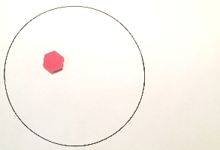 | - Inside the circle, the teacher places a shape fitting the rule.
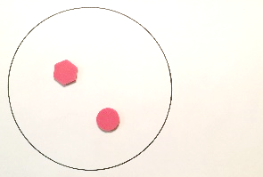 | - A student puts his shape outside the circle, incorrectly guessing it does not fit the rule. Teacher moves it into the circle, explaining that it does fit. This mistake helps the class start thinking about possibilities for the secret rule.
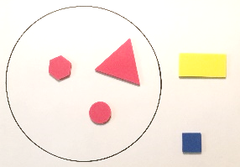 | - Students place additional shapes. After guessing where their shapes belong, teacher moves them to the correct location. After placing several shapes, the class guesses the rule is “red shapes”.

Ideas for Other Secret Rules
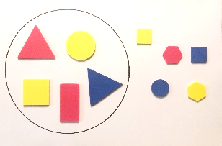 | 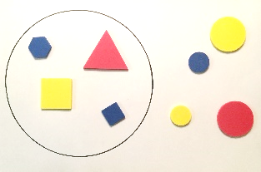
Big Shapes | Shapes with Corners
- Discuss: After playing “Guess My Rule” several times, discuss benefits of making mistakes.
- Ask: Did anyone make a mistake when placing their shape? How did this help you figure out the rule?
- Ask: Did anyone guess the wrong rule at first? What made you change your mind?
- Say: Today and every day, you will be faced with hard problems in math. Remember, it is alright to make mistakes. Mistakes make your brain get smarter. When you make mistakes, don’t give up. Instead, look at what you did wrong, and try something different. Today and every day, you can learn from your mistakes, using them to help you solve problems and get smarter.
- Closure
  - Watch the video Mistakes are Powerful, by Jo Boaler
  - Create a class anchor chart “What to Do when You Make a Mistake” (student generated)

Sample Chart
“What to Do when You Make a Mistake”
- Take a deep breath
- Try the task again
- Ask a friend for help
- Look for different tools to use to solve the problem
- Remember the power of yet
- Remember your brain is growing

Evaluation of Student Understanding:
Informal Evaluation:
- Students will begin to recognize mistakes as learning opportunities in math. They will begin to embrace mistakes, using them to refine their thinking.
- Students will identify ways to classify shapes using defining attributes (e.g., corners and sides) and non-defining attributes (e.g., color and size).

Meeting the Needs of the Range of Learners:
Interventions:
- As this was an introductory lesson, it is not expected that students are proficient classifying shapes and other objects. Continue to provide all students with experiences classifying objects into categories based on their attributes.
Extensions:
- Guess My Rule may be repeated using objects other than shapes (e.g., students, favorite toys). The most important part of this activity is to highlight the idea that students are learning from their mistakes.

Possible Misconceptions/Suggestions:
Possible Errors  and Misconceptions | Suggestions
Students do not notice a variety of attributes, and may focus only on color or size. | - Prompt students to think of other attributes using questions such as, What can you tell me about the sides of these shapes? What rule can you create using sides (number, straight or curved, etc.) of shapes?  - As this was an introductory lesson, students are not expected to proficiently classify shapes into categories. Throughout the school year, give students many experiences classifying objects.  - It may be helpful to classify items meaningful to students (e.g., students in the class, food, toys).  - Prior to classifying objects, discuss attributes of the items.

Special Notes:
Throughout the school year, celebrate mistakes as learning opportunities. When a student makes a mistake, some possible responses may be:
- I’m glad you made that mistake. It happens a lot, and now the whole class can learn from it.
- That’s such an important mistake to make because we can learn so much from it.
- This mistake helped me to see what you already know so that I can help you understand what’s next in your learning.

