Dear Parents,
Over the course of this school year, your child will be asked to use multiplication in many ways. The fourth grade standards call for students to compare two amounts using multiplication, find area by multiplying, determine factors and multiples, develop strategies for multiplying and dividing larger numbers, and solve word problems involving multiplication and division. All of these concepts are made easier when students are able to quickly and accurately recall their multiplication facts. This letter will include strategies and fun games you can use at home to help your child learn his or her facts and recall them quickly.

X4

Multiplying by four can be thought of as doubling a double. Ask your child to think about the two hands and double that amount again. Here is an example for 4 x 3.
3 + 3 = 6
6 + 6 = 12
So, 4 x 3 = 12
X2

Multiplying by two is the same as doubling, or adding the number to itself. Ask your child to think about two hands, each with the same amount in them. Here is an example for 2 x 3.
3 + 3 = 6 2 x 3 = 6.

X8

Multiplying by eight can be accomplished by doubling the result of multiplying by 4. Here is an example for 8 x 3.
4 x 3 = 12, so 12 more would be 24.
8 x 3 = 24

X10

Students have experience from earlier grades with counting by tens and can use this skill to multiply by ten. Here is an example with 3 x 10.
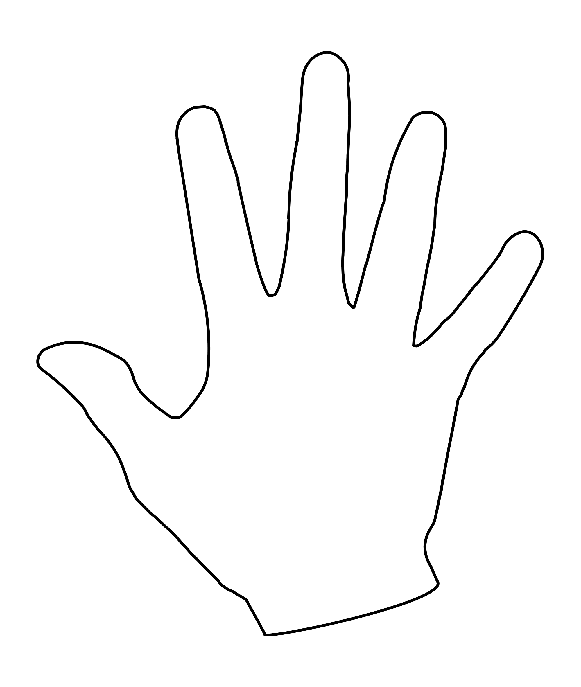
Skip count by tens three times: 10, 20, 30.
3 x 10 = 30
Students may also connect to place value when multiplying by 10.
4 x 6 = 24
4 x 6 tens = 24 tens or 240

20
30
10

X5

Students have lots of experience skip counting and counting money. When multiplying by five, students can count by fives. Here is an example for 3 x 5.
Skip count by fives three times: 5, 10, 15.
3 x 5 = 15

Students may multiply by ten and then take half.
10 x 3 = 30 - Half of 30 is 15 5 x 3 = 15
10 x 9 = 90 - Half of 90 is 45 5 x 9 = 45
10 x 18 = 180 - Half of 180 5 x 18 = 90
X3, X6

Multiplying by three can be thought of as doubling and then adding one more group. Here’s an example with 3 x 3.
Double 3 is 6. One more group of 3 makes 9.
Multiplying by six can be done by doubling the result of multiplying by three. Here’s an example with 6 x 3.
3 x 3 = 9 9 doubled is 18
It can also be accomplished by multiplying by five and adding one more set.
5 x 3 = 15 one more group of 3 makes 18

15
10
5

X7

Multiplying by 7 can be done by breaking the 7 apart and multiplying by simpler facts. Here’s an example with 7 x 3.
I’ll break the 7 into 5 and 2.
5 x 3 = 15 and 2 x 3 = 6
15 + 6 = 21 so 7 x 3 = 21

It may be easier to reverse the factors for students.
I can solve 7 x 3, because I know 3 x 7 = 21.
X9

Using x10 facts makes x9 facts much easier. The product of a x9 fact is one group less than the product of the same x10 fact. Here’s an example with 9 x 3.
10 x 3 = 30, so I need to take away one group of 3 to have nine groups.
30 – 3 = 27

Games to Play at Home
Salute
Number of Players: 3
Materials: playing cards or number cards 2-10
Directions: Players A and B are dealt 10 cards face down. They sit facing one another. They each take a card from their stack and put it on their foreheads, so they can’t see it but the other person can. Player C says the product of the two cards. The first player to shout out the number on their own head wins the round. The player with the most points at the end of 10 rounds wins.

Greatest Product
Number of Players: 2 or more
Materials: playing cards or number cards 2-10
Directions: Each player is dealt an equal number of cards. At each turn, each player turns over two cards and finds their product. The player with the greatest product keeps all the cards. The winner is the player with the most points at the end of 10 rounds.

Print your own deck of cards here: https://www.timvandevall.com/wp-content/uploads/2014/05/Playing-Card-Template.pdf

