Even Design Challenge

In this lesson, the students will explore even and odd numbers through a variety of hands-on learning activities. Students will explore numbers up to 100, comparisons of groups, and odd/even relationships of numbers up to 20.

NC Mathematics Standard(s):
Operations and Algebraic Thinking
NC.2.OA.3
Determine whether a group of objects (up to 20) has an odd or even number of members.
- Pairing objects, then counting them by 2s.
- Determining whether objects can be placed into two equal groups.
- Writing an equation to express an even number as the sum of two equal addends..

Standards for Mathematical Practice:
1. Make sense and persevere in solving problems.
2. Reason abstractly and quantitatively.
4. Model with mathematics.

Student Outcomes:
- I can determine if a group of objects is even or odd.
- I can write an equation to show that a group of objects is even by using 2 equal addends.

Math Language:
- odd
- even
- sum
- addends
- equation
- equal

Materials:
- pictures of patterned designs using two colors (examples are shown below)
- pattern blocks
- an iPad or phone to take pictures of their designs

Advance Preparation:
- locate pictures of designs with two colors (example: tile backsplash designs)
- put pattern blocks in containers for each student
- examples of tile designs are located at the end of the lesson

Launch: (10-15 minutes)
Ask the students if they have ever seen a home design show on TV where someone has created a design using a pattern. Where might we find tile designs in our homes or school? (Bathroom floors, shower enclosures, kitchen backsplashes) See the table below for designs to display. Ask students to look at each design and determine if the pattern uses an even or odd number of tiles. Does each tile have a partner? What does that mean if each tile has a partner? Together, write equations to represent each patterned design. What do you notice about the addends? Some addends are the same in the equations and others are different. What do you notice about the addends that you identified as even?

Introduce the Task:
Your job is to create a design for your bedroom wall. You can only use 2 different types of pattern blocks to create your design. Does your pattern have an even or odd number of tiles? How do you know? Write an equation representing your pattern.

Explore:
- Solving the Problem
Allow the students time to work individually or with a partner to solve the task. As students work, observe students to see how they are solving the task. Encourage students to share their strategies with one another and to describe how they are answering each question.
Observe and Ask:
- Tell me about the shapes you see in your design.
- What equation would represent the number of tiles in the design?
- How many [pattern block shape] did you use? How many [other pattern block shape] did you use?
- What do the addends in your equation represent?

While students are finishing the designs, use an iPad or phone to take pictures of their designs. Take pictures of both even and odd numbered tile designs. Upload designs for students to use when they share their design with the class.

Discuss:
- Pattern Presentations:
Bring the group back together and have preselected students share their designs.

Ask:
- How do you know your design uses an even or odd number of tiles?
- What do you notice about your equation?
  - Did you use equal addends? What does that tell us?
  - Does your equation use an odd addend plus an even addend? Or is it two odd addends?
- What relationship did you notice with the equations that used equal addends and the number of tiles used in the design?
- What could you do to change your design to make it an odd number or even number?

Evaluation of Student Understanding
Informal Evaluation:
Observe and monitor students as they solve the problem. Are they making sense of the problem? Are they using mathematical vocabulary as they solve and discuss the problem?

Formal Evaluation/Exit Ticket:
Give the students a specific bi-color design. Have the students write an equation to show whether the design is even or odd and justify their answer.

Meeting the Needs of the Range of Learners
Intervention:
Create a class chart with equations using equal addends to help the students see numbers that are even.

Extension:
Have students create a design using 3 colors. Have them determine if the design uses an even or odd number to pattern blocks.

Possible Misconceptions/Suggestions:
Possible Misconceptions | Suggestions
-not having a clear understanding of the vocabulary (odd/even) | -Have student pair objects. Talk about if each object has a partner, the number is even. If one object does not have a partner, the number is odd.  -Tell the students that odd has 3 letters and that is an odd number, even has 4 letters and that is an even number. See if the letters in “even” and “odd” can be paired. ev en od d

Possible Solutions: Solutions will vary based on student designs.

Photos of bi-color backsplash designs
Tile Design | Equation
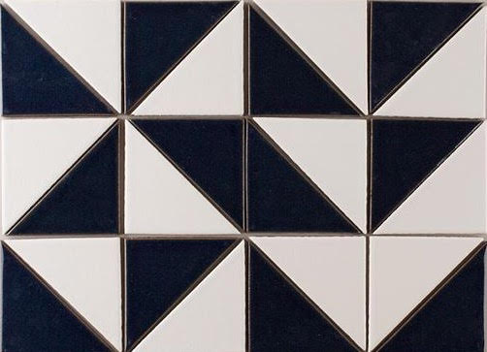 | Total of 24 triangular tiles.  12 black  12 white  12 + 12 = 24
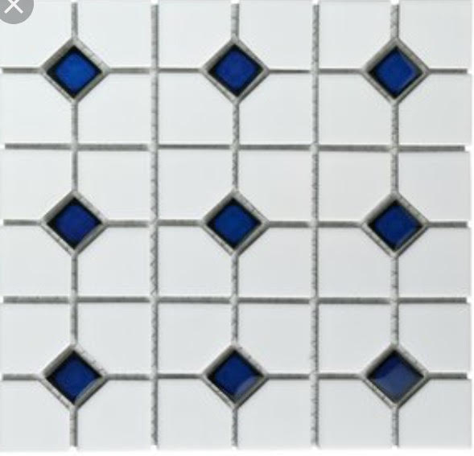 | Total of 45 tiles.  36 white tiles  9 blue tiles  36 + 9 = 45
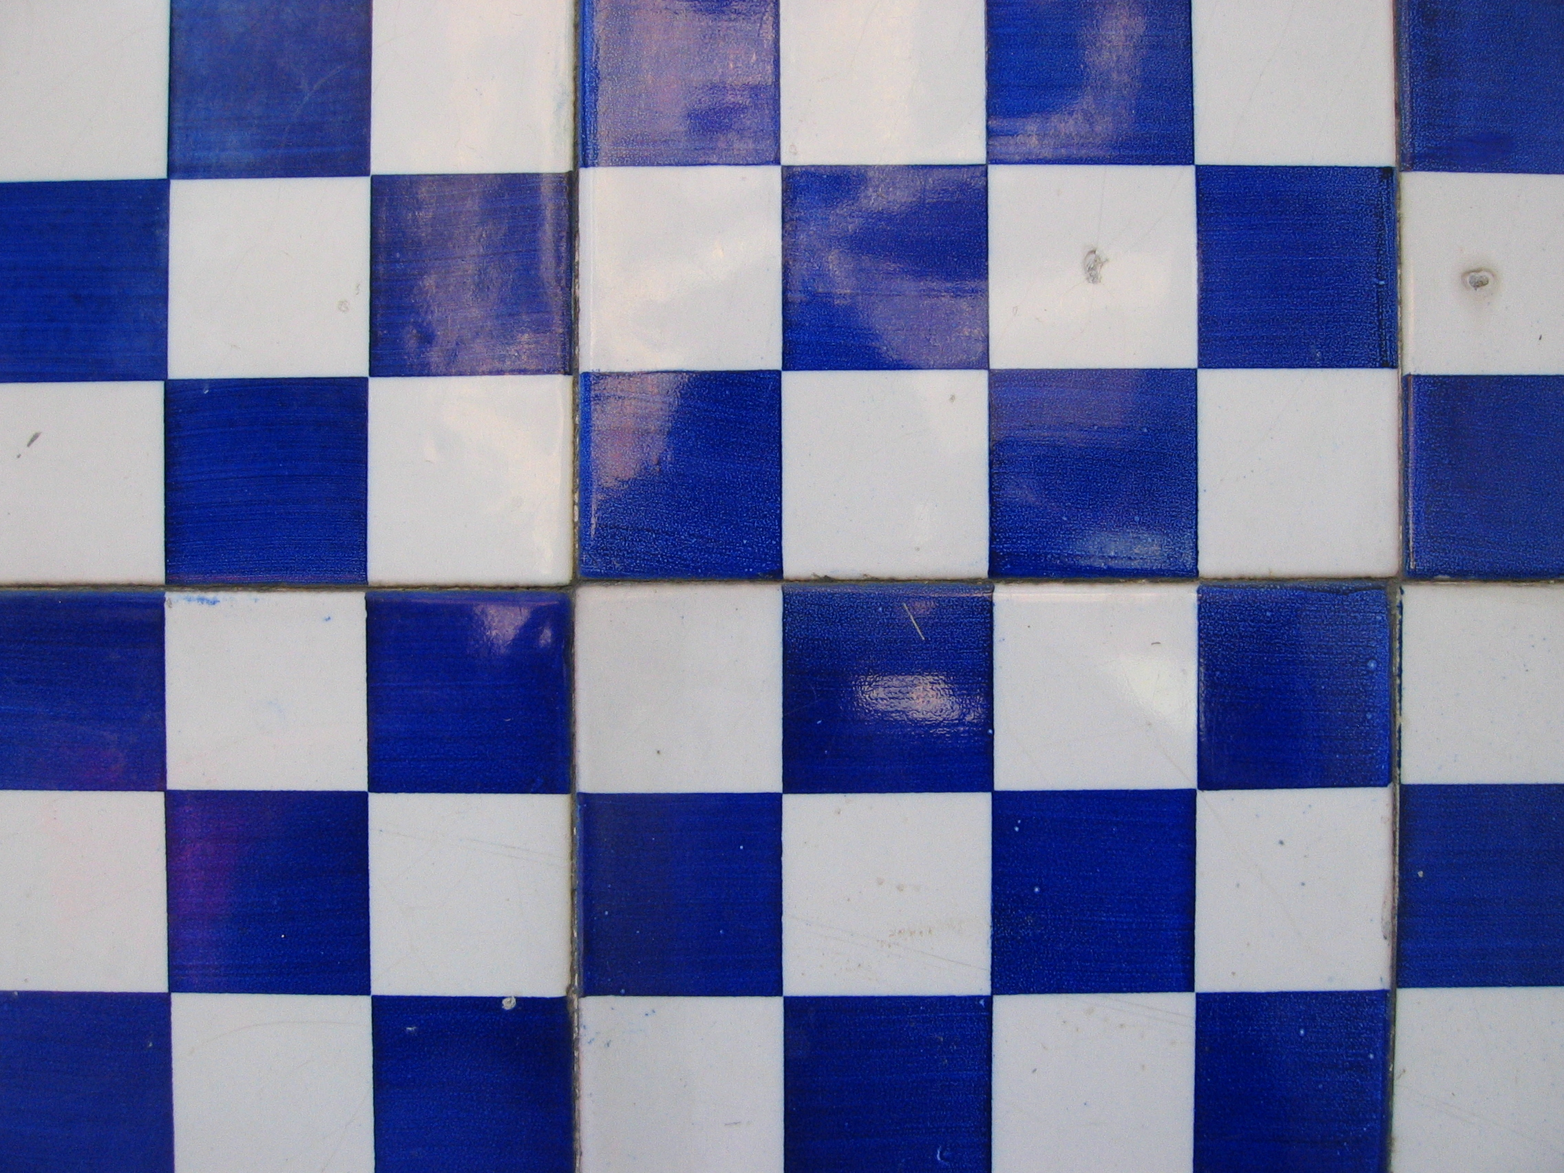 | Total of 48 tiles.  24 blue tiles  24 white tiles  24 + 24 = 48

Student Task Sheet
Your job is to create a design for your bedroom wall. You can only use 2 different types of pattern blocks to create your design. Does your pattern have an even or odd number of tiles? How do you know? Write an equation representing your pattern.
Use this space to create your design or to place a picture of your design.

Is your design even or odd? Write an equation to show whether or not your design is even or odd. Use pictures, words, or numbers to explain your answer.

