Friendship Necklace
This purpose of this lesson is to give students the opportunity to problem solve and analyze other
students’ solutions while using a number line.

NC Mathematics Standards
Relate addition and subtraction to length
NC.2.MD.6 Represent whole numbers as lengths from 0 on a number line diagram with equally spaced points corresponding to the numbers 0,1,2,…, and represent whole-number sums and differences within 100 on a number line diagram.

Additional/Supporting Standard(s)
NC.2.OA.1 Use addition and subtraction within 100 to solve one- and two-step word problems involving situations of adding to, taking from, putting together, taking apart, and comparing, with unknowns in all positions, e.g., by using drawings and equations with a symbol for the unknown number to represent the problem.

Standards for Mathematical Practice:
- Make sense of problems and persevere in solving them.
- Reason abstractly and quantitatively.
- Construct viable arguments and critique the reasoning of others.
- Model with mathematics.
- Use appropriate tools strategically.
- Attend to precision.
Student Outcomes:
- I can represent numbers on a number line with equally spaced points.
- I can use the number line as a tool to solve the problem accurately.
- I can correctly solve the problem and represent the strategy I used on the number line.

Math Language:
What words or phrases do I expect students to talk about during this lesson?
●length
●centimeter
●number line
●sum
●difference
●add
●left
●sum

Materials:
- student handout ( 1 per student)
- pencil

Advance Preparation:
- Make copies of the handout.
- Images of a friendship necklace or actual examples of the necklace

Launch
1. Introduce the problem. ( 5 minutes)
Ask students if they have made or received a friendship necklace as a symbol of friendship. You can share pictures or examples of friendship necklaces.
Ask the students to share what they know about length.

Discuss the standard and metric systems of measuring (Our standard units for measuring length came from the English system of measurement, while the metric units for measuring length were developed in other parts of Europe, creating a common way of measuring amounts of goods for trade), so that students understand the units that will be used in the problem.

Explain that today they will solve a problem about friendship bracelets and they will use a number line to show their strategy. Show two number lines that represent 5 centimeters in two different ways: One number line with single tick marks from 0 to 5, One number line with tick marks at 0 and 5. Note that the number lines can represent the length of 5 centimeters without having to be exactly 5 centimeters.

Problem:
Ella has a string that is 17 centimeters long. Marsha has a string that is 24 centimeters long. To make a friendship necklace, they will need 46 centimeters of string. If the girls put their strings together, how much more string do the girls need? Use the number line to solve the problem.

Possible Questions:
- What is length? Can you describe the length of something in this room?
- When you make a necklace you need a string. What do you need to know to make sure the necklace fits well?
- How big is a centimeter? (A good estimate is that a centimeter is about the width of a pinky finger.)
- Share the problem. What do you know about the problem?
- What do we need to find out?
- Think of a plan to solve the problem. Will you need more than one step?

Explore
Solving the problem (15 – 20 minutes).
Allow students time to work individually and then with partners to solve the problem.
As students work, observe them. How they are solving the task. Encourage students to share their strategies with one another and describe how they are answering each question.

Observe:
- How students understand the concept of finding the length of the string that both girls have using the number line?
- How students determine how much more string they need to make a necklace? (adding up the number line or subtracting down the number line)
- How students organize their thinking to represent numbers as length on the number line with equally spaced points corresponding to necessary numbers?
- What vocabulary is used by students while explaining their strategies?

Walk around and monitor, listening for student insights and challenges. Select students to present to the class, looking for the students who modeled the problem using the number line and determined the length of the string the girls have together and the length of string they need to add to make the necklace. Also, look for strategies that will generate discussions to help others move toward a deeper understanding of the adding up and /or subtracting.

Possible Questions During the Explore Step:
- What does this number mean/represent in the problem?
- Where would these numbers sit on your number line?
- Can you tell me why you decided to add/subtract using these numbers?
- Why did you decompose your numbers in this way?
- What do you think the next step might be?
- What will this step help you find out?

Discuss
Discussion of Solutions (15 – 25 minutes).
Bring the group back together and have selected students share their strategies for solving the task. Encourage students to show their solutions on their number lines.
Ask the whole group how a solution is similar to or different from the previous solution.

Key ideas to discuss:
- How to find the sum to determine the length of the string that both girls have using the number line ( 17 + 24 = 41)
- How to determine how much more string they need to make a necklace by adding up to 46 (41 + ____ = 46; 41 + 5 = 46) or by subtracting: 46 - 17 = 29; 29 - 24 = 5 or 46-41 = 5 (centimeters)
- Students should explain how they used the number line to determine the answer. You may have students who do the arithmetic without the number line, so look for students who can share ways of thinking about the sum or difference, while moving along their number line.
- Encourage students to critique the strategies of other students. Ask the students which strategy they understood and why.

Evaluation of Student Understanding

Informal Evaluation: Observe and monitor students as they solve the problem. How are they making sense of the problem? Are they using mathematical vocabulary as they solve and discuss the problem? Are they using a number line in their process of finding the solution or are they solving and then creating a number line?
How are they using a number line to figure out the solution?

Formal Evaluation: At the end of the lesson ask the students how much string Ella and Marsha would need if the required length of the necklace was 50 centimeters. Ask students to show their solution on their number line.

Meeting the Needs of the Range of Learners:
Interventions:
● Suggest that students use representational drawings to understand the concept of adding up and finding the difference.
● Use yarn to role play the problem.

Extensions:
● Ask the students to figure out how much more string the girls would need if they needed to make 2 necklaces 46 centimeters each.

Possible Misconceptions/Suggestions:
Possible Misconceptions | Suggestions
● Students do not understand the problem.  ● Students do not understand the concept of using a number line in order to add the numbers and find the difference. | ● As a class, act out the problem using a piece of yarn.  ● Demonstrate how to show 5+7 on a number line with 0 to 5, 5 to 10, 10 to 11, and 11 to 12

Possible Solutions:

Students may use different ways to add/subtract using the number line. For example, they may choose to add 17 + 3 + 20 + 1 (having decomposed 24 as 3+ 1 + 20). Then they may add up 5 to make 46.

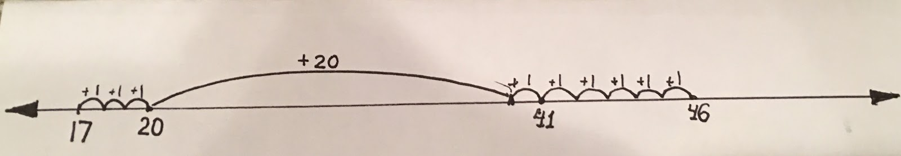

Students may choose to subtract the sum of girls’ string length from the length they need to find out the difference:

46 - (17 + 24) = 5 (centimeters)
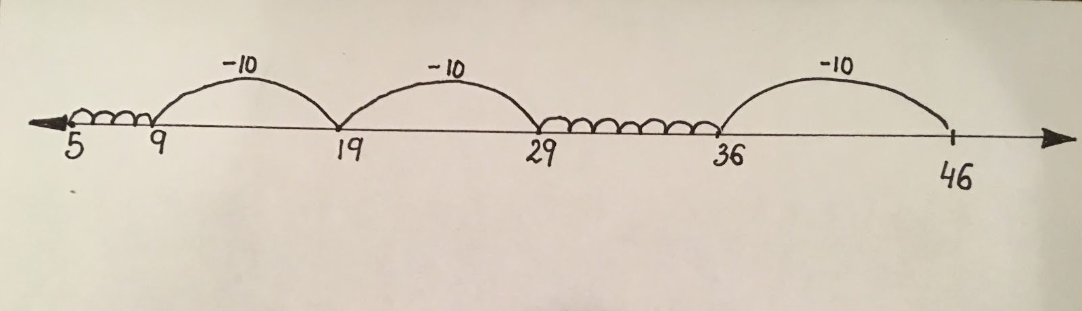

Name:_______________________

Ella has a string that is 17 centimeters long. Marsha has a string that is 24 centimeters long. To make a friendship necklace, they will need 46 centimeters of string. If the girls put their strings together, how much more string do the girls need? Use a number line to solve the problem.

Use a number line to solve.
Use numbers and words to show your thinking.

__________________ centimeters

