Designing Flower Beds
In this lesson, students design four flower beds and explore various strategies for finding the areas and perimeters of rectilinear figures.

NC Mathematics Standards:
Measurement and Data
NC.4.MD.3 Solve problems with area and perimeter.
- Find areas of rectilinear figures with known side lengths.
- Solve problems involving a fixed area and varying perimeters and a fixed perimeter and varying areas.
- Apply the area and perimeter formulas for rectangles in real world and mathematical problems.

Standards for Mathematical Practice:
- Make sense of problems and persevere in solving problems.
- Reason abstractly and quantitatively.
- Construct viable arguments and critique the reasoning of others.
- Model with mathematics.
- Look for and make use of structure.
- Look for and express regularity in repeated reasoning.

Student Outcomes:
- I can find the area of rectilinear figures.
- I can find the perimeter of rectilinear figures.
- I can communicate my process for finding the area and perimeter of rectilinear figures.

Math Language:
- decompose
- rectangle
- rectilinear
- dimensions
- length
- width
- sum
- product

Materials:
- geoboards/rubber bands
- masking tape
- crayons/markers
- various types of paper (graph paper, construction paper, index cards, post-it notes)
- scissors
- “Rectilinear Figures” sheet (1 per student)

Advance Preparation:
- Gather materials
- Decide how to group students into small groups of 3 to 4 students

Launch:
- Introduction of Task (10 minutes)
Present the following scenario to students.
The student council organization at Level Cross Elementary School wants to build four flower beds at the front of the school. Instead of traditional rectangles, students would like the flower beds to be in the shape of the school’s initials – L, C, E, S. They agreed the flower beds must only have right angles since wooden boards would be used to frame or border the beds. As the students began planning the four flower beds, they became confused about how to determine the amount of tarp needed to line the flower beds and the measurements of the boards that border the beds. Help the students at Level Cross Elementary!

Provide each group of students with materials including geoboards and rubber bands, paper (graph paper, construction paper, index cards, post-it notes), scissors, crayons/markers, and masking tape. Tell students that they may use any of these materials to help the student council organization at LCES plan the four flower beds.

Explore:
- Solving the Task (30 minutes)
Allow students to work with their group to complete the task using the materials provided. Students may create the rectilinear shapes on geoboards, draw them on graph paper, or build the shapes using masking tape on the floor or post-it notes.
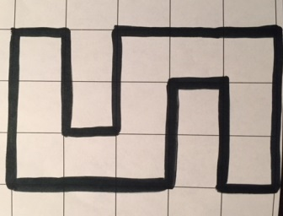
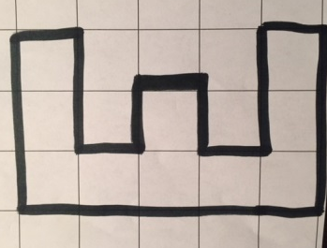
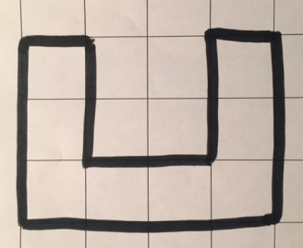
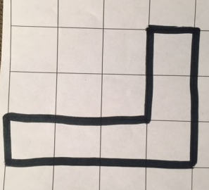

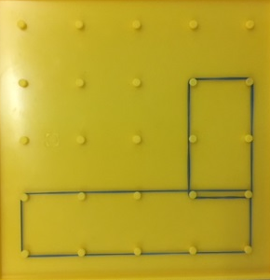
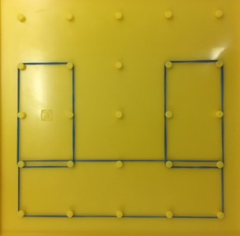

Notice that the dimensions of the flower beds are not provided. Students may decide the measurements (feet, inches, yards, meters, centimeters) they would like to use. Therefore, the areas and perimeters of the gardens will be different. The strategies that students use to find the area and perimeter of the shapes are the focus of this task rather than a singular number or answer.

Observe students to see how they are interpreting and solving the task.
Observe:
  - How are students interpreting the task?
  - Do students understand that they are finding the area and perimeter of the rectilinear shapes (letters)?
  - What tools are students using to create the shapes?
  - How do students determine the area of the rectilinear figure?
  - How do students determine the perimeter of the rectilinear figure?
  - How do students find the dimensions of the shapes they create?
  - What strategies are students use to determine the area? the perimeter?
  - What vocabulary are students using as they solve the task?

Carefully select students to present to the class. Look for various strategies that students used to determine the perimeter and area of the rectilinear shapes. Have each group display their final products for a gallery walk during the discussion portion of the lesson.

Discuss:
- Discussion of Solutions (15-20 minutes)
Bring the group together and take a gallery walk to view each group’s design of the four flower beds.

Introduce students to the term “rectilinear”. Discuss the meaning and point out that these gardens are rectilinear shapes, because they are made out of several rectangles. Have selected students demonstrate the various ways they found the perimeter and area of the shapes. Possible strategies for area include counting the number of square units in the figure, decomposing the shape into smaller rectangles and adding the two products, or drawing a large rectangle around the shape and subtracting the extra portion from the area.
Ask probing questions such as:
- What portion of the flower bed represents area? (tarp) What part represents the perimeter of the flower bed? (boards)
- What strategies did you use to find the area of the figures?
- What strategies did you use to find the perimeter of the figures?
- How did you show or model your strategy for finding the area of the figures? (Example: Students may use rubber bands to show the separation of the rectangles or the square units they counted or use different colors to show how they decomposed the rectangles.)
- Compare the rectilinear shapes to simple rectangles. How are these shapes different from rectangle flower beds? How are they like rectangles?

Make an anchor chart to show how to find the perimeter and area of rectilinear shapes. See example below.

Close the lesson by having students to respond to the following questions in their math journals:
- How does finding the perimeter of a rectangle compare to finding the perimeter of a rectilinear figure?
- How does finding the area of a rectangle compare to finding the area of a rectilinear figure?

FINDING THE AREA OF RECTILINEAR SHAPES

- Count the number of square units in the shape.
15 square units + 14 square units = 29 square units

- Decompose the shape into two rectangles.
4cm 6cm
4cm 6cm 1cm
1cm
2cm 1cm
4cm
Find the area of each rectangle:
4 x 2 = 8 sq. cm 6 x 1 = 6sq. cm
8 sq. cm + 6 sq. cm = 14 sq. cm
Add the two measurements together to find the area.

- Draw a large rectangle around the shape and find the
area. Subtract the extra portion from the rectangle.
4 cm
10 cm x 8 cm = 80 sq cm
6 cm x 4 cm = 24 sq cm
80 – 24 sq cm = 56 sq cm
4 cm
6 cm
8 cm
4 cm
10 cm

Evaluation of Student Understanding:
Informal Evaluation:
- Observe students as they are solving the task to determine what students understand about area and perimeter and the strategies they utilize to find the area and perimeter of the rectilinear shapes.
Formal Evaluation/Exit Ticket:
- Follow-up with the Rectilinear Figures sheet.

Meeting the Needs of the Range of Learners:
Interventions:
- Have students outline or color each separate rectangle using crayons or markers in order to identify the rectangles that create the larger, rectilinear figure.
- Provide students with a rectilinear figure on graph paper. Have students decompose the shape into smaller rectangles by cutting the smaller rectangles apart. They can find the areas of the decomposed shapes and then add the products to find the total area.
Extensions:
- Encourage students to find different ways to solve the task. Avoid the idea that students should “always” divide the shape in one way. Students can use the various ways to check their work and ensure their answers are correct.
- Provide students with more complex rectilinear figures and have them find the area and perimeter of each shape.
- Have students convert the measurements to a different unit. (For example: A student solved the task using meters and converts the measurements to centimeters.)

Possible Misconceptions/Suggestions:
Possible Misconceptions | Suggestions
- Students demonstrate difficulty dividing the shape into smaller rectangles.  - Students demonstrate difficulty working with the areas of separate shapes to find the total area. | - Encourage students to look for horizontal or vertical lines that are on the shape that they can extend to easily the separate the shape.  - Encourage students to notate the shape by writing the dimensions or area inside of the smaller rectangles and estimating to make sure their final answer makes sense.

Possible Solutions:
- Answers will vary according to the flower beds that students create.
- Rectilinear Figures:
A. Perimeter: 20 units
Area: 16 square units
B. Perimeter: 24 units
Area: 27 square units
C. Perimeter: 28 units
Area: 20 square units

Rectilinear Figures

Find the perimeter and area of each figure.

Perimeter:

Area:

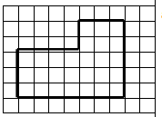

Perimeter:

Area:

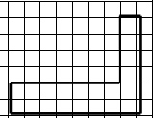

Perimeter:

Area:

Describe how you found the area for the figures above.

How do you know that your answers are correct?

