NC.2.MD.6 & OA.1
The Jumping Contest
Domain | Measurement and Data  Operations and Algebraic Thinking
Cluster | Relate addition and subtraction to length.  Represent and solve problems involving addition & subtraction.
Standard(s) | NC.2.MD.6 Represent whole numbers as lengths from 0 on a number line diagram with equally spaced points and represent whole-number sums and differences, within 100, on a number line.  NC.2.OA.1 Represent and solve addition and subtraction word problems, within 100, with unknowns in all positions, by using representations and equations with a symbol for the unknown number to represent the problem, when solving:  - One-Step problems:  o (continued from 1st grade) Compare-Difference Unknown
Materials | SF, pencil
Task | Provide materials to the student. Read the problem to the student: The 2nd graders had a jumping contest. Mary jumped 38 inches. Sue jumped 55 inches. How much farther did Sue jump than Mary? Use a number line to solve. Use numbers and words to show your thinking.

Continuum of Understanding
Not Yet Proficient | - Provide conceptual instruction on making sense of the situation as a comparison difference unknown problem  - Provide procedural instruction on solving comparison difference unknown problems  - Provide instruction on place value when adding and subtracting with regrouping  - Provide instruction on accurately drawing a number line | - Draws and uses a number line as a tool to solve the problem accurately.  - Solves the problem correctly  - Clearly explains their thinking  Strategy(ies) Used:  - Counting On  - Counting Back  - Makes Tens  - Creates easier or known sums  - Basic Facts  - Doubles  - Doubles +/- 1, 2  - Other:
Progressing | - Attempts to draw a number line but is unable to represent spaces accurately.  - Solves the problem incorrectly.  - Draws the number line inaccurately.  - Justification is weak and/or does not accurately represent the strategy used on the number line.
Meets Expectation | - Correctly solves the problem: 17 inches  - Represents numbers as lengths on a number line with equally spaced points corresponding to necessary numbers.  - Uses the number line as a tool to solve the problem accurately.  - The justification is clear and uses numbers, pictures, or words to show their thinking.  - The justification accurately represents the strategy used on the number line

Standards for Mathematical Practice
1. Makes sand perseveres in solving problems.

2. Reasons abstractly and quantitatively.
3. Constructs viable arguments and critiques the reasoning of others.
4. Models with mathematics.
5. Uses appropriate tools strategically.
6. Attends to precision.
7. Looks for and makes use of structure.
8. Looks for and expresses regularity in repeated reasoning.

NC.2.MD.6 & NC.2.OA.1 Name
Formative Instructional and Assessment Tasks

The 2nd graders had a jumping contest. Mary jumped 38 inches. Sue jumped 55 inches. How much farther did Sue jump than Mary?

Use a number line to solve.
Use numbers and words to show your thinking.

inches

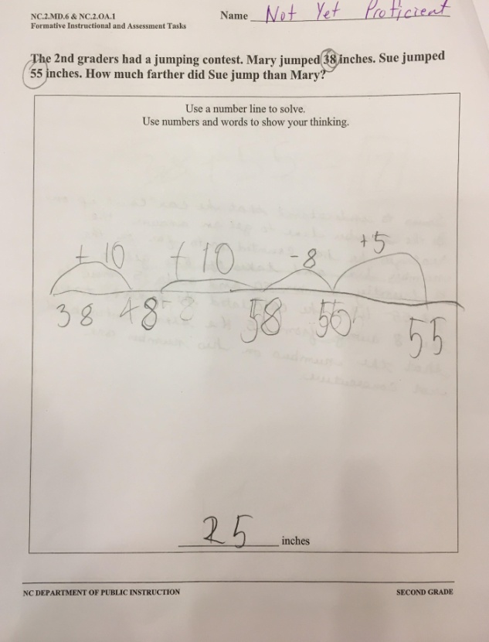
Student seems to understand that he can count up on the number line to get an answer. He realizes that he counts up too far on the number line so the take away 8 to a friendly number, 50, and adds 5 more to get 55. When he calculated, he didn’t take the 8 away from 25. He doesn’t seem to understand that the numbers on the number line are not consecutive.

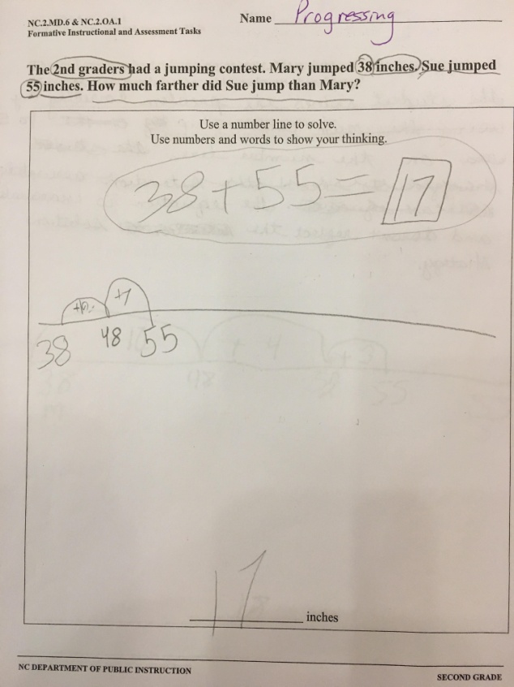
The student solves the problem correctly by counting up to 55 on the number line and adding his jumps for his answer. However, the equation is inaccurate and doesn’t reflect the solution strategy.

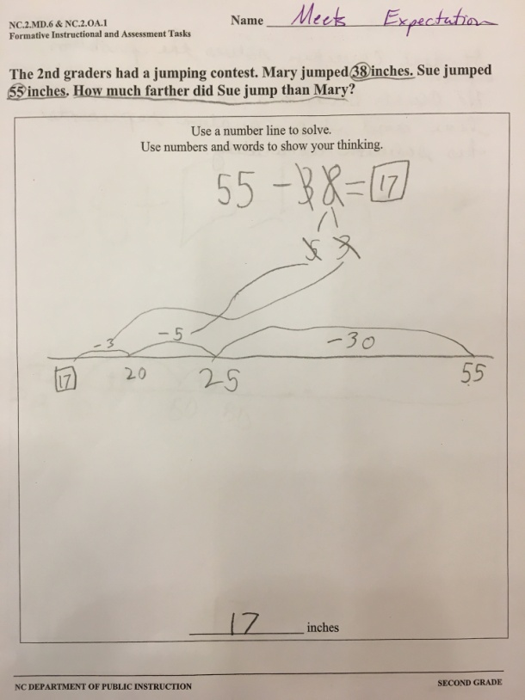
Student correctly solves the problem. He counts backward on a number line and his equation accurately represents his solution accurately.

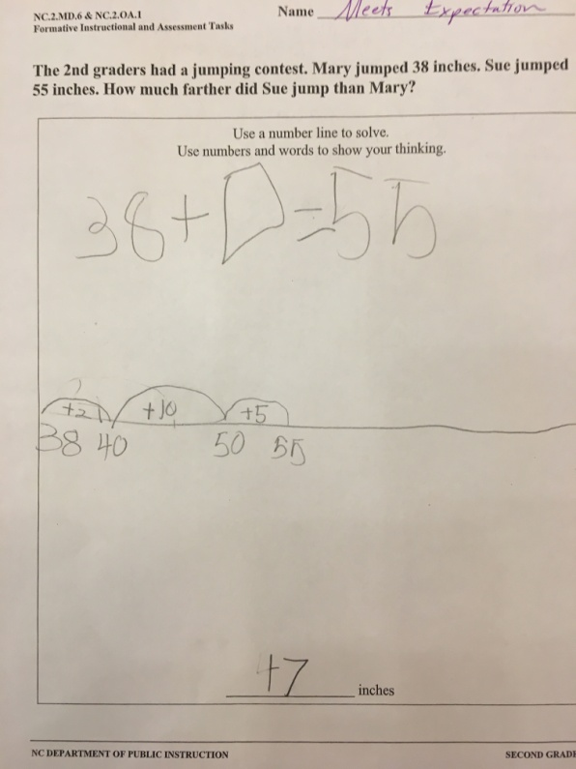
The student loves the problem correctly. He counts up on the number line and the equation accurately represents the solution strategy.

