Giraffes and Ostriches
In this lesson, students will be introduced to Polya’s four-step problem-solving process to solve word problems.

NC Mathematics Standards:
Operation and Algebraic Thinking
NC.4.OA.3 Solve two-step word problems involving the four operations with whole numbers.
- Use estimation strategies to assess reasonableness of answers.
- Interpret remainders in word problems.
- Represent problems using equations with a letter standing for the unknown quantity.

Standards for Mathematical Practice:
1. Make sense of problems and persevere in solving them.
2. Reason abstractly and quantitatively.
3. Construct viable arguments and critique the reasoning of others.
4. Model with mathematics.
6. Attend to precision.
7. Look for and make use of structure.

Student Outcomes:
- I can solve a problem using the four-step problem-solving process.

Materials:
- student handout (1 per student)
- poster/markers for anchor chart

Advance Preparation:
- Review Polya’s four-step problem-solving process (Cluster 2 Additional Resources)

Launch:
- Introduce Problem (5 minutes)
Display and read aloud the problem to students. Do not unpack the problem or help students understand the problem. Simply display and read the problem aloud. You want to see what students do on their own.

Problem:
The NC Zoo in Asheboro, North Carolina has several ostriches and several giraffes. There is a total of 30 eyes and 44 legs. How many ostriches and how many giraffes are in the zoo?

Explore:
- Solving the Problem (15 – 20 minutes)
Allow students time to work independently on the problem. As students work, observe students to see how they are solving the problem and the strategies they use to understand the problem. Do not help students; allow them to struggle and work through the problem on their own. Observe and take notes on how students are using the four-step problem-solving process:
  - How are students understanding the problem?
  - How are students planning to solve the problem?
  - How are students solving the problem?
  - How are students checking their solutions?

In order to understand the problem, students may reread the problem, circle, highlight, or underline important information, cross out erroneous information, write down facts such as ostriches have 2 legs and giraffes have 4 legs, relate the number of eyes (30) to the number of animals (15), etc. As students craft a plan to solve the problem, they may use such strategies as drawing a picture, making a table, guessing and checking various combinations, or using equations with multiplication or division.
Example of notes when observing students.
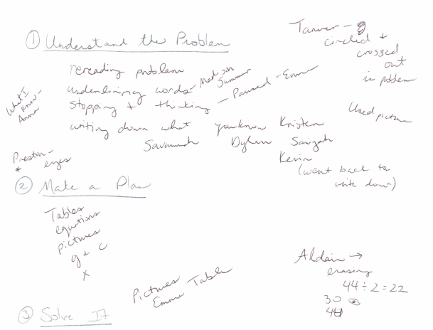
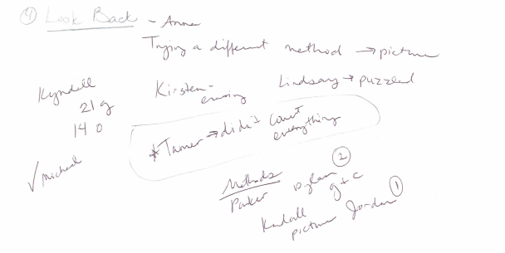

Possible ways that students might solve the problem (picture, table, guess and check, equations):
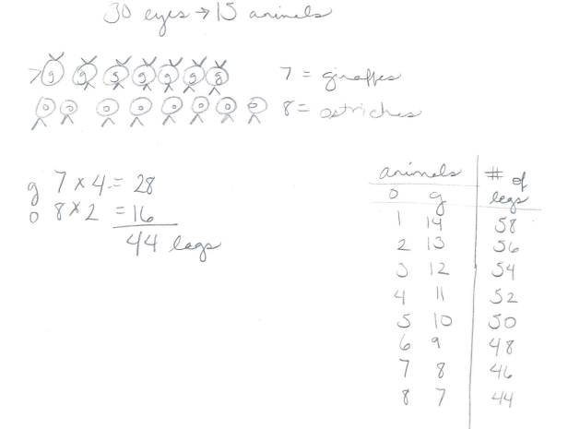
Use your observations and notes to select which students will share how they solved the problem.

Discuss:
- Discussion of Solutions (20-30 minutes)
Bring the group back together. Begin by introducing students to Polya’s Four-Step Problem-solving Process. (Poster found in Cluster 2 Additional Resources or at http://www.mathcoachscorner.com/2012/05/primary-problem-solving-poster/.)
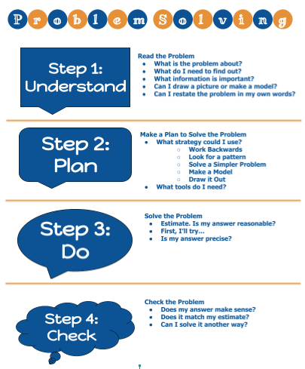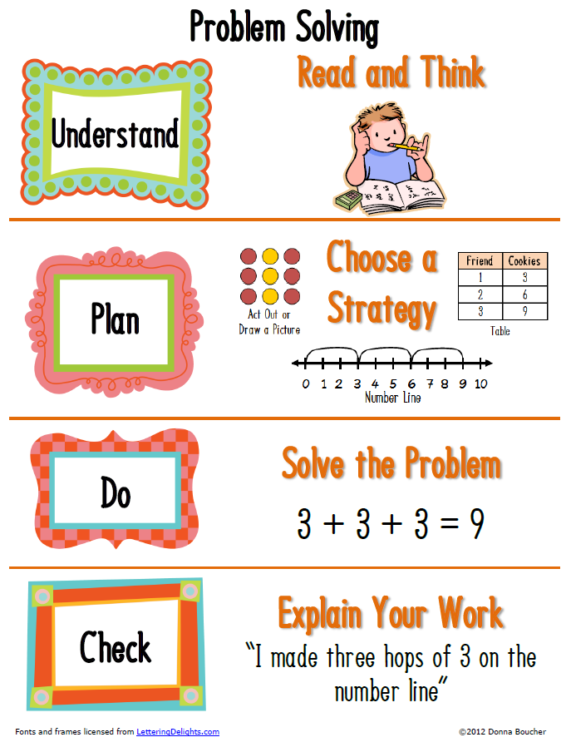

Discuss each step with students and present the various strategies students used to understand, plan, solve, or check the problem (using your observations and notes). Have students also share and describe their process. Record strategies on a large anchor chart that students can use throughout the year. Keep the chart posted in your classroom and refer to it while teaching and solving problems.

Possible questions and points to address:
What did you do to understand to problem?
- What is the problem about?
- What do you need to find out?
- What information is important?
- Can you restate the questions in my own words?

How did you plan to solve the problem?
- How did you plan to solve the problem? What strategies did you attempt to use?
- Did you use any models or drawings to help you?

How did you solve the problem?
- Estimate. Is your answer reasonable?
- What strategies did you use to solve the problem?
- Did you change strategies along the way? Why?

How did you check to see if your answer was correct?
- Does your answer make sense?
- Does it match your estimate?
- Did you solve the problem another way?
- Does your solution answer the question?

As a closure, review the problem solving steps. Relate to the Mathematical Practice #1: Make sense of problems and persevere in solving them. Have students do a quick write about why the problem solving steps are important. Have students reflect on their usage of each step – which steps do they feel they have mastered and which steps they need to continue working on to improve their problem-solving skills.

Evaluation of Student Understanding:
Informal Evaluation:
- Observe students to see if they have strategies for understanding, planning, doing, and checking the problem. What parts of the process do students find most challenging?
Formal Evaluation/Exit Ticket:
- Possible problems to allow students to practice using the problem-solving process:
  - A zoo has several ostriches and several giraffes. There are 17 animals and 48 legs. How many ostriches and how many giraffes are in the zoo?
  - An aquarium at a pet store has lizards and crickets in it. There is a total of 15 critters. The critters have 78 legs in all. How many lizards and crickets are in the aquarium?

Solution:
- There are 7 giraffes and 8 ostriches.

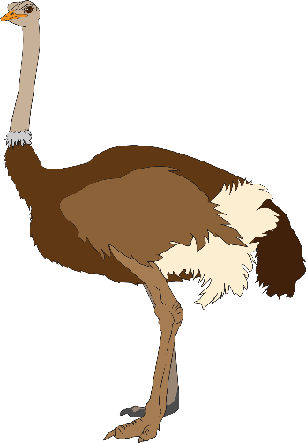
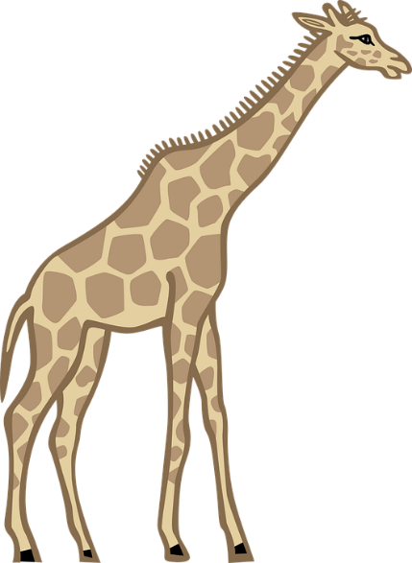
The NC Zoo in Asheboro, North Carolina has several ostriches and several giraffes. There is a total of 30 eyes and 44 legs. How many ostriches and how many giraffes are in the zoo?

