Grandmother’s Cake Recipe
In this lesson, students apply their knowledge of multiplication to solve multiplicative comparison problems.

NC Mathematics Standards:
Operations and Algebraic Thinking
NC.4.OA.1 Interpret a multiplication equation as a comparison. Multiply or divide to solve word problems involving multiplicative comparisons using models and equations with a symbol for the unknown number. Distinguish multiplicative comparison from additive comparison.

Standards for Mathematical Practice:
1. Make sense of problems and persevere in solving them.
2. Reason abstractly and quantitatively.
3. Construct viable arguments and critique the reasoning of others.
4. Model with mathematics.
8. Look for and express regularity in repeated reasoning.

Student Outcomes:
- I can use multiplication to solve multiplicative comparison problems.
- I can interpret a word problem and decide how to solve it.

Math Language:
- times as much
- multiplicative comparison

Materials:
- student handout (1 per student)
- presentation

Advance Preparation:
- Make copies of the student handout (1 per student)

Launch:
- Introduce Problem (5 minutes)
Display and read the problem to students. Be sure to sell this as your grandmother’s recipe so that students are engaged in the lesson and think they are helping you. You may want to bring a recipe book or recipe card and cake pans (8-inch, 12-inch, 18-inch) to help students visualize the scenario.

Problem:
I am making two cakes for my friend's birthday party, and I want to use my grandmother’s delicious cake recipe. I’m going to use a 12-inch cake pan to make one cake and an 18-inch cake pan to make the other. The only problem is my grandmother’s recipe makes an 8-inch cake. I need your help figuring out the amount of each ingredient to use for both cakes.
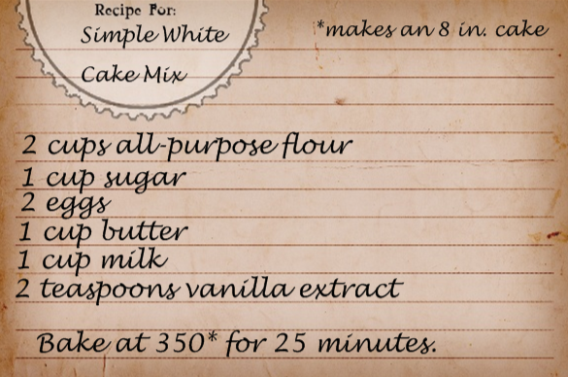
The recipe for the 12-inch cake takes 3 times as much of each ingredient as the 8-inch cake. How much of each ingredient will I need to make the 12-inch cake?
The recipe for the 18-inch cake takes 5 times as much of each ingredient as the 8-inch cake. How much of each ingredient will I need to make the 18-inch cake?
How much of each ingredient do I need if I bake all three sizes of the cakes?
After giving students all the information, allow them to get with a partner and explore the problem and come up with possible ways to solve.
Explore:
- Solving the Problem (15 – 20 minutes)
Allow students time to work with partners in order to solve the task. As students work, observe students to see how they are solving the task. Encourage students to share their strategies with one another and describe how they are answering each question.
Observe:
  - How are students organizing and representing their thinking?
  - How do students make sense of the question?
  - How do students solve the problems?
  - Do they use addition or multiplication?
  - What vocabulary are students using as they solve the task?

Carefully select students to present to the class. Choose students that can help extend the understanding of multiplicative comparisons and contrast the difference between additive and multiplicative reasoning. Choose students who used repeated addition and multiplication in order to relate the two methods.

Discuss:
- Discussion of Solutions (15 – 25 minutes)
Bring the group back together and have selected students share their strategies for solving the task. Possible points to address and questions to ask:
- Discuss the vocabulary of “times as much”. What does that mean?
- How did you organize the information? Choose students who organized their information in precise ways so that it is easy to understand how they solved the problem.
- Have a student who used repeated addition to show how and why they solved the problem using this strategy and then move to students who used multiplication. Be sure to make a connection between the repeated addition and multiplication. Relate to the vocabulary of “times as much.”
Close the lesson by having students summarize the meaning of “times as much” and relate to multiplication.

Evaluation of Student Understanding:
Informal Evaluation:
- How are students modeling the problem?
- Are students using additive or multiplicative reasoning in order to solve the problem?
- How are students interpreting the phrase “times as much”?
- Can students find the amount of ingredients needed for all three cakes?
Formal Evaluation/Exit Ticket:
- A 24-inch cake would be 7 times the amount of ingredients in the original recipe. How much of each ingredient would she need to make the 24-inch cake?

Meeting the Needs of the Range of Learners:
Interventions:
- Discuss with students what it would mean to show three times as much of something. Use manipulatives to model the ingredient. Example: Give the student 1 cube to represent one cup of sugar and ask him/her to show what it would mean to get three times that amount. Students should get out three cubes.
Extensions:
- Have students figure out how much of each ingredient would you need to make all three cakes.
- The 8-inch cake will bake at 350 degrees for 25 minutes. If the 12-inch cake takes 3 times as long and the 18-inch cake takes 5 times as long, how long will the entire cake need to bake?

Possible Solutions:
- 12-inch cake = 6 cups flour, 3 cups sugar, 6 eggs, 3 cups butter, 3 cups milk, 6 tsp. vanilla
- 18-inch cake = 10 cups flour, 5 cups sugar, 10 eggs, 5 cups butter, 5 cups milk, 10 tsp. vanilla
- Extension: 18 cups flour, 9 cups sugar, 18 eggs, 9 cups butter, 9 cups milk, 18 tsp. vanilla
  - 8-inch cake = 25 minutes, 12-inch cake = 75 minutes, 18-inch cake = 125 minutes Total: 225 minutes
- Exit Ticket: 24-inch cake = 14 cups flour, 7 cups sugar, 14 eggs, 7 cups butter, 7 cups milk, 14 tsp. vanilla

Grandmother’s Cake Recipe

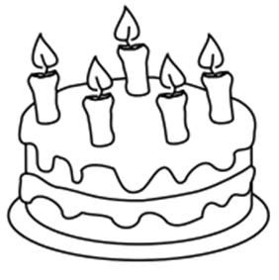
Simple Vanilla Cake
2 cups all-purpose flour
1 cup sugar
2 eggs
1 cup butter
1 cup milk
2 teaspoons vanilla extract

Bake at 350° for 25 minutes.
Makes one 8-inch cake.

I am making two cakes for my friend's birthday party, and I want to use my grandmother’s delicious cake recipe. I’m going to use a 12-inch cake pan to make one cake and an 18-inch cake pan to make the other. The only problem is my grandmother’s recipe makes an 8-inch cake. I need your help figuring out the amount of each ingredient to use for both cakes.

The recipe for the 12-inch cake takes 3 times as much of each ingredient as the 8-inch cake. How much of each ingredient will I need to make the 12-inch cake?

The recipe for the 18-inch cake takes 5 times as much of each ingredient as the 8-inch cake. How much of each ingredient will I need to make the 18-inch cake?

How much of each ingredient do I need if I bake all three sizes of the cakes?

