NC State Fair: Line of Fortune
In this lesson, students apply concepts of factors and multiples to determine if they will win prizes at an imaginary fair game.

NC Mathematics Standards:
Operations and Algebraic Thinking
NC.4.OA.4 Find all factor pairs for whole numbers up to and including 50 to:
- Recognize that a whole number is a multiple of each of its factors.
- Determine whether a given whole number is a multiple of a given one-digit number.
- Determine if the number is prime or composite.

Standards for Mathematical Practice:
1. Make sense of problems and persevere in solving them.
3. Construct viable arguments and critique the reasoning of others.
4. Model with mathematics.
7. Look for and make use of structure.
8. Look for and express regularity in repeated reasoning.

Student Outcomes:
- I can apply my knowledge of factors and multiples to help me solve problems.
- I can solve problems that involve analyzing patterns and relationships.

Math Language:
- factor
- multiple
- prime
- composite
- patterns

Materials:
- pictures of the NC State Fair
- student handout (1 per student)
- grid paper
- hundred boards/markers
- calculators

Advance Preparation:
- Collect pictures of the NC State Fair to show students
- Make copies of the student handout

Launch:
- Introduce Problem (5 minutes)
Ask students if they have ever been to a fair or carnival. Have students describe their favorite parts (food, rides, games, prizes, clowns, etc.). Display pictures of the NC State Fair in order to spark students’ interest in the task. (Information about the NC State Fair: http://www.ncstatefair.org/)
Problem:
Our fourth grade class took a fieldtrip to the state fair in Raleigh. As soon as the class arrived at the state fair, they saw an event that they wanted to try – The Line of Fortune. It looked like it would be fun and most importantly, it offered lots of prizes. However, the class wasn’t sure everyone would be a winner. The game attendant promised, “All you have to do is get in line to win a prize.” Prizes will be given as follows:
Every second person wins a candy bar.
Every third person wins a small stuffed animal.
Every fourth person wins cotton candy.
Every fifth person wins a basketball.
Every sixth person wins a large stuffed animal.

If there are 65 places for the students to choose to stand in line, where can the students stand to be sure to get at least three prizes? four prizes? Where should you stand if you want to get all five prizes? Which places should you avoid? How do you know to avoid those spots?

Explore:
- Solving the Problem (15 – 20 minutes)
Allow students time to work individually and then with partners in order to solve the task. As students work, observe students to see how they are solving the task. Encourage students to share their strategies with one another and describe how they are answering each question.
Observe:
  - How are students organizing and representing their thinking?
  - How do students make sense of the numbers that receive three, four, or no prizes?
  - How do students determine the place that receives all 5 prizes?
  - What vocabulary are students using as they solve the task?

Carefully select students to present to the class. Look for students who modeled the problem and kept track of the places and the prizes. Also look for strategies that will generate discussion to help others move toward a deeper understanding of numbers as factors, multiples, composite, and prime.

Discuss:
- Discussion of Solutions (15 – 25 minutes)
Bring the group back together and have selected students share their strategies for solving the task. Relate the task to factors, multiples, and prime and composite numbers.
Possible points to address and questions to ask:
- Discuss and relate various modeling strategies (charts or tables, lists, arrays).
- If you are standing in the sixth spot, how many prizes will you receive? (3 – candy bar, small stuffed animal, and a large stuffed animal. The number 6 is a composite number with 1, 2, 3, and 6 as factors.)
- What patterns do you notice? Why do these patterns occur? (Ex: Every second person receives a candy bar. Every even number is a multiple of 2 or has a factor of 2.)
- What do you know about the number that receives all five prizes? (It is a multiple of 5 and an even number. Therefore, it must end in 0, making it a multiple of ten. Being a multiple of 6 and 10 -- 30, 60, and 90 are possibilities. 60 is a multiple of 2, 3, 4, 5, 6.)
- Which places should you avoid? (The following prime numbers should be avoided: 7, 11, 13, 17, 19, 23, 29, 31, 37, 41, 43, 47, 53, 59, 61; 1 and 49 should also be avoided.)
- Why would you want to avoid these spots? (These are prime numbers. You will not receive a prize in these spots. You will not receive a prize at the first spot – 1 is neither a prime nor composite number. Spot #49 also does not receive a prize because of its factors of 1, 7, and 49.)
- Why do the third and fifth students in line receive a prize when 3 and 5 are prime numbers? (These are assigned spots at the beginning of the line. Although the numbers are prime, they receive a prize since they are the first numbers in the line.) Do any other prime number places get a prize? (spot #2)

Evaluation of Student Understanding:
Informal Evaluation:
- Observe and monitor students as they solve the problem. How are they making sense of the problem? Are they using mathematical vocabulary as they solve and discuss the problem? How are students relating factors and multiples to the task?
Formal Evaluation/Exit Ticket:
- At the end of the lesson, give students a specific spot in the Line of Fortune. Ask students to name the prizes they will receive at the spot and justify their answer. Example: If you are standing in the 36th spot, how many prizes will you receive?

Meeting the Needs of the Range of Learners:
Interventions:
- Suggest that students use models such as tables, lists, and arrays on grid paper to help them solve the task and visualize patterns.
- Create a class chart to help students see patterns and assist with the discussion.
Extensions:
- Ask students to create a representation to show the prizes each spot will receive.
- Extend the Line of Fortune to 100 spots. How would this change the game? Which spots would receive the most prizes? Which spots would not receive any prizes?
- Assign each prize a monetary amount. (Example: Cotton candy costs $1, and a small stuffed animal costs $3.) Have students determine the amount of money the game attendant will spend if every spot is full during a round of the Line of Fortune.

Possible Misconceptions/Suggestions:
Possible Misconceptions | Suggestions
- Students do not understand the problem.  - Students do not realize that a spot receives multiple prizes. For example, the 30th spot receives four prizes.  - Students do not make connections between the task and factors/multiples. | - As a class, act out the problem.  - Simplify the game to 12 spots.  - Demonstrate with smaller numbers (such as 6).  - Discuss as a class, asking questions to encourage students to consider other prizes (and factors).  - Make connections to skip counting and arrays.  - Count around the room by twos to help students make connections between skip counting and multiples. Continue with threes – drawing students’ attention to the students that stood up on both the twos and threes.  - Provide students with a hundred boards and a variety of markers so they can color each spot in line and notice the patterns.

Special Notes:
- The standard NC.4.OA.4 requires students to find all factor pairs for whole numbers up to and including 50. This task asks students to find the factors for numbers up to 65 (rather than 50). This allows students to see patterns and find the number that will receive 5 prizes.

Possible Solutions:
Key
no prizes
1 prize
2 prizes
3 prizes
4 prizes
5 prizes

Spot in Line | Prizes
1 | no prizes
2 | candy bar
3 | small stuffed animal
4 | candy bar, cotton candy
5 | basketball
6 | candy bar, small stuffed animal, large stuffed animal
7 | no prizes
8 | candy bar, cotton candy
9 | small stuffed animal
10 | candy bar, basketball
11 | no prizes
12 | candy bar, small stuffed animal, cotton candy, large stuffed animal
13 | no prizes
14 | candy bar
15 | small stuffed animal, basketball
16 | candy bar, cotton candy
17 | no prizes
18 | candy bar, small stuffed animal, large stuffed animal
19 | no prizes
20 | candy bar, cotton candy, basketball
21 | small stuffed animal
22 | candy bar
23 | no prizes
24 | candy bar, small stuffed animal, cotton candy, large stuffed animal
25 | basketball
26 | candy bar
27 | small stuffed animal
28 | candy bar, cotton candy
29 | no prizes
30 | candy bar, small stuffed animal, basketball
31 | no prizes
32 | candy bar, cotton candy
33 | small stuffed animal
34 | candy bar
35 | basketball
36 | candy bar, small stuffed animal, cotton candy, large stuffed animal
37 | no prizes
38 | candy bar
39 | candy bar, small stuffed animal
40 | candy bar, cotton candy, basketball
41 | no prizes
42 | candy bar, small stuffed animal, large stuffed animal
43 | no prizes
44 | candy bar, cotton candy
45 | small stuffed animal, basketball
46 | candy bar
47 | no prizes
48 | candy bar, small stuffed animal, cotton candy, large stuffed animal
49 | no prizes
50 | candy bar, basketball
51 | small stuffed animal
52 | candy bar, cotton candy
53 | no prizes
54 | candy bar, small stuffed animal, large stuffed animal
55 | basketball
56 | candy bar, cotton candy
57 | small stuffed animal
58 | candy bar
59 | no prizes
60 | candy bar, small stuffed animal, cotton candy, basketball, large stuffed animal
61 | no prizes
62 | candy bar
63 | small stuffed animal
64 | candy bar, cotton candy
65 | basketball

NC State Fair: Line of Fortune

Step right up to the Line of Fortune!

Prizes will be given as follows:
- Every second person wins a candy bar.
- Every third person wins a small stuffed animal.
- Every fourth person wins cotton candy.
- Every fifth person wins a basketball.
- Every sixth person wins a large stuffed animal.

1. If there are 65 places for the students to choose to stand in line,
where can the students stand to be sure to get 3 prizes?

2. Where can the students stand to be sure to get 4 prizes?

3. Where should you stand if you want to get all 5 prizes?

4. Which places should you avoid? How do you know to avoid the
spots?

Lesson Pictures
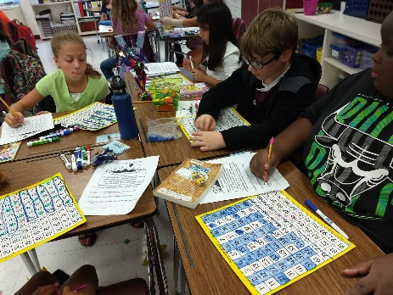
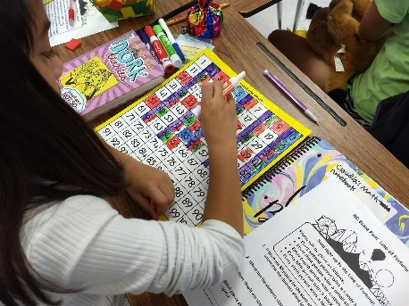
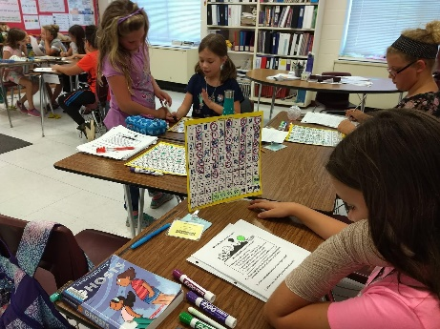

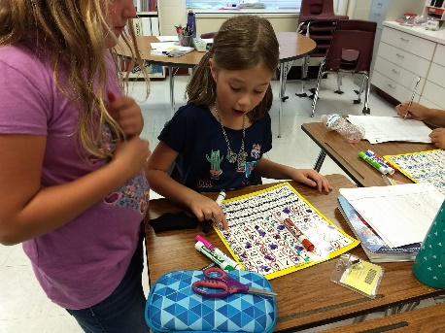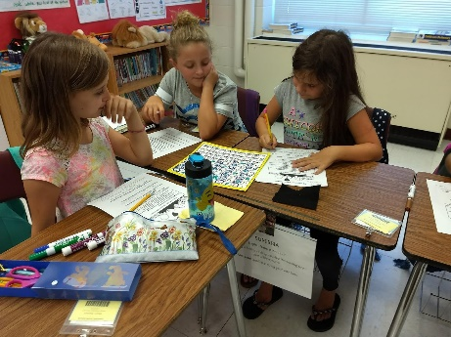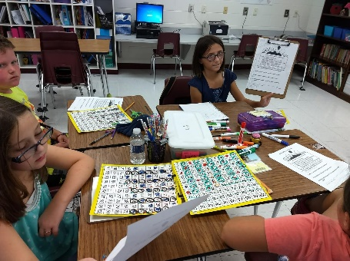

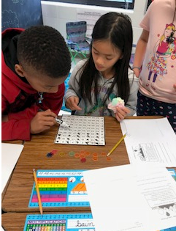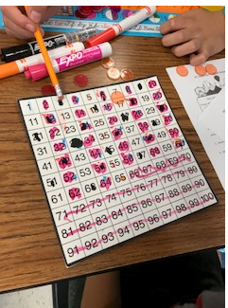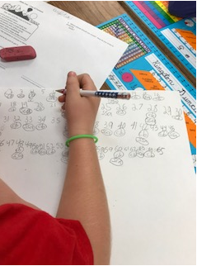

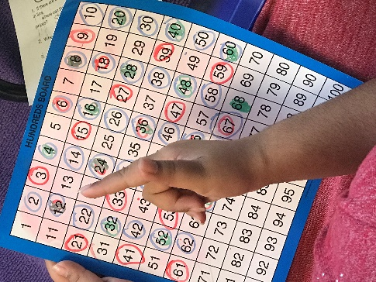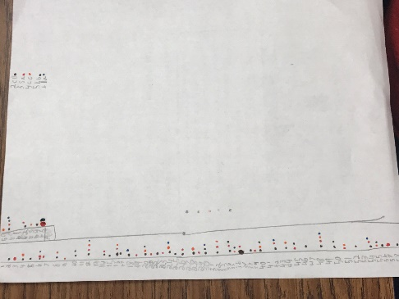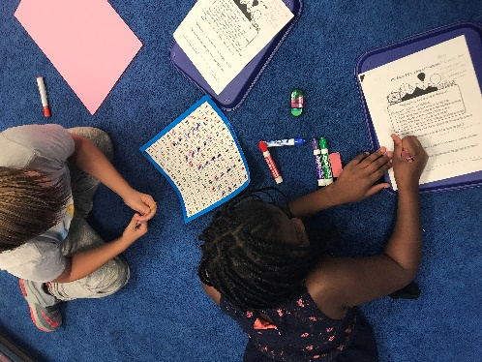

Student Work Samples

