Making Rectangles
In this lesson, students create arrays using square tiles and grid paper in order to determine the factors of numbers 1-25. The lesson will introduce students to the vocabulary of factor, multiple, prime, and composite.

NC Mathematics Standards:
Operations and Algebraic Thinking
NC.4.OA.4 Find all factor pairs for whole numbers up to and including 50 to:
- Recognize that a whole number is a multiple of each of its factors.
- Determine whether a given whole number is a multiple of a given one-digit number.
- Determine if the number is prime or composite.

Standards for Mathematical Practice:
4. Model with mathematics.
7. Look for and make use of structure.
8. Look for and express regularity in repeated reasoning.

Student Outcomes:
- I can create rectangular array models to represent the factors for a given whole number.
- I can identify factor pairs of a multiple between 1 and 25.
- I can determine if a number is prime or composite by using rectangular arrays.

Math Language:
- array
- factor
- multiple
- prime
- composite
- square number
- patterns

Materials:
- one inch color tiles/square tiles
- one inch grid paper
- scissors
- tape
- large bulletin board paper or poster paper

Advance Preparation:
- Make copies of one inch grid paper
- Create six groups of students
- Create a large chart (see example below) to display the rectangular arrays
Partition the chart into 25 sections and label each section 1 – 25.

Launch:
- Rectangles with 12 Tiles (10 minutes)
Give each student a set of 12 color tiles and instruct them to make as many different rectangles as possible using the 12 tiles.

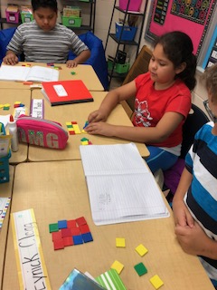

Discuss the rectangles that students created.
Possible discussion questions:
- What did you notice?
- How many different rectangles can you make?
- Were the rectangles the same?
- Were the rectangles different?
- How would you describe your rectangle?
- Does the orientation of the rectangles matter? Is a 2 x 6 rectangle the same as a 6 x 2 rectangle?
The rectangles are different in that they show two distinct arrays, but they cover the same area: a 2 x 6 rectangle can be rotated to represent a 6 x 2 rectangle. Changing the order of the factors merely corresponds to turning the rectangles, but it doesn’t change the number of tiles it contains. Relate this discussion to the commutative property of multiplication which states that the order of factors in a multiplication equation does not matter. In an array, 3 rows of 4 are the same as 4 rows of 3. For this activity, we are interested in the dimensions of the rectangles (or the factors of the numbers), not in their vertical or horizontal orientation. A 3 x 4 rectangle and a 4 x 3 rectangle will be considered the same in this activity.

As a class, create a table to record the dimensions of the rectangles.
Rectangles with 12 Tiles
Number of Rows | Number in Each Row | Multiplication Equation
2 | 6 | 2 x 6 = 12

Instruct students to record the rectangles on grid paper and then cut them out to make three rectangular arrays, recording the dimensions and the multiplication equation on each rectangle. The rectangles, along with the class-generated table, can be added to students’ math journals.

Explore:
- Making Rectangles (15 – 20 minutes)
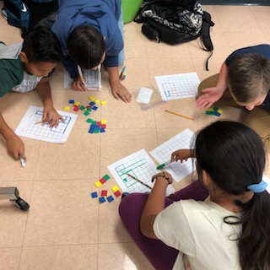
The class will now work together to make rectangular arrays for numbers 1 – 25. Divide the students into six different groups to make the rectangles and assign the following numbers to each group.
- Group 1: 1, 10, 18, 23
- Group 2: 2, 7, 9, 11, 12
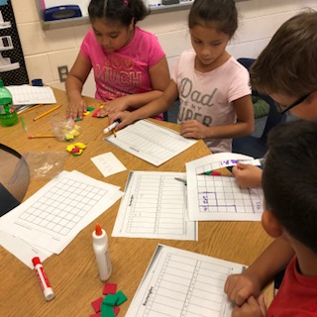
- Group 3: 3, 13, 17, 24
- Group 4: 4, 8, 16, 20
- Group 5: 5, 15, 22, 25
- Group 6: 6, 14, 19, 21
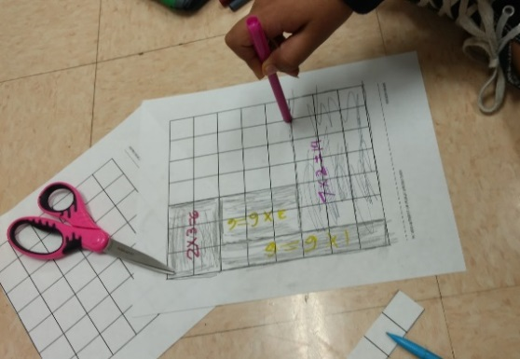

Instruct students to:
- Work together to make all possible rectangles for their assigned numbers
- Draw the rectangles on grid paper and cut them out
- Write the corresponding multiplication equation on the rectangle and attach the rectangles to the class chart

Class Chart:
1 | 2 | 3 | 4 | 5 | 6 | 7 | 8 | 9 | 10 | 11 | 12 | 13
14 | 15 | 16 | 17 | 18 | 19 | 20 | 21 | 22 | 23 | 24 | 25

As groups finish creating the rectangles, instruct students to list three observations about the chart in their math journal and discuss their observations with a partner.
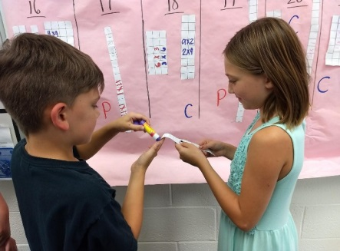
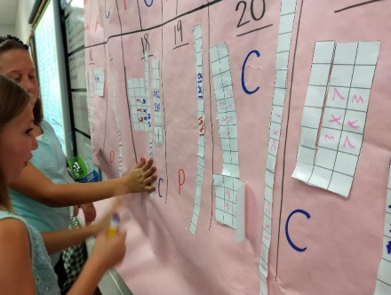
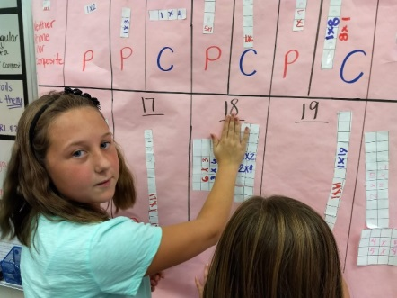

Discuss:
- Discussion of Rectangles (30 minutes)
Bring the group back together and have students share their observations. Use these observations to guide your discussion and introduce new vocabulary. Record new vocabulary, definitions, and examples on an anchor chart.

Possible discussions:
- Which numbers have rectangles with 2 rows? 3 rows? 4 rows? Write the numbers from smallest to largest.
  - 2 rows: 2, 4, 6, 8, 10, 12, 14, 16, 18, 20, 22, 24
  - 3 rows: 3, 6, 9, 12, 15, 18, 21, 24
  - 4 rows: 4, 8, 12, 16, 20, 24
Introduce the word multiple.
A number is a multiple of 2 if it equals 2 times another whole number. If you can make a rectangle with 2 rows for a number then it is a multiple of 2. When you skip count you say the multiples of a number. For example, skip counting by 3 gives the multiples of 3. The multiples of 3 are 3, 6, 9, 12 and so on. They are all the numbers that have rectangles with 3 rows. Students may notice that numbers that are multiples of two (2, 4, 6, 8, etc…) are even numbers, and numbers that are not multiplies of 2 (1, 3, 5, 7 etc…) are odd numbers.
- Which numbers have rectangles that are squares? (1, 4, 9, 16, 25)
Introduce the terms square numbers, factors, and factor pairs.
Ancient Greek mathematicians thought of number relationships in geometric terms and called numbers like this square numbers, because of the rectangular arrays they can be represented by a square. The square numbers have an odd number of factors, whereas the other numbers examined have an even number of factors. Numbers that are not square always have factor pairs. For example 12, the factor pairs are 1 and 12, 2, and 6, and 3 and 4. But square numbers always have one factor that has no partner other than itself. For example 9, 1 and 9 are factor pair, but 3 is its own partner because 3 x 3 = 9. The factor of a square number that has no partner – 3 for the square number 9 – isn’t listed twice. Therefore, the factors of 9 are 1, 3, and 9, and the factors of 16 are 1, 2, 4, 8, and 16 – an odd number of factors.
- Which numbers have only one array or rectangle? (1, 2, 3, 5, 7, 11, 13, 17, 19, 23)
Introduce the terms prime and composite numbers.
Numbers that are larger than one and have only one rectangle have a special name. They are called prime numbers. For example, 5 and 7 are prime numbers. Prime numbers are defined as numbers that are larger than one and have only one rectangle. One is not prime, since a prime number is a number with exactly two factors (itself and one). Two is prime since its only factors are itself and one. Two is the only even prime number. The numbers that have more than one rectangular array are called composite numbers. The definition of a composite number is one that has more than two distinct factors. All numbers that are not prime and are not one are composite numbers. Composite numbers can be represented by at least two unique rectangular arrays.
- How about 1?
The number 1 has one factor (itself) and forms one rectangle (a 1-by-1 square). It is classified by mathematicians as a special number and is neither prime nor composite.

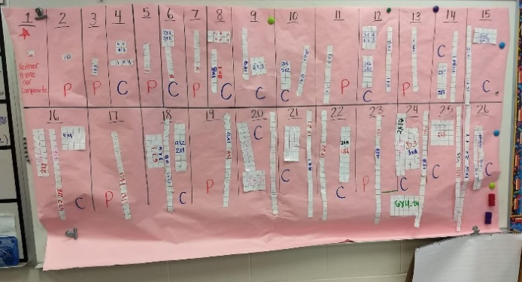
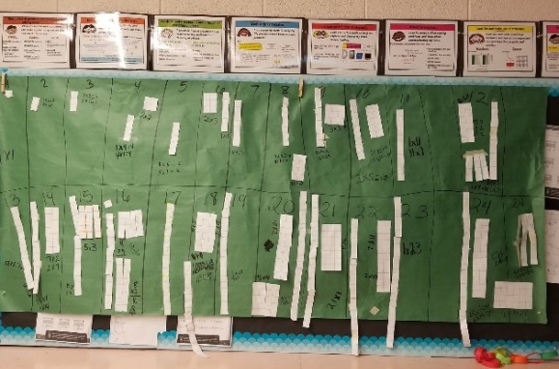

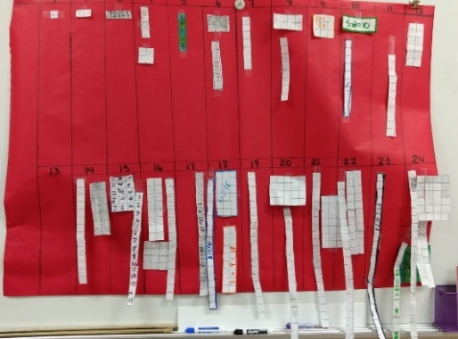

Close the lesson by having students record the vocabulary terms in their math journals and respond to the exit ticket below.

Evaluation of Student Understanding:
Informal Evaluation:
- Observe and monitor students as they create the rectangular arrays. How are they determining the factors of the number? How do they know if they have found all of the rectangles for the assigned number?
Formal Evaluation/Exit Ticket:
- At the end of the lesson, have students select one number and list at least three mathematical facts about the number. Challenge students to use the vocabulary introduced in today’s lesson.

Meeting the Needs of the Range of Learners:
Interventions:
- Encourage students to model the array with square tiles before drawing on grid paper.
Extensions:
- Ask students to create rectangular arrays and find the factors for larger numbers.
- Have students find all of the prime numbers after 25.

Possible Misconceptions/Suggestions:
Possible Misconceptions | Suggestions
Students are unable to find the arrays for their assigned numbers. | Provide students with the specified number of square tiles and have students make the arrays with square tiles before drawing on grid paper.

*This lesson was adapted from the following resources: Math Matters Grade K-8 Understanding the Math You Teach by Suzanne Chapin and Art Johnson, A Collection of Math Lessons from Grades 3 through 6 by Marilyn Burns, and Trailblazer Fourth Grade, Unit 4: Product and Factors A TIMS Curriculum from University at Chicago.

