Multiplicative Comparison Word Problems Using Area and Perimeter
In this area and perimeter investigation, students will solve multi-step multiplicative comparison word problems. This lesson combines three of the four standards covered in Cluster 2.

NC Mathematics Standards:
Operations & Algebraic Thinking
NC.4.OA.1 Interpret a multiplication equation as a comparison. Multiply or divide to solve word problems involving multiplicative comparison using models and equations with a symbol for the unknown number. Distinguish multiplicative comparison from additive comparison.
NC.4.OA.3 Solve two-step word problems involving the four operations with whole numbers.
- Use estimation strategies to assess reasonableness of answers.
- Interpret remainders in word problems.
- Represent problems using equations with a letter standing for the unknown quantity.
Measurement and Data
NC.4.MD.3 Solve problems with area and perimeter.
- Find areas of rectilinear figures with known side lengths.
- Solve problems involving a fixed area and varying perimeters and a fixed perimeter and varying areas.
- Apply the area and perimeter formulas for rectangles in real world and mathematical problems.

Standards for Mathematical Practice:
1. Make sense of problems and persevere in solving them.
2. Reason abstractly and quantitatively.
3. Construct viable arguments and critique the reasoning of others.
4. Model with mathematics.
7. Look for and make use of structure.
8. Look for and express regularity in repeated reasoning.

Student Outcomes:
- I can solve multiplicative comparison word problems related to area and perimeter.

Math Language:
- multiplicative comparison
- product
- area
- perimeter
- array
- width
- length

Materials:
- square tiles
- poster paper/markers for anchor chart
- student handout (1 per student)
- graph paper (if needed)

Advance Preparation:
- Make copies of student handout and exit ticket (1 per student).

Launch:
- Review and Introduction (10-15 minutes)
Part I:
Review area and perimeter by asking students to describe what they know and remember about the concepts of area and perimeter. Record student responses on an anchor chart.
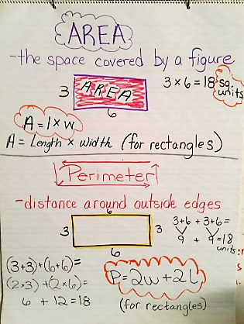
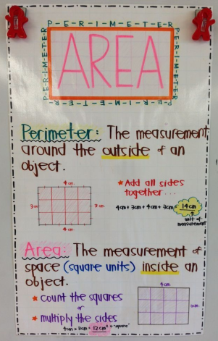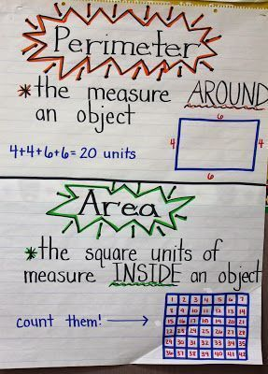
Provide students with square tiles and have them model a rectangle that is one unit wide and 4 times as long using the square tiles. Students should place four tiles on their desks in a row. Instruct students to discuss with a partner what the width and length of the rectangle are and the area and perimeter of the figure.

Say: The width is 1 unit and the length is 4 units for the first rectangle. What would the length be if the length was twice as long? Model the rectangle using square tiles on your desk. (Students should make a rectangle that is 1 unit wide and 8 units long.) Now the length is 8 units long. What if the length was three times longer than the original rectangle? What would the new length be? (12 units) Tell your partner how you could find it. Is there an equation you could use to find the new length? (3 x 4 units = 12 units)

Part II:
Provide each student with a handout and a set of square tiles. Instruct students to solve and model each problem. Students may work independently or with a partner.
- Problem 1: What would the length be if a rectangle is 2 units wide and the length is 3 times the width? Create a model using your tiles.
What is the width? What is the length?
What is the area of your rectangle? What is the perimeter of your rectangle?
- Problem 2: What would the length be if a rectangle is 3 units wide and 4 times as long?
- Problem 3: Amanda painted a mural for the school with an area of 24 square meters and a length of 8 meters. What is the width of her mural? Her next mural will be the same length as the first but 3 times as wide. What is the perimeter of her next mural?
- Problem 4: Mary’s rectangular garden is 20 square meters. The longer side of the garden is 5 meters. Katie’s garden is twice as long and twice as wide as Mary’s rectangular garden. What is the perimeter of Katie’s garden?

Explore:
- Solving the Problems (15 – 20 minutes)
Observe students as they work on the task. Select possible responses for the discussion portion of the lesson.
Observe:
- How are they making sense of the problem?
- How are students modeling or drawing a diagram to find the correct solution?
- Do students understand the multiplicative comparison in each problem?

If students have difficultly, use some of these guiding questions:
- Why does it say 20 square meters in the problem? Is that the area or the perimeter?
- If you know the area and you know the longer side, how can you find the missing side length?
- What does “twice as wide” mean? What do you have to do to the numbers to find the length and width of Katie’s garden?

Discuss:
- Discussion of Solutions (15 – 25 minutes)
Bring the group back together and discuss the ways students tried to solve the problems and the diagrams they created for each problem. Discuss the relationship of the perimeters in problem 3 and how this relationship relates to multiplicative reasoning.
Possible points to address and questions to ask:
- How did you use your knowledge of area and perimeter to solve the problems?
- What was the relationship between the perimeter of Mary’s garden and Katie’s garden? If Mary had a neighbor who had a garden that was three times the length and three times the width, what would be the relationship of the perimeters of those two gardens?
- What conclusion can you make about the areas of two rectangles when the length and width of one rectangle are each twice as much as the length and width of the other rectangle?

Close the lesson by returning to the learning target: I can solve multi-step multiplicative comparison word problems related to area and perimeter. Have students discuss how they used multiplicative reasoning to solve the area and perimeter problems.

Evaluation of Student Understanding:
Informal Evaluation:
- Observe and monitor students as they solve the problem. How are they making sense of the problem? Are they correctly drawing a diagram and using the formulas for area and perimeter to find the correct solution? Do students understand the multiplicative comparison in each problem?
Formal Evaluation/Exit Ticket:
- Have students draw a diagram and answer the question below:
The area of Riley’s sandbox at home is 15 square meters. The longer side is 5 square meters. The sandbox he plays in at the park is twice as long and twice as wide.
  - Draw a diagram and find the perimeter for both sandboxes.
  - What is the relationship between the two perimeters?
  - Find the area of the park’s sandbox. What is the relationship of the areas of the two sandboxes?

Meeting the Needs of the Range of Learners:
Interventions:
- Suggest that students use tiles to create the diagrams. Students can then trace the tiles to draw the diagrams on their papers.
- Use enlarged graph paper and have students use the graph paper to create their diagrams for each problem.
- Review area and perimeter using a video such as this one from Flocabulary: https://www.flocabulary.com/unit/area-and-perimeter/
Extensions:
- Have students create their own problems that involve finding the missing side using area and perimeter and then finding a new rectangle with multiplicative comparison.
- Change the numbers to larger numbers to make the problems more challenging.

Possible Misconceptions/Suggestions:
Possible Misconceptions | Suggestions
- Students do not understand the problem.  - Students do not make connections between the perimeters and areas of the two shapes. | - Read the problems aloud to the class and repeat parts of the problem to students who need it.  - Have students model the problem with square tiles or with drawings on graph paper.

*This lesson was adapted from Engage NY Grade 4 Module 3 Topic A Lesson 2.

Solutions:
Student Handout – Using Area and Perimeter:
- width= 2 feet, length=6 feet, area=12 square feet, perimeter=16 feet
- length=12 inches, area=36 square inches, perimeter=30 inches
- The first mural’s width=3 meters (24 divided by 8 is 3). The perimeter of the larger mural is 34 meters. (3x3=9 and 9+9+8+8=34)
- The width of the first garden is 4 (20 divided by 5 is 4). The perimeter of the second garden is 36 meters (10+10+8+8=36). The perimeter of the second garden is twice the perimeter of the first garden (18 meters versus 36 meters), but the area of the second garden is 4 times the area of the first garden (20 square meters versus 80 square meters).
Exit Ticket:
5 m 10 m Area=60 square meters

3 m 15 divided by 5 is 3
Area=15 square meters 6 m Perimeter=32 meters
Perimeter=3+3+5+5=16 meters
The perimeter of the second sandbox is twice the perimeter of the first sandbox, but the area of the second sandbox is 4 times the area of the first sandbox.
Using Area and Perimeter

- What would the length be if a rectangle is 2 feet wide and the length is 3 times the width? Create a model using your tiles.
- What is the width?
- What is the length?
- What is the area of your rectangle?
- What is the perimeter of your rectangle?

- What would the length be if a rectangle is 3 inches wide and 4 times as long?
  - What is the area of the rectangle?
  - What is the perimeter of the rectangle?

- Amanda painted a mural for the school with an area of 24 square meters and a length of 8 meters. What is the width of her mural? Her next mural will be the same length as the first but 3 times as wide. What is the perimeter of her next mural?

- Mary’s rectangular garden is 20 square meters. The longer side of the garden is 5 meters. Katie’s garden is twice as long and twice as wide as Mary’s rectangular garden. What is the perimeter of Katie’s garden?

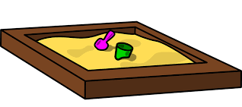
Exit Ticket

The area of Riley’s sandbox at home is 15 square meters. The longer side is 5 square meters. The sandbox he plays in at the park is twice as long and twice as wide.
  - Draw a diagram and find the perimeter for both sandboxes.

  - What is the relationship between the two perimeters?

  - Find the area of the park’s sandbox. What is the relationship of the areas of the two sandboxes?

