Patterns with Multiples
In this lesson, students will skip count and place colored sticky dots on a number line to 144 in order to explore factors, multiples, and prime and composite numbers.

NC Mathematics Standards:
Operations and Algebraic Thinking
NC.4.OA.4 Find all factor pairs for whole numbers up to and including 50 to:
- Recognize that a whole number is a multiple of each of its factors.
- Determine whether a given whole number is a multiple of a given one-digit number.
- Determine if the number is prime or composite.

Standards for Mathematical Practice:
4. Models with mathematics.
7. Looks for and makes use of structure.

Student Outcomes:
- I can skip count to determine the multiples of a given number.
- I can find the factors of a given number.
- I can determine if a number is prime or composite.
- I can describe patterns in my number line.

Math Language:
- factor
- multiple
- product
- prime
- composite
- skip counting

Materials:
- crayons
- Number Line Activity Sheet
- Class Number Line
- Number Line Color Coding Key
- Multiplication Table (optional extension)
- Sticky colored dots in the following colors: red, green, orange, yellow, light blue, neon orange, neon green, black, navy blue, purple, gold star
Advance Preparation:
- Consider how you will group or partner students
- Print, assemble, and display the Class Number Line along with the Number Line Color Coding Key
- Copy the Number Line Activity Sheet for each student/partner group
Launch:
- Introduction (Total of 30 – 40 minutes)
Part I: Introduce Lesson (5 minutes)
Tell students that today the class will be exploring patterns as they skip count on a number line. Have students discuss what it means to skip count. Based on prior knowledge, they may already make connections to multiplication.

Part II: Skip Count by Twos (15-20 minutes)
Explain that the class will first skip count by twos and place a red sticky dot above each number said. Have students assist in placing the sticky dots as the class counts. After the class sticky dots are placed, explain that the student sheet has blank dots that will need to be filled in as the class number line is made. Students should color in one dot red above each number that has a red sticky dot above it on the class number line. To keep the student number lines consistent with the class number line, you may ask students to color in dots from the bottom to the top of the ‘stack’ of dots above each number. After students finish, tell them that all of the numbers with a red dot above them are multiples of 2. In partners, have students turn and talk, using the word multiple to describe what they see on the number line. Decide on a class definition for the word multiple and display it near the class number line. Ask: What do you notice about the multiples of 2?

Part III: Complete the Class and Student Number Lines (10 – 15 minutes)
Lead the class as they skip count by threes. Have students assist in placing the green dots as the class counts. Then allow time for students to color in their own number lines with green dots. Have students look at the number six on the number line and describe what they see. Tell them that 2 and 3 are both factors of 6. Lead a class discussion to define the term factor, and place the definition near the class number line. Explain that 2 and 3 are a factor pair for 6, since they can be multiplied together to make 6. Ask: What is another factor pair for 6? Why do you think we didn’t skip count by 1s? Which other numbers are multiples of both 2 and 3? How are multiples and multiplication facts related? As we continue counting, which numbers do you predict will have the most factors? Why?

Explore:
- Completing the Number Lines (30 – 40 minutes)
Assign the remaining numbers (4-12) to groups and give students the corresponding sticky dots to place on the class number line. The assignment you give each group can be differentiated. Here are the remaining numbers in suggested groupings:
5 and 10
4 and 8
11
7
6, 9, and 12
Allow time for students to color in their personal number lines.

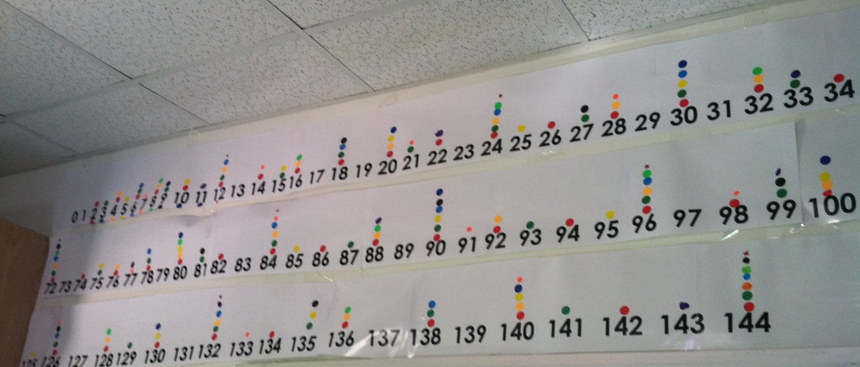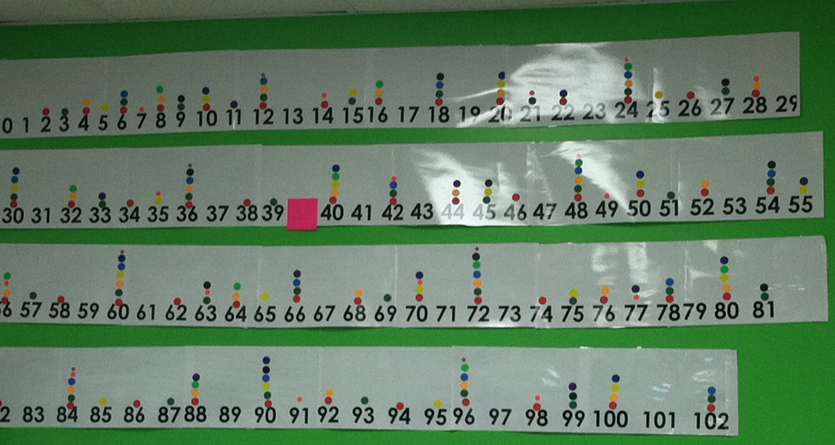

Discuss:
3. Discuss Patterns (20-30 minutes)
Once the class and student number lines are complete, ask students to work with partners or a small group to examine the number lines for a) relationships and similarities, and b) things that stick out. As students are working together, they should record their ideas. The teacher should listen to student conversations in order to choose students to share when the class discusses. When students have had time to record their thinking, bring the class together for a discussion. The following big ideas should be discussed:
- Some numbers have only one dot above them or nothing at all. Ask students if this means these numbers have no factor pairs or only one factor. Students should be able to explain that these numbers have one factor pair, 1 and the number itself. Add the word prime and its definition near the number line. Have students find all of the prime numbers on their number lines.
- Some numbers have very similar factors. Have students list the factors for 4 and for 8. What is similar and different? Is this true for all numbers as they double? Have students look for examples and non-examples from their number lines.
- Some numbers have several factor pairs. Introduce the word composite to describe numbers with multiple factor pairs. Add this word and definition beside the class number line. Ask students to identify the numbers on their number lines with the most factors pairs. Ask if there is an organized way to determine how many factors a number has.

4. Review and Closure (10 minutes)
Display a multiplication table. Review the vocabulary discussed in today’s lesson.
Ask students to define and find an example of:
- A prime number
- A factor pair
- The multiples of 3 (or 4, 5, etc.)
- A composite number with many factor pairs
Highlight the columns for 2, 4, and 8. Look for patterns in the multiples of these numbers. Are there other columns that are related in this way?

Evaluation of Student Understanding:
Informal Evaluation:
- The teacher will evaluate students’ vocabulary acquisition and understanding of factors, factor pairs, multiples, prime, and composite numbers during class, small group, and partner discussions.
Formal Evaluation/Exit Ticket:
- Have students answer the following prompt in writing:
If a new student joins our class tomorrow, how should we explain how to use our class number line? Use these words (factor, factor pairs, multiple, prime, composite, multiplication facts) and examples from your number line in your response.

Meeting the Needs of the Range of Learners:
Intervention:
- Students who struggle to skip count can be shown how to count up on the number line to determine multiples. An alternative would be to provide a multiplication table for these students.
Extensions:
- Challenge students to think of the next largest composite number (that does not appear on their chart) with at least five factors.
- Challenge students to come up with a rule to describe all multiples of 6.

Possible Misconceptions/Suggestions:
Possible Misconceptions | Suggestions
- Students may believe that all numbers must have an even number of factors.  - Students may believe that all odd numbers are prime numbers (ex. 9, 15, 21). | - Have students find examples of numbers on the number line with an odd number of factors. Allow time for students to list the factor pairs for those numbers so that they can see that sometimes a number is the product of a number multiplied by itself.  - Have students find examples of odd numbers that are composite numbers (not prime numbers).  - Show examples with arrays using grid paper or square tiles.

Special Notes:
- Although NC.OA.4 only requires students to find factors for numbers to 50, it is recommended to continue the number line to 144 so that students can connect the factors and multiples they see to the multiplication facts they know. However, it is acceptable to revise this activity to only skip count through 50.

*This lesson was adapted from “Everything You Need to Know about Kim’s Number Line”. www.creativemathematics.com

Class Number Line
1 | 2 | 3 | 4 | 5 | 6
7 | 8 | 9 | 10 | 11 | 12
13 | 14 | 15 | 16 | 17 | 18
19 | 20 | 21 | 22 | 23 | 24
25 | 26 | 27 | 28 | 29 | 30
31 | 32 | 33 | 34 | 35 | 36
37 | 38 | 39 | 40 | 41 | 42
43 | 44 | 45 | 56 | 47 | 48
49 | 50 | 51 | 52 | 53 | 54
55 | 56 | 57 | 58 | 59 | 60
61 | 62 | 63 | 64 | 65 | 66
67 | 68 | 69 | 70 | 71 | 72
73 | 74 | 75 | 76 | 77 | 78
79 | 80 | 81 | 82 | 83 | 84
85 | 86 | 87 | 88 | 89 | 90
91 | 92 | 93 | 94 | 95 | 96
97 | 98 | 99 | 100 | 101 | 102
103 | 104 | 105 | 106 | 107 | 108

109 | 110 | 111 | 112 | 113 | 114

115 | 116 | 117 | 118 | 119 | 120

121 | 122 | 123 | 124 | 125 | 126

127 | 128 | 129 | 130 | 131 | 132
133 | 134 | 135 | 136 | 137 | 138
139 | 140 | 141 | 142 | 143 | 144
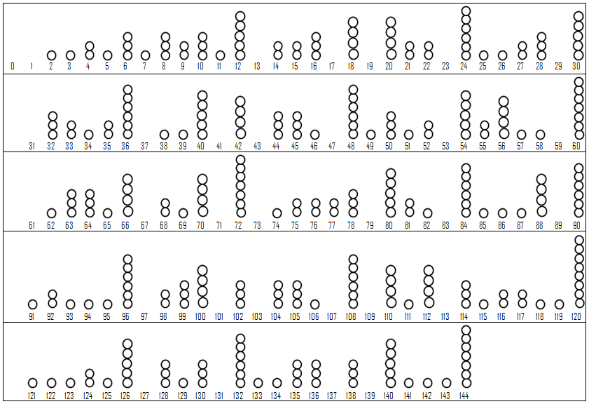
Number Line Activity Sheet
Number Line Color Coding Key
2s Red
3s Green
4s Orange
5s Yellow
6s Light Blue
7s Neon Orange
8s Neon Green
9s Black
10s Navy Blue
11s Purple
12s Gold Star

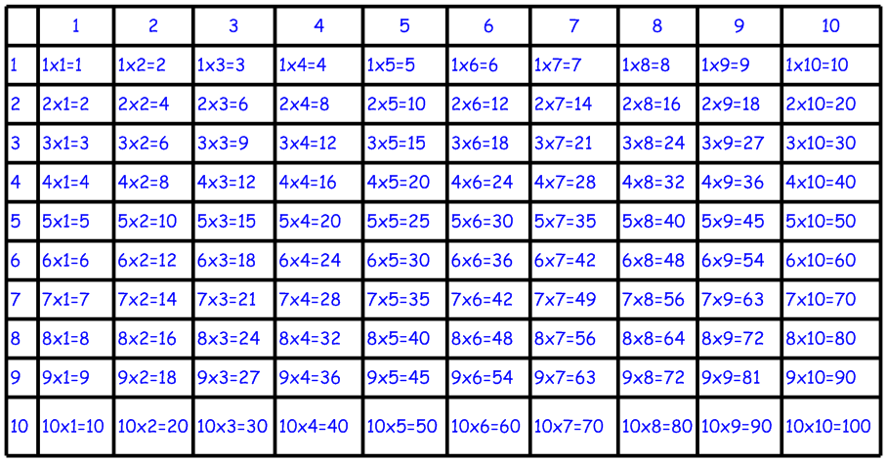
Multiplication Table

