Area and Perimeter: Spaghetti and Meatballs
In this lesson, students apply concepts of area and perimeter to come up with possible seating arrangements for 32 people by combining square tables.

NC Mathematics Standard:
Measurement and Data
NC.4.MD.3 Solve problems with area and perimeter.
- Find areas of rectilinear figures with known side lengths.
- Solve problems involving a fixed area and varying perimeters and a fixed perimeter and varying areas.
- Apply the area and perimeter formulas for rectangles in real world and mathematical problems.

Standards for Mathematical Practice:
1. Make sense of problems and persevere in solving them.
2. Reason abstractly and quantitatively.
3. Construct viable arguments and critique the reasoning of others.
4. Model with mathematics.
7. Look for and make use of structure.
8. Look for and express regularity in repeated reasoning.

Student Outcomes:
- I can find different perimeters that have the same area.
- I can find different areas that have the same perimeter.

Math Language:
- area
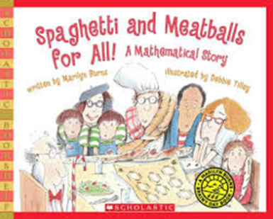
- perimeter
- array

Materials:
- Book: Spaghetti and Meatballs for All! by Marilyn Burns
- graph paper
- small square cubes (to represent the chairs)
- square tiles (to represent the tables)
- review video Flocabulary: https://www.flocabulary.com/unit/area-and-perimeter/ (optional)

Advance Preparation:
- Obtain a copy of the book to read to students.
- Group students into pairs.
- Prepare models that students can use for tables and chairs. You can use square tiles for tables and unit cubes for chairs or construction paper squares of one color to represent tables and smaller construction paper squares or circles for chairs. Each group should get 8 large squares (square tiles) and 32 small squares/circles (unit cubes).

Launch:
- Introduction (15 minutes)
Review area and perimeter by asking students to explain the two concepts. Area is the inside of a two-dimensional shape. Perimeter is the linear measurement of the distance around the shape. You may want to review the concepts using the Flocabulary video.

Introduce the book by saying:
Today we’re going to read a story called Spaghetti and Meatballs for All!.
In the book, Mr. and Mrs. Comfort invite 32 people to a reunion. To accommodate their guests, they set up eight square tables to seat 4 people at each, one to a side. The guests, however, rearrange things so different-size groups can sit together. Mrs. Comfort protests, knowing the arrangements won’t work, but no one listens.

Read the first part of this book (up until the guests begin to move the tables) to the class. Then tell the class that they are going to help Mrs. Comfort set her tables so everyone is happy.

Provide each pair of students with eight squares that represent the tables and 32 smaller squares for the guests. Have students work with their partner to see if they can come up with a way to help Mrs. Comfort rearrange the tables. Once students have created a model, have them draw the various arrangements on graph paper.

Explore:
- Solving the Problem (15 – 20 minutes)
Observe students as they are working on the task. Carefully select students to present the different arrangements of tables.

Observe:
- How are students arranging the tables/tiles?
- Are students able to draw models on graph paper?
- Are the students successfully finding the new perimeters of the groups of tiles they are making?
- Are students making the connection that they are finding the perimeter when they count the number of people that can sit around the table?
- Do the students understand that when you push the tiles together they lose places (perimeter) to sit people because the tables would be pushed up against each other?

Discuss:
- Discussion of Solutions (15 – 25 minutes)
Bring the group back together and have students discuss the ways students tried to solve the problem. Record the different arrangements on an anchor chart.
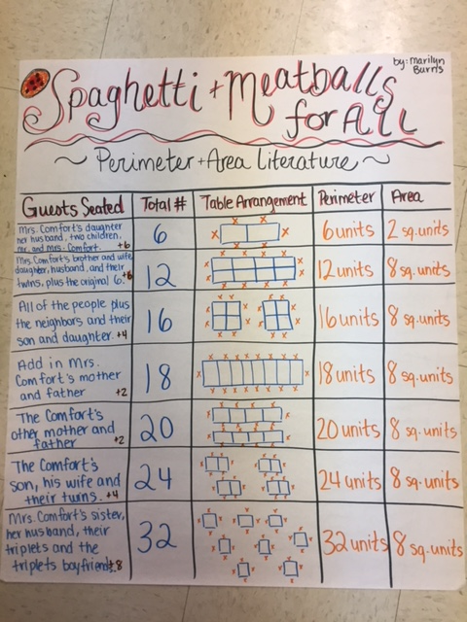

Discuss any arrangements that did not work. Like the guests in the book, students will find that the different arrangements they make by joining the 8 tables together will not fit all 32 guests. It is only by having 8 separate tables with 4 guests at each table that they will fit all 32 guests.

Relate the task to area and perimeter. For this problem, students kept the same area but had to arrange the tables differently, creating different perimeters. Return to the learning target: I can find different perimeters that have the same area. and have students summarize what they have learned from this lesson.

Evaluation of Student Understanding:
Informal Evaluation:
- Observe and monitor students as they solve the problem. How are they making sense of the problem? Are they using the tiles to create different rectangles and then correctly measuring the perimeter of those rectangles?
Formal Evaluation/Exit Ticket:
- Have students find different perimeters for an area of ten tiles and model them on a half sheet of paper to turn into you.

Meeting the Needs of the Range of Learners:
Interventions:
- Suggest that students use models such as tables, lists, and arrays on grid paper to help them solve the task.
- Use enlarged graph paper and have students create their different sized groups and write the number of people that can sit in each arrangement.
Extensions:
- Have students create different areas that have a perimeter of 32 using the tiles. This is explained in detail in the link (https://mathsolutions.com/wp-content/uploads/Spaghetti-and-Meatballs-5-6.pdf). This can be a continuation of this lesson the following day.
- Have students create pictures (snowmen, robots, etc) using graph paper and then have them find the area and perimeter of the different objects in their picture.

Possible Misconceptions/Suggestions:
Possible Misconceptions | Suggestions
- Students do not understand the problem.  - Students do not realize that they will lose spots for two people by pushing two tables together.  - Students do not make connections between the task and area/perimeter. | - As a class, act out the problem.  - Demonstrate with smaller numbers (such as 6).  - Discuss as a class, asking questions to encourage students to consider other possible solutions.  - Remind students that people sit around the outside of the table and have them talk about whether they are finding the area or perimeter.

*Adapted from Marilyn Burn’s Math Solutions lesson plan: https://mathsolutions.com/wp-content/uploads/Spaghetti-and-Meatballs-5-6.pdf.

