NC.4.MD.3
Area & Perimeter Exploration
Domain | Measurement and Data
Cluster | Solve problems with area and perimeter.
Standard(s) | NC.4.MD.3 Solve problems with area and perimeter.  - Find areas of rectilinear figures with known side lengths.  - Solve problems involving a fixed area and varying perimeters and a fixed perimeter and varying areas.  - Apply the area and perimeter formulas for rectangles in real world and mathematical problems.
Materials | activity sheet, pencil, graph paper and/or square tiles
Task | Area & Perimeter Exploration  Part 1:  Create all the possible arrays with an area of 36 square units. Draw your arrays on grid paper and label their dimensions.  - How can you be sure that you found all the possible arrays with an area of 36 square units?  Find the perimeter for each figure that you made.  - What do you notice about the shapes and their perimeters?  - What is the relationship between the perimeter and the shape of an array?  Possible Solutions:  Perimeter Dimensions  74 units 1 x 36  40 units 2 x 18  30 units 3 x 12  26 units 4 x 9  24 units 6 x 6  Part 2:  Create all the possible arrays with a perimeter of 36 units. Draw your arrays on grid paper and label their dimensions. Use a chart to keep track of the area and dimensions for each rectangle.  - How can you be sure that you found all the possible arrays with a perimeter of 36 units? What do you notice about the shapes and their areas?  - What is the relationship between the area and the shape of an array?  Possible Solutions:  Area Dimensions  17 sq units 1 x 17  32 sq units 2 x 16  45 sq units 3 x 15  56 sq units 4 x 14  65 sq units 5 x 13  72 sq units 6 x 12  77 sq units 7 x 11  80 sq units 8 x 10  81 sq units 9 x 9  Part 3:  What generalizations can be made about the relationship between the area and perimeter of a figure?  Possible Conclusions:  - The closer a shape gets to being a square, the smaller its perimeter.  - The closer a shape gets to being a square, the larger its area.  - Squares have the largest possible area and the smallest possible perimeter.

 | Rubric
 | Level I  Not Yet | Level II  Progressing | Level III  Meets Expectation
Part 1 | Student is able to generate 0-2 arrays with an area of 36 square units and label the perimeter of each. | Student is able to generate 3-4 arrays with an area of 36 square units and label the perimeter of each. | Student is able to generate all arrays with an area of 36 square units and label the perimeter of each.
Part 2 | Student is able to generate 0-4 arrays with a perimeter of 36 units and label the area of each. | Student is able to generate 5-8 arrays with a perimeter of 36 units and label the area of each. | Student is able to generate all arrays with a perimeter of 36 units and label the area of each.
Part 3 | Generalization demonstrates no understanding of the relationship between the area and perimeter of a figure. | Generalization demonstrates incomplete understanding of the relationship between the area and perimeter of a figure. | Generalization demonstrates complete understanding of the relationship between the area and perimeter of a figure.

Standards for Mathematical Practice
1. Makes sense and perseveres in solving problems.
2. Reasons abstractly and quantitatively.
3. Constructs viable arguments and critiques the reasoning of others.
4. Models with mathematics.
5. Uses appropriate tools strategically.
6. Attends to precision.
7. Looks for and makes use of structure.
8. Looks for and expresses regularity in repeated reasoning.

Area & Perimeter Exploration

Part 1:
Create all the possible arrays with an area of 36 square units. Draw your arrays on grid paper and label their dimensions.
- How can you be sure that you found all the possible arrays with an area of 36 square units?
Find the perimeter for each figure that you made.
- What do you notice about the shapes and their perimeters?
- What is the relationship between the perimeter and the shape of an array?

Part 2:
Create all the possible arrays with a perimeter of 36 units. Draw your arrays on grid paper and label their dimensions. Use a chart to keep track of the area and dimensions for each rectangle.
- How can you be sure that you found all the possible arrays with a perimeter of 36 units?
- What do you notice about the shapes and their areas?
- What is the relationship between the area and the shape of an array?

Part 3:
- What generalizations can be made about the relationship between the area and perimeter of a figure?
- How could this this information be used to solve a problem in real life? When might it be useful to have this information?

Scoring Examples
Not Yet: The student generates few arrays with an area and/or perimeter of 36. The student does not demonstrate an understanding of the relationship between area and perimeter.
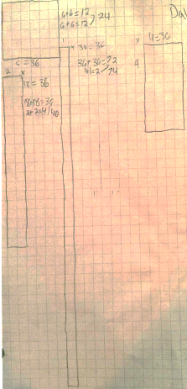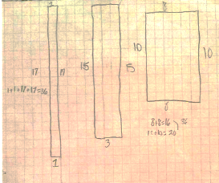
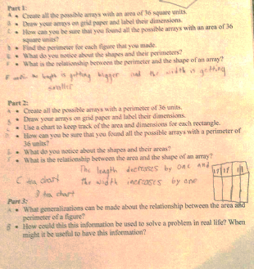
Progressing: The student generates several (but not all) areas with an area and/or perimeter of 36. The student does not show a complete understanding of the relationship between area and perimeter.
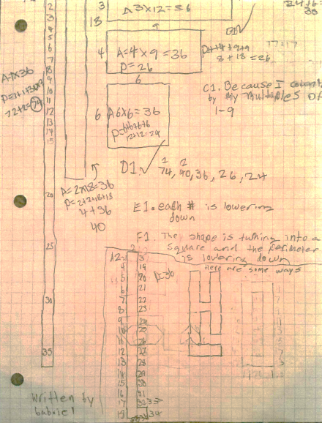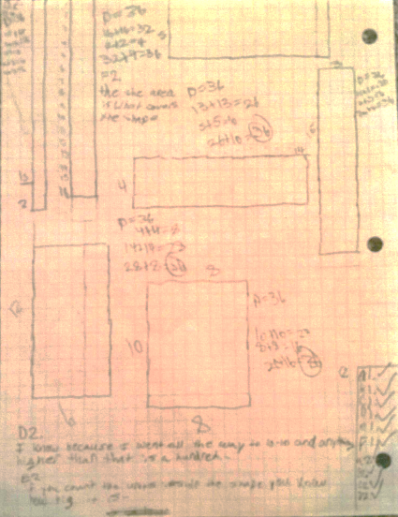
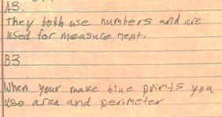

Meets Expectation: The student generates all arrays with an area and/or perimeter of 36. The student’s work demonstrates a complete understanding of the relationship between area and perimeter.
