NC.4.OA.4
Arranging Chairs
Domain | Operations and Algebraic Thinking
Cluster | Gain familiarity with factors and multiples.
Standard(s) | NC.4.OA.4 Find all factor pairs for whole numbers up to and including 50 to:  - Recognize that a whole number is a multiple of each of its factors.  - Determine whether a given whole number is a multiple of a given one-digit number.  - Determine if the number is prime or composite.
Materials | activity sheet, pencil, square tiles (optional)
Task | Arranging Chairs  Part 1:  There are 24 chairs in the art room. What are the different ways that the chairs can be arranged into equal groups if you want at least 2 groups and want at least 2 chairs in each group? How do you know that you have found every arrangement? Write equations to show your answers.  Possible Solutions:  2 groups of 12; 3 groups of 8; 4 groups of 6; 6 groups of 4; 8 groups of 3; 12 groups of 2  (Example equations: 2 x 12 = 24, 24 ÷ 2 = 12)  Part 2:  There are 48 chairs in the multi-purpose room. What are the different ways that the chairs can be arranged into equal groups if you want at least 2 groups and want at least 2 chairs in each group? How do you know that you have found every arrangement? Write equations to show your answers.  Possible Solutions:  2 groups of 24; 3 groups of 16; 4 groups of 12; 6 groups of 8; 8 groups of 6; 12 groups of 4; 16 groups of 3; 24 groups of 2  (Example equations: 2 x 24 = 48, 48 ÷ 2 = 24)  Part 3:  What relationship do you notice about the size of the groups if the chairs were arranged in 4 groups in both Part 1 and Part 2? What about if the chairs were arranged in 8 groups? Explain why you think this relationship exists.  Possible Solutions:  24 chairs can be put into 4 groups of 6. 48 chairs can be put into 4 groups of 12. 24 chairs can be put into 8 groups of 3. 48 chairs can be put into 8 groups of 6. The explanation should reference that 48 is double 24, which means that when one factor remains constant, the other factor is doubled.

Rubric
Level I  Not Yet | Level II  Progressing | Level III  Meets Expectation
Student has minimal to no solutions to each part of the task AND is unable to explain reasoning. | Student has some possible solutions to each part of the task and is able to explain reasoning. | Student has all possible solutions to each part of the task and is able to clearly explain reasoning.

Standards for Mathematical Practice
1. Makes sense and perseveres in solving problems.
2. Reasons abstractly and quantitatively.
3. Constructs viable arguments and critiques the reasoning of others.
4. Models with mathematics.
5. Uses appropriate tools strategically.
6. Attends to precision.
7. Looks for and makes use of structure.
8. Looks for and expresses regularity in repeated reasoning
Arranging Chairs
Part 1:
There are 24 chairs in the art room. What are the different ways that the chairs can be arranged into equal groups if you want at least 2 groups and want at least 2 chairs in each group? How do you know that you have found every arrangement? Write equations to show your answers.

Part 2:
There are 48 chairs in the multi-purpose room. What are the different ways that the chairs can be arranged into equal groups if you want at least 2 groups and want at least 2 chairs in each group? How do you know that you have found every arrangement? Write equations to show your answers.

Part 3:
What relationship do you notice about the size of the groups if the chairs were arranged in 4 groups in both Part 1 and Part 2? What about if the chairs were arranged in 8 groups? Explain why you think this relationship exists.

Scoring Examples
Not Yet: The student was unable to generate a correct solution for either problem and was unable to explain his/her reasoning.
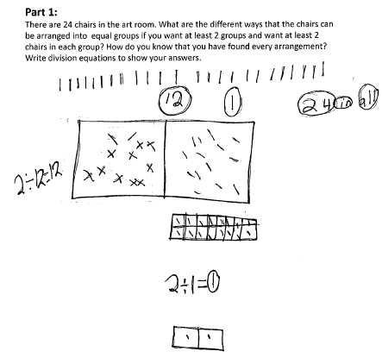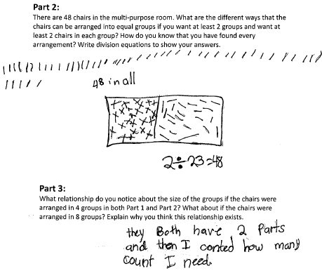

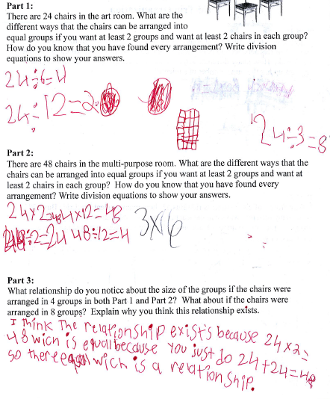
Progressing: The student has several possible solutions to each part of the task and is able to partially explain his/her reasoning.

Meets Expectation: The student has all possible solutions to each part of the task and is able to clearly explain his/her reasoning.
