NC.4.MD.3
Carpets
Domain | Measurement and Data
Cluster | Solve problems with area and perimeter.
Standard(s) | NC.4.MD.3 Solve problems with area and perimeter.  - Find areas of rectilinear figures with known side lengths  - Solve problems involving a fixed area and varying perimeters and a fixed perimeter and varying areas.  - Apply the area and perimeter formulas for rectangles in real world and mathematical problems.
Materials | activity sheet, pencil
Task | Carpets  A classroom wants to have 60 square meters of carpet for shared reading time. Two carpets have been placed in the classroom, but there is still not enough space. Draw the third carpet that would be needed to make a total of 60 square meters of carpet. Use drawings, numbers, equations, and/or words to explain how you found your answer.  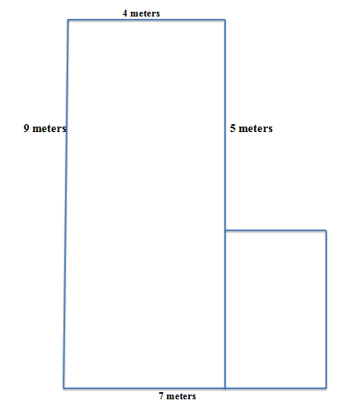

Rubric
Level I  Not Yet | Level II  Progressing | Level III  Meets Expectation
Student is able to correctly complete 0-1 of the following:  - Calculate the area of the rugs that are already in the classroom  - Determine that there are 12 square feet missing to create a total rug area of 60 square feet  - Draw a third carpet that creates a total rug area of 60 square meters  - Justify solution using drawings, numbers, words, and/or equations | Student is able to correctly complete 2-3 of the following:  - Calculate the area of the rugs that are already in the classroom  - Determine that there are 12 square feet missing to create a total rug area of 60 square feet  - Draw a third carpet that creates a total rug area of 60 square meters  - Justify solution using drawings, numbers, words, and/or equations | Student is able to correctly complete all of the following:  - Calculate the area of the rugs that are already in the classroom  - Determine that there are 12 square feet missing to create a total rug area of 60 square feet  - Draw a third carpet that creates a total rug area of 60 square meters  - Justify solution using drawings, numbers, words, and/or equations
Standards for Mathematical Practice
1. Makes sense and perseveres in solving problems.
2. Reasons abstractly and quantitatively.
3. Constructs viable arguments and critiques the reasoning of others.
4. Models with mathematics.
5. Uses appropriate tools strategically.
6. Attends to precision.
7. Looks for and makes use of structure.
8. Looks for and expresses regularity in repeated reasoning.

Carpets
A classroom wants to have 60 square meters of carpet for shared reading time. Two carpets have been placed in the classroom, but there is still not enough space. Draw the third carpet that would be needed to make a total of 60 square meters of carpet. Use drawings, numbers, equations, and/or words to explain how you found your answer.

Scoring Examples

Not Yet: The student is unable to correctly calculate the areas of the rugs already in the room and cannot draw another rug section in order to make a total rug area of 60 square meters.
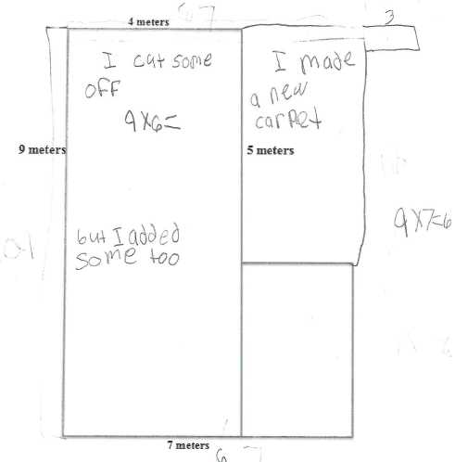

Progressing: The student is inconsistently able to label the dimensions for each section of the rug and find the areas of each section. The student is not able to correctly add a section of rug to create a total area of 60 square meters.

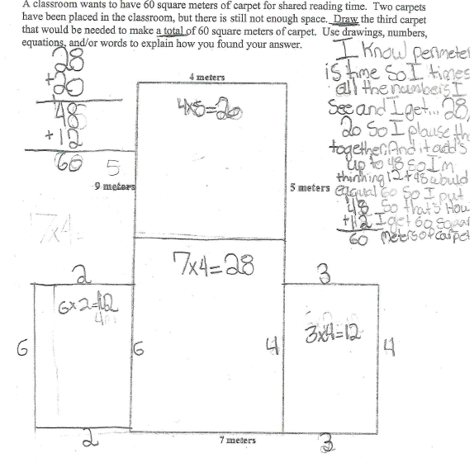

Meets Expectation: The student correctly finds the area of the existing rug sections and correctly adds another rug section to create a total rug area of 60 square meters.
