NC.4.OA.1
Clothing Prices
Domain | Operations and Algebraic Thinking
Cluster | Use the four operations with whole numbers to solve problems.
Standard(s) | NC.4.OA.1 Interpret a multiplication equation as a comparison. Multiply or divide to solve word problems involving multiplicative comparisons using models and equations with a symbol for the unknown number. Distinguish multiplicative comparison from additive comparison.
Materials | pencil, activity sheet
Task | Part 1:  Two stores in Greensboro sell shirts and pants together in matching outfits. In Store A, pants are half the cost of shirts. In Store B, pants are $4 less than the cost of shirts. Complete the tables below for each store.  Answers:  Store A Store B  Shirts Pants Shirts Pants  10 5 10 6  12 6 12 8  14 7 14 10  16 8 16 12  18 9 18 14  20 10 20 16  Store A Store B  Shirts Pants Shirts Pants  10 10  6 8  14 14  16 16  9 18  20 20  Part 2:  If a shirt costs $30, how much will the matching pants cost in each store?  For each store, write an equation with a symbol to show your work. Write a sentence explaining your strategy for finding the cost of the pants.  Answers: Store A: $30 ÷ 2 = ? Store B: $30 - $4 = ?  ? = $15 ? = $26  Explanations should reflect the operations used to find the cost for each store. Store A should include dividing by 2 and Store B should include subtracting by 4.  Extensions:  - Where would you rather shop – Store A or Store B? Explain why.  - Is there a time when the pants at Store A and Store B would be sold for the same price? Justify your answer. (Answer: Yes. If the shirt cost $8, both sets of pants would be $4.)  - Is there a time when the pants at Store B would be cheaper than the pants at Store A? Explain your reasoning. (Answer: Yes. If the cost of the shirt is $4 or $6, then Store B would be cheaper.)

Rubric
Level I  Not Yet | Level II  Progressing | Level III  Meets Expectation
Student is able to correctly complete 0-1 of the following:  - Complete the missing numbers in each table  - Write a matching equation with symbol for each store  - Write a sentence explaining the strategy for finding the cost of the pants from each store | Student is able to complete at least two of the following tasks:  - Complete the missing numbers in each table  - Write a matching equation with symbol for each store  - Write a sentence explaining the strategy for finding the cost of the pants from each store | Student is able to complete all of the following tasks:  - Complete the missing numbers in each table  - Write a matching equation with symbol for each store  - Write a sentence explaining the strategy for finding the cost of the pants from each store

Standards for Mathematical Practice
1. Makes sense and perseveres in solving problems.
2. Reasons abstractly and quantitatively.
3. Constructs viable arguments and critiques the reasoning of others.
4. Models with mathematics.
5. Uses appropriate tools strategically.
6. Attends to precision.
7. Looks for and makes use of structure.
8. Looks for and expresses regularity in repeated reasoning.

Clothing Prices

Part 1:
Two stores in Greensboro sell shirts and pants together in matching outfits. In Store A, pants are half the cost of shirts. In Store B, pants are $4 less than the cost of shirts. Complete the tables below for each store.

Store A |  |  | 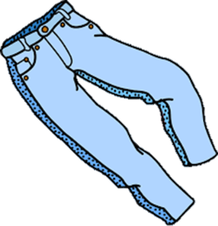  Store B
Shirts | Pants |  | Shirts | Pants
10 |  |  | 10
 | 6 |  |  | 8
14 |  |  | 14
16 |  |  | 16
 | 9 |  | 18
20 |  |  | 20

Part 2:
If a shirt costs $30 how much will the matching pants cost in each store?
For each store, write an equation with a symbol to show your work. Write a sentence explaining your strategy for finding the cost of the pants.

Extensions:
- Where would you rather shop – Store A or Store B? Explain why.

- Is there a time when the pants at Store A and Store B would be sold for the same price? Justify your answer.

- Is there a time when the pants at Store B would be cheaper than the pants at Store A? Explain your reasoning.

Scoring Examples
Not Yet: The student correctly completed the missing numbers in each table and found the correct answer for Part 2 – the cost of the pants at each store when a shirt costs $30. However, the student did not include an explanation or matching equation with a symbol in Part 2.
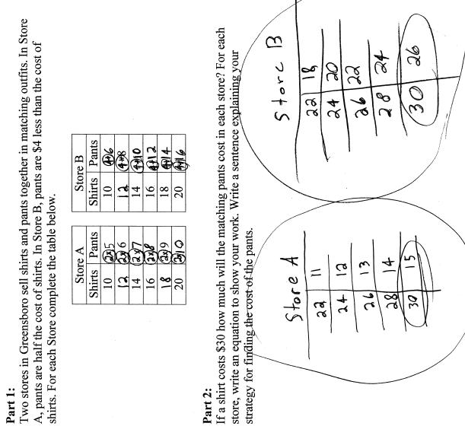
Progressing: The student completed portions, but not all, of the task correctly. In both examples, the students were able to partially complete the tables in Part 1 and find the answers to Part 2 with an explanation. However, the students are missing equations with symbols to represent each store. In order to progress, these students need to understand the relationship between the cost of the shirts and pants and express this relationship with a matching equation.
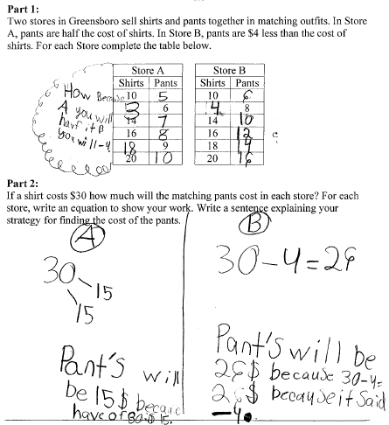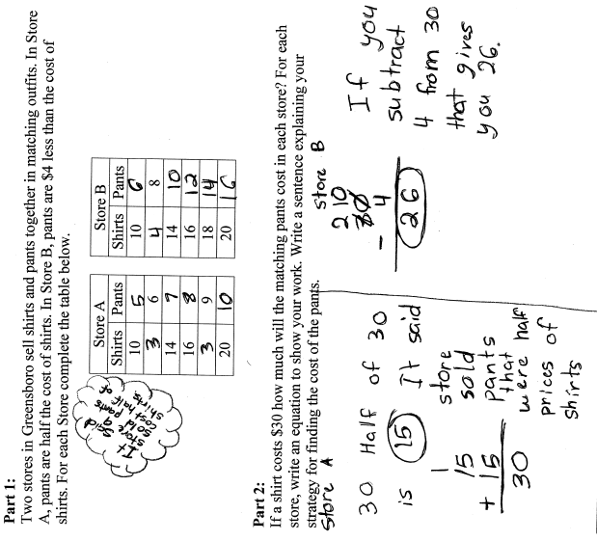
Meetings Expectation: This student correctly completed each part of the task by adding missing numbers to the table, writing a matching equation for each store, and writing a sentence that explains the strategy for finding the cost of the pants from each store.
