NC.4.OA.4
Field Trip Organization
Domain | Operations and Algebraic Thinking
Cluster | Gain familiarity with factors and multiples.
Standard(s) | NC.4.OA.4 Find all factor pairs for whole numbers up to and including 50 to:  - Recognize that a whole number is a multiple of each of its factors.  - Determine whether a given whole number is a multiple of a given one-digit number.  - Determine if the number is prime or composite.
Materials | pencil, activity sheet, counters (if needed)
Task | Field Trip Organization  Eighty 4th grade students at Andrews Elementary School are going on a field trip. Their teachers need to put between 3 and 25 students in each group to visit the shark tank. If four groups of eight students ride Bus #1, how many students will ride Bus #2?  How many different ways can the teacher group the students on Bus #2 so that each group has the same number of students? Find all possible solutions and explain your reasoning using pictures, numbers, or words.  Possible Solutions:  Bus 2 has a total of 48 students. 80 – (4 x 8) = n  Possible groupings: 1 x 48*, 2 x 24*, 3 x 16, 4 x 12, 6 x 8  *While 1 x 48 and 2 x 24 are correct answers, they do not fit the requirement of groupings.

Rubric
Level I  Not Yet | Level II  Progressing | Level III  Meets Expectation
Student has minimal to no solutions to each part of the task and may or may not be able to explain their reasoning. | Student has some possible solutions to each part of the task and is able to explain their reasoning. | Student has all possible solutions to each part of the task and is able to clearly explain their reasoning.

Standards for Mathematical Practice
1. Makes sense and perseveres in solving problems.
2. Reasons abstractly and quantitatively.
3. Constructs viable arguments and critiques the reasoning of others.
4. Models with mathematics.
5. Uses appropriate tools strategically.
6. Attends to precision.
7. Looks for and makes use of structure.
8. Looks for and expresses regularity in repeated reasoning.

Field Trip Organization

Eighty 4th grade students at Andrews Elementary School are going on a field trip. Their teachers need to put between 3 and 25 students in each group to visit the shark tank. If four groups of eight students ride Bus #1, how many students will ride Bus #2?

How many different ways can the teacher group the students on Bus #2 so that each group has the same number of students? Find all possible solutions and explain your reasoning using pictures, numbers, or words.

Scoring Examples
Not Yet: The student only answered one part of the task correctly. The student was unable to find the factor pairs for 48 and was unable to explain his/her reasoning.
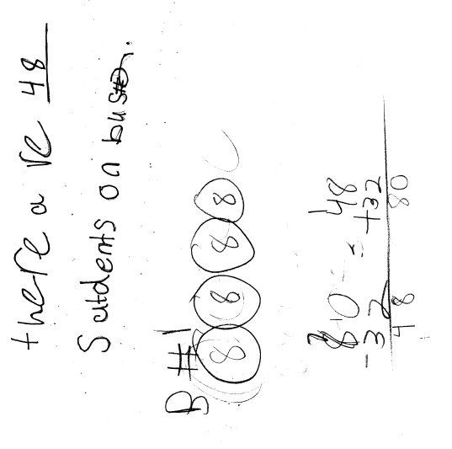

Progressing: While the student demonstrates an ability to find factor pairs of 32, the student was unable to find the factor pairs for 48 (the correct answer) and was unable to explain his/her reasoning.
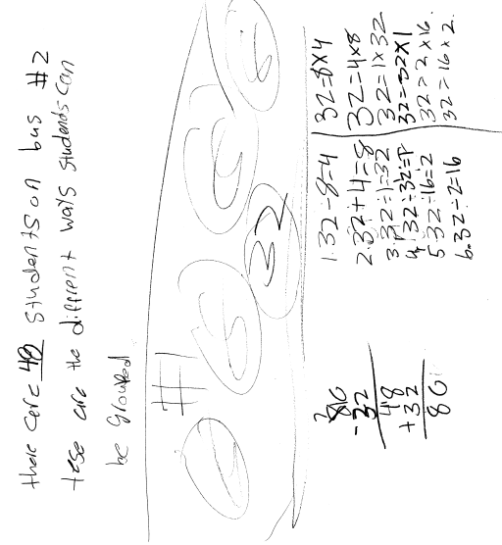

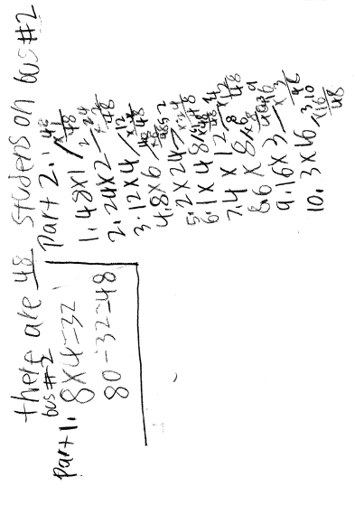
Meets Expectation: This student correctly solved the problem and found all of the possible factor pairs for 48.
(While 1 x 48 and 2 x 24 are correct answers, they do not fit the requirement of groupings.)

