NC.4.OA.3
How many Taki’s?
Domain | Operations and Algebraic Thinking
Cluster | Use the four operations with whole numbers to solve problems.
Standard(s) | NC.4.OA.3 Solve two-step word problems involving the four operations with whole numbers.  - Use estimation strategies to assess reasonableness of answers.  - Interpret remainders in word problems.  - Represent problems using equations with a letter standing for unknown quantity.
Materials | pencil, activity sheet
Task | How Many Taki’s?  Part 1: Kennedy’s Mini-Mart has sold out of Taki’s. Therefore, a truck is delivering Taki’s to the store this morning. The truck will be carrying 8 boxes of Taki’s. There will be 9 bags of Taki’s in each box on the truck. How many bags of Taki’s will Kennedy’s Mini-Mart have in stock after the truck delivery?  Solution:  72 bags  Part 2: Later in the day, another truck delivers 387 more bags of Taki’s to the store. How many Taki’s does the store have in stock after the second delivery?  Solution:  72 + 387 = 459  Part 3: That evening, Sutton’s Skating Rink comes to the store and buys 160 bags of Taki’s to sell at their concession stand. About how many Taki’s are in stock at Kennedy’s Mini-Mart now? Write a sentence explaining how you know.  Solution:  Explanations will vary. Estimates should be about 300 after students use estimation strategies to solve. 459 is about 460. 460 subtract 160 leaves about 300 Taki’s in the store OR 459 – 100 is 359. 359-50 is 309. 309-10 is 299 which is about 300.

Rubric
Level I  Not Yet | Level II  Progressing | Level III  Meets Expectation
Student is able to correctly answer one part of the task. | Student is able to correctly answer two parts of the task OR student is able to answer all three parts of the task correctly, but does not correctly explain their reasoning in part three. | Student is able to answer all three parts of the task correctly AND explain his/her reasoning in part three.

Standards for Mathematical Practice
1. Makes sense and perseveres in solving problems.
2. Reasons abstractly and quantitatively.
3. Constructs viable arguments and critiques the reasoning of others.
4. Models with mathematics.
5. Uses appropriate tools strategically.
6. Attends to precision.
7. Looks for and makes use of structure.
8. Looks for and expresses regularity in repeated reasoning.
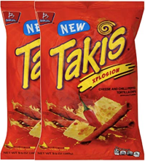
How Many Taki’s?

Part 1: Kennedy’s Mini-Mart has sold out of Taki’s. Therefore, a truck is delivering Taki’s to the store this morning. The truck will be carrying 8 boxes of Taki’s. There will be 9 bags of Taki’s in each box on the truck. How many bags of Taki’s will Kennedy’s Mini-Mart have in stock after the truck delivery?

Part 2: Later in the day, another truck delivers 387 more bags of Taki’s to the store. How many Taki’s does the store have in stock after the second delivery?

Part 3: That evening, Sutton’s Skating Rink comes to the store and buys 160 bags of Taki’s to sell at their concession stand. About how many Taki’s are in stock at Kennedy’s Mini-Mart now? Write a sentence explaining how you know.

Scoring Examples

Not Yet: Student is unable to complete any part of the task correctly. The number 8 is added too many times in Part 1 resulting in an incorrect answer. This error affects the other parts of the task.
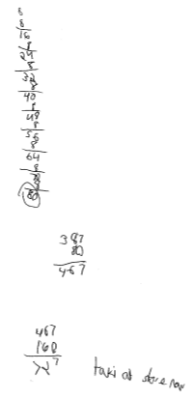

Progressing: Parts 1 and 2 are completed correctly, but student fails to regroup in Part 3 or give reasoning, resulting in an incorrect answer.
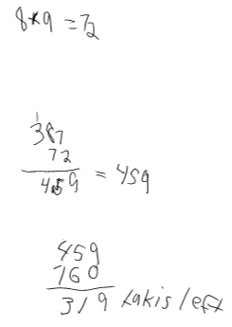

Meets Expectation: All parts of the task are completed correctly and clear reasoning is given for Part 3.
