NC.4.MD.3
Putting Down Carpet
Domain | Measurement and Data
Cluster | Solve problems with area and perimeter.
Standard(s) | NC.4.MD.3 Solve problems with area and perimeter.  - Find areas of rectilinear figures with known side lengths  - Solve problems involving a fixed area and varying perimeters and a fixed perimeter and varying areas.  - Apply the area and perimeter formulas for rectangles in real world and mathematical problems.
Materials | square tiles, activity sheet, pencil, graph paper (optional)
Putting Down Carpet
Part 1:
You want to carpet three rooms of a house. Using the dimensions below, determine how much carpet is needed.
Room 1: Perimeter is 38 yards and the width of the room is 12 yards.
Room 2: Perimeter is 50 yards and the width is 13 yards.
Room 3: Perimeter is 46 yards and the width is 10 yards.
For each room, determine how much carpet is needed.

Solutions:
Room 1:
Width =12 yards, Length = 7 yards
Area = 84 square yards

Room 2:
Width =13 yards, Length = 12 yards
Area = 156 square yards

Room 3:
Width = 10 yards, Length = 13 yards
Area = 130 square yards

Part 2:
Write a sentence and explain how you solved this task. How many total square yards of carpet are needed for all three rooms?

Solution: 370 square yards

Rubric
Level I  Not Yet | Level II  Progressing | Level III  Meets Expectation
Student found no missing side lengths or areas for each of the three rooms and is not able to clearly and accurately explain how they solved the task. | Student was inconsistent in finding missing side lengths and areas for each of the three rooms and may or may not be able to clearly and accurately explain how they solved the task. | Student is able to find missing side lengths and areas for all three rooms and is able to clearly and accurately explain how they solved the task.

Standards for Mathematical Practice
1. Makes sense and perseveres in solving problems.
2. Reasons abstractly and quantitatively.
3. Constructs viable arguments and critiques the reasoning of others.
4. Models with mathematics.
5. Uses appropriate tools strategically.
6. Attends to precision.
7. Looks for and makes use of structure.
8. Looks for and expresses regularity in repeated reasoning.

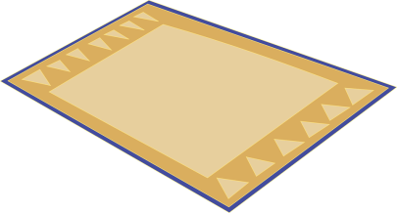
Putting Down Carpet

Part 1:
You want to carpet three rooms of a house. Using the dimensions below, determine how much carpet is needed.
Room 1: Perimeter is 38 yards and the width of the room is 12 yards.
Room 2: Perimeter is 50 yards and the width is 13 yards.
Room 3: Perimeter is 46 yards and the width is 10 yards.

For each room, determine how much carpet is needed.

Part 2:
Write a sentence and explain how you solved this task. How many total square yards of carpet are needed for all three rooms?

Scoring Examples
Not Yet: The student does not find missing side lengths or areas for any of the rooms. The student could not correctly explain how the task was solved.
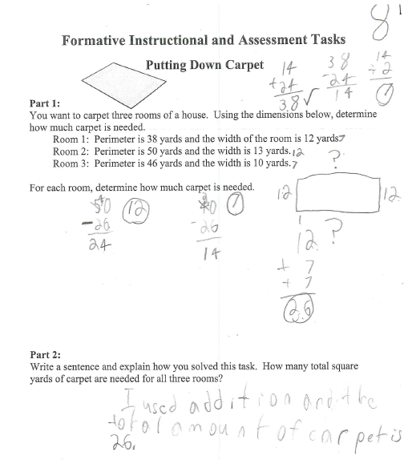

Progressing: The student determined the amount of carpet that was needed for Part 1 by finding the length and the area. In Part 2, the student was unable to find the total of all three rooms and did not completely explain the strategy for solving the problem.
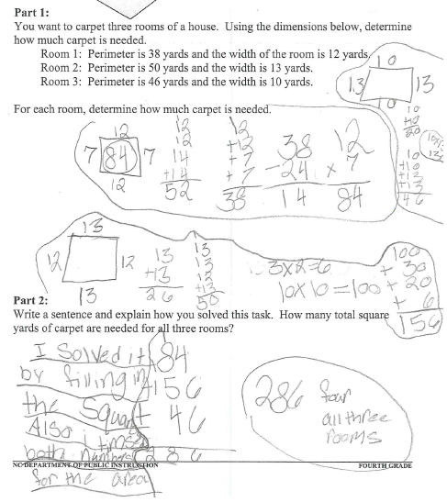

Meets Expectation: The student found all the missing side lengths and areas and explained the strategy for solving the problem clearly and accurately.
