NC.4.OA.1
Soup Chef
Domain | Operations and Algebraic Thinking
Cluster | Represent and solve problems involving multiplication and division.
Standard(s) | NC.4.OA.1 Interpret a multiplication equation as a comparison. Multiply or divide to solve word problems involving multiplicative comparisons using models and equations with a symbol for the unknown number. Distinguish multiplicative comparison from additive comparison.
Materials | pencil, activity sheet
Task | Soup Chef  Our class is making soup in a pot that holds two gallons. The pot already contains 8 cups of broth. We want to make a soup that has:  Possible Ingredients:  - carrots  - peas  - potatoes  - celery  - tomatoes  - green peppers  - onions  - 3 times the amount of carrots as celery  - 4 times the amount of potatoes as celery  Create a recipe using the possible ingredients.  Show your work using models and equations with a symbol for the unknown.  *Task adapted from Core Academy in Mathematics: http://ccak52012.wikispaces.com/Fourth+Grade+Teacher+Created+Tasks

Rubric
Level I  Not Yet | Level II  Progressing | Level III  Meets Expectation
The student does not demonstrate the ability to correctly show multiplicative comparison using multiplication or division.  OR  The student relies on the assistance of teachers and other students to understand and complete the task.  OR  The student incorrectly uses additive comparison. | Multiplies or divides to interpret a multiplication equation as a comparison but does not include:  - model(s)  - equation(s) with a symbol for the unknown  OR  Creates a recipe that is incorrect and does not follow the recipe guidelines.  OR  Inconsistently demonstrates conceptual understanding of multiplicative comparison situations.  OR  Uses an additive strategy to correctly interpret a multiplication equation. | Multiplies or divides to interpret a multiplication equation as a comparison by consistently and correctly using:  - model(s) OR  - equation(s) with a symbol for the unknown  AND  Correctly solves the task, creating a recipe with 32 cups of ingredients (including 8 cups of broth).

Standards for Mathematical Practice
1. Makes sense and perseveres in solving problems.
2. Reasons abstractly and quantitatively.
3. Constructs viable arguments and critiques the reasoning of others.
4. Models with mathematics.
5. Uses appropriate tools strategically.
6. Attends to precision.
7. Looks for and makes use of structure.
8. Looks for and expresses regularity in repeated reasoning.

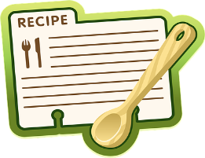
Soup Chef
Possible Ingredients:  - carrots  - peas  - potatoes  - celery  - tomatoes  - green peppers  - onions | Our class is making soup in a pot that holds two gallons. The pot already contains 8 cups of broth.  We want to make a soup that has:  - 3 times the amount of carrots as celery  - 4 times the amount of potatoes as celery  Create a recipe using the possible ingredients. Show your work using models and equations with a symbol for the unknown.

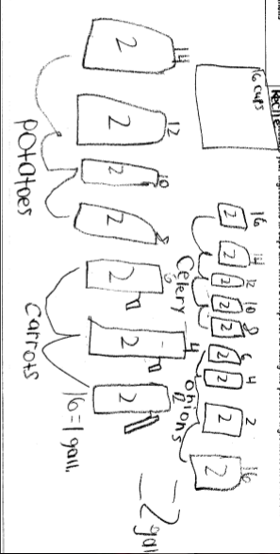
Scoring Examples

Not Yet: The student was unsuccessful in attempting to use an additive strategy. The student correctly combines the ingredients to create a recipe with 32 cups (2 gallons), but does not consider the 8 cups of broth already in the pot. Additionally, the student does not correctly relate the amount of the carrots and potatoes to the amount of celery – either multiplicatively or additively.

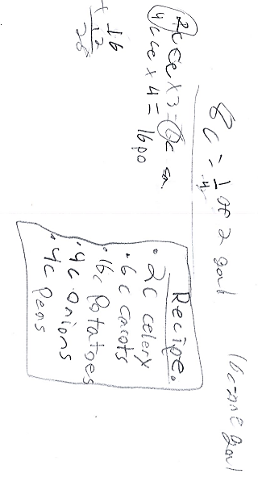

Progressing: The student was able to solve parts of the problem correctly. The student correctly determined the amount of carrots – showing the multiplicative comparison between the celery and the carrots with an equation. However, the student incorrectly determined the amount of potatoes for the soup. The student created a soup recipe, but did not follow the guidelines by including the 8 cups of broth in the recipe. The student is progressing - showing some levels of understanding multiplicative comparisons.

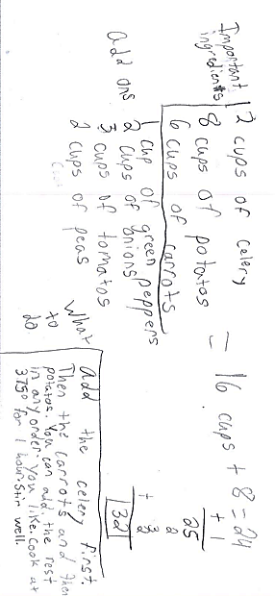

Meets Expectation: The student correctly solved the problem using a model and an equation with a symbol for the unknown to demonstrate the multiplicative comparisons. The student used the multiplicative comparisons to create a recipe with 32 cups of ingredients (including 8 cups of broth).
