NC.4.OA.1
Threatened and Endangered
Domain | Operations and Algebraic Thinking
Cluster | Represent and solve problems involving multiplication and division.
Standard(s) | NC.4.OA.1 Interpret a multiplication equation as a comparison. Multiply or divide to solve word problems involving multiplicative comparisons using models and equations with a symbol for the unknown number. Distinguish multiplicative comparison from additive comparison.
Materials | activity sheet, pencil
Task | Threatened and Endangered  Maned wolves are a threatened species that live in South America. People estimate that there are about 24,000 of them living in the wild.  The dhole is an endangered species that lives in Asia. People estimate there are ten times as many maned wolves as dholes living in the wild.  About how many dholes are there living in the wild?  Show your thinking with a model and an equation with a symbol for the unknown.  More Information that can be used to peak interest in the task:  - Maned Wolves: https://nationalzoo.si.edu/animals/maned-wolf  - Dhole: http://animals.sandiegozoo.org/animals/dhole  Videos:  - Maned Wolves https://www.youtube.com/watch?v=Vn9Hj23ggjA  - Dhole: https://www.youtube.com/watch?v=eXHGlhrfLbQ  *Adapted from Illustrative Mathematics: https://goo.gl/D2Eux8

Rubric
Level I  Not Yet | Level II  Progressing | Level III  Meets Expectation
The student does not correctly show multiplicative comparison using multiplication or division.  OR  The student relies on the assistance of teachers and other students to understand and complete the task.  OR  The student incorrectly uses additive comparison. | Multiplies or divides to interpret a multiplication equation as a comparison by correctly using one of the following:  - model(s)  - equation(s) with a symbol for the unknown  OR  Inconsistently demonstrates conceptual understanding of multiplicative comparison situations.  OR  Uses an additive strategy to correctly interpret a multiplication equation. | Multiplies or divides to interpret a multiplication equation as a comparison by consistently and correctly using both of the following:  - model(s)  - equation(s) with a symbol for the unknown

Standards for Mathematical Practice
1. Makes sense and perseveres in solving problems.
2. Reasons abstractly and quantitatively.
3. Constructs viable arguments and critiques the reasoning of others.
4. Models with mathematics.
5. Uses appropriate tools strategically.
6. Attends to precision.
7. Looks for and makes use of structure.
8. Looks for and expresses regularity in repeated reasoning.

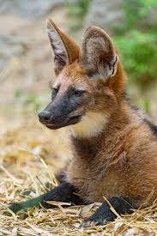
Threatened and Endangered

Maned wolves are a threatened species that live in South America. People estimate that there are about 24,000 of them living in the wild.
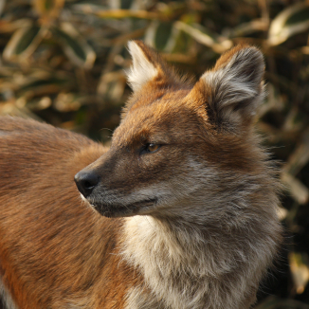

The dhole is an endangered species that lives in Asia. People estimate there are ten times as many maned wolves as dholes living in the wild.

About how many dholes are there living in the wild?
Show your thinking using a model and an equation with a symbol for the unknown.

Scoring Examples

Not Yet: This student incorrectly used subtraction to solve the problem and did not show a multiplicative relationship.
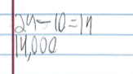

Progressing: This student incorrectly used multiplicative comparison to solve the problem.
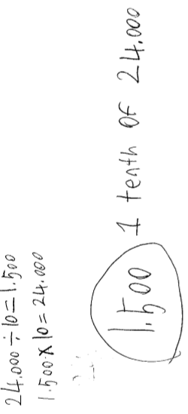

Meets Expectation: This student used both models and an equation with a symbol for the unknown to correctly show the multiplicative relationship in the problem.
