Making Connections to Subtraction Algorithms
NC.4.NBT.4

This document is intended to help teachers and parents understand the strategies students use to subtract multi-digit numbers. These strategies allow students to mentally compute differences and better understand the standard subtraction algorithm, which they are expected to learn in fourth grade. It is important for students to understand that our standard algorithm is based on place value and that each step relates to the value of the digits. Students should be able to utilize the strategies below as they solve computation problems.
Adding Up  Students add up from the subtrahend (number being subtracted) to the minuend (the whole). This strategy builds on student’s early understandings of addition.  Examples:  123 – 59 = ?  +1 + 40 + 23  59 60 100 123  The number line illustrates how this student chose to add up to find the difference. Notice how the student added up to friendly numbers. The numbers above the number line show the total difference between 59 and 123. A student could also keep track of how they added up using equations:  59 + 1 = 60  60 + 40 = 100  100 + 23 = 123  1 + 40 + 23 = 64  It is also easy to “Add Up” with larger numbers. See below for example with 7,000 – 5,945:  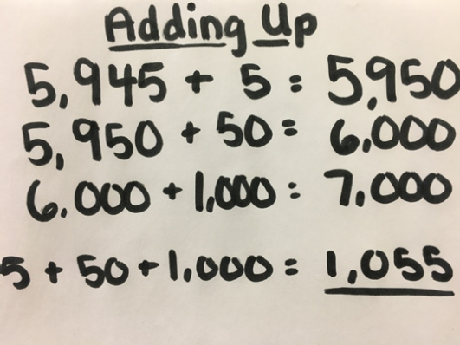 | Removal/Counting Back  Starting with the minuend, or whole number, students will decompose the subtrahend (number being subtracted) into friendly numbers (often by place values). Finally, they subtract each part - one step at a time.  Example:  123 – 59 = ?  123 – (10 + 10 + 10 + 10 + 10 + 3 + 6) = ?  123 – 10 = 113  113 – 10 = 103  103 – 10 = 93  93 – 10 = 83  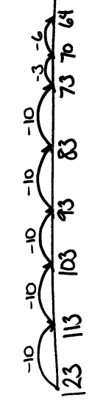  83 – 10 = 73  73 – 3 = 70  70 – 6 = 64  Students having trouble with this strategy can use an open number line to help them model each step.  While this looks like a lot of steps, it is often easier for a student to subtract groups of ten before subtracting larger groups. Eventually, students are ready for more sophisticated subtraction chunks like:  123 – 20 = 103 (39 left to subtract)  103 – 33 = 70 (6 left to subtract)  70 – 6 = 64  *As students become more flexible with their subtraction chunks, their number sense improves.
Keeping a Constant Difference  Adding or subtracting the same quantity from both the subtrahend and the minuend maintains the difference between the numbers. The friendly numbers make it easier to subtract.  Examples:  123 – 59 = ?  123 + 1 = 124  - + 1 = 60  - - 60 = 64  *Adding one to each number keeps the distance between the numbers the same so the answer will be the same.  7,000 – 5,945 = ?  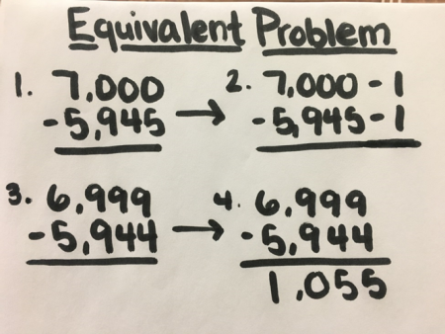  *Subtracting one from each number keeps the difference the same so the answer will be same. | Adjusting One Number to Create an Easier Problem  In this strategy, students adjust only one of the numbers. Students will need to decide which number will be the most helpful to adjust.  Examples:  123 – 59 = ?  123 123  - 59 + 1 = - 60  63 + 1 = 64  *Since one extra was subtracted, one had to be added back to the answer. (If you had 123 apples and you took 60 away, but you only meant to take 59, you have to give one apple back.)  7,000 – 5,945 = ?  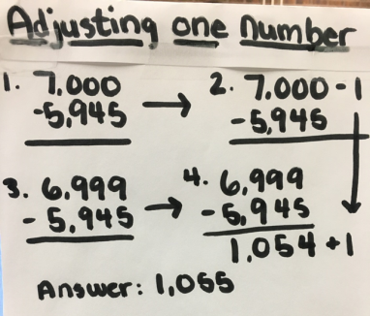  *Since the total was adjusted by subtracting one, that one had to be given back at the end.
Standard Algorithm

Students will use their conceptual understanding of subtraction and place value to move to the standard algorithm to solve subtraction problems. In the standard subtraction algorithm, students rename or regroup the numbers in order to make it easier to subtract. This method can be efficient for subtracting larger numbers and is easier when recorded on paper and pencil. It is critical for students to understand the steps involved so they do not make errors.
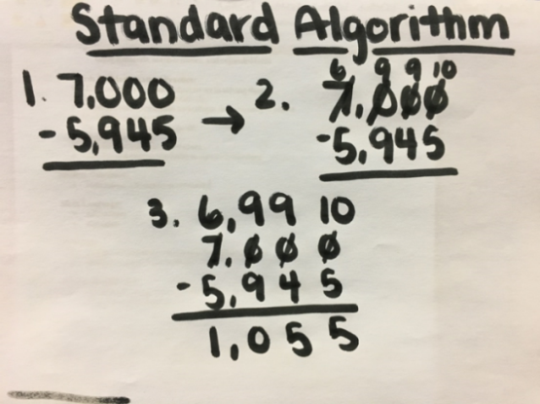
Example:
11 13
123
- 59
64
Students need to understand they are renaming 123 when they subtract. The 123 becomes 11 tens or 110 and 13 ones so 9 can be taken from the 13 and 50 from the 110. 123 is equal to 110 + 13. Understanding place value is the key to mastering this method.
7,000 is regrouped into 6990 and 10 to make it easier to subtract 5,945

