Addition Algorithm
In this lesson, students apply their knowledge of place value to add whole numbers using the standard algorithm.

NC Mathematics Standard:
Number and Operations in Base Ten
NC.4.NBT.4 Add and subtract multi-digit whole numbers up to and including 100,000 using the standard algorithm with place value understanding.

Standards for Mathematical Practice:
1. Make sense of problems and persevere in solving them.
2. Reason abstractly and quantitatively.
3. Construct viable arguments and critique the reasoning of others.
4. Model with mathematics.
6. Attend to precision.
7. Look for and make use of structure.

Student Outcomes:
- I can add multi-digit whole numbers.
- I can use the standard addition algorithm to solve multi-digit addition problems.

Math Language:
- add
- standard algorithm
- sum
- expanded form
- place value

Materials:
- poster paper/markers for anchor chart
- index cards

Launch:
- Introduce Problem (5 minutes)
Give students the following problem.
In her spare time, Mikala babysits to earn extra money. After two months, Mikala saved $237 from babysitting. She opened her own bank account and deposited the money she earned. Throughout the year, Mikala deposited $656 into the account. How much money did she have in the bank at the end of the year?

Read the problem aloud to students and ask some probing questions.
    - What’s happening in the problem?
    - How do you visualize what is happening in the problem?
Tell students to solve the problem in as many ways as they can with the time provided.
Explore:
- Solving the Problem (10 – 15 minutes)
Allow students time to work individually to solve the problem. As students work, observe students to see how they are solving the task. Encourage students to solve the problem as many ways as they can.
Observe:
  - How are students solving the problem?
  - How do students make sense of the question?
  - What strategies do students use to solve the problem? (number lines, adding by place value, making friendly numbers, standard algorithm, etc.)

Carefully select students to present to the class. Look for students to share different ways of solving the problem using addition. Look for a variety of strategies from the list above and others if needed.

Discussion #1:
- Discussion of Strategies (20 – 30 minutes)
Bring the group back together and have selected students share their method for solving the problem. For the discussion, have a progression of students share their strategies – for example, start with making friendly numbers and end with decomposing by place value. Make an anchor chart of the various strategies, leaving enough room for the standard algorithm. End with decomposing by place value in order to lead into the discussion on how to solve the problem using the standard algorithm.

Possible points to address and questions to ask:
- Discuss how students solved the problem and how it relates to addition.
- Encourage students to ask questions about the strategies shared.
- Discuss how the strategies relate to each other. How are the strategies alike? How are the strategies different? What do the strategies have in common?

Discussion #2:
4. Discussion of Decomposing by Place Value to the Standard Addition Algorithm
Have a student share their place value strategy. Discuss how the decomposed numbers are connected to the original numbers. Use this strategy to introduce the standard algorithm --discussing how we can use place value to help us solve addition problems.
- “Today we are going to focus on the standard algorithm for addition. This algorithm is a clear and concise way to solve problems.”
- “In the standard algorithm, you start with the ones place. Align the place values vertically so that each place value is in a row. (If students need help lining the numbers up, give them graph paper.) Next, put the numbers into expanded form.

Step 1:
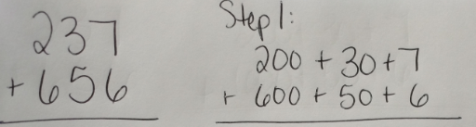
“We are going to start with the ones place. We can add 7 and 6 which is 13. We regroup 13 into tens and ones – 1 ten and 3 ones. We leave the 3 in the ones place and carry the 10 to the tens place. Then we add the tens place, 10 + 30 + 50 is 90. Then, we add the hundreds place, 200 + 600 is 800. Add the answers together, 800 + 90 + 3 = 893.”

Step 2: 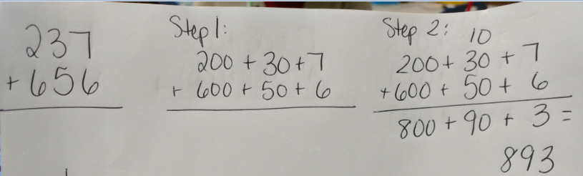

“When using the standard algorithm, people use what is called shorthand notation, instead of writing it out into expanded form.” Write the algorithm on the board and discuss each of the steps and show the shorthand notation.

“I start with the ones place. I add 7 and 6 which is 13. I regroup the 10 from the 13 over to the tens place representing it with a 1 above the tens place. I keep the 3 in the ones place. Next, I add all the numbers in the tens place, 1 ten and 3 tens and 5 tens which is 9 tens – 10, 30, 50 = 90. Finally, I add all the numbers in the hundreds place, 2 hundreds and 6 hundreds which is 8 hundreds.”

Questions to ask when modeling the standard algorithm:
  - What is the value of the 3 in the problem?
  - What is the value of the 9 in the problem?
  - What is the value of the 8 in the problem?
  - What does the 1 above the tens place represent?

Step 3:
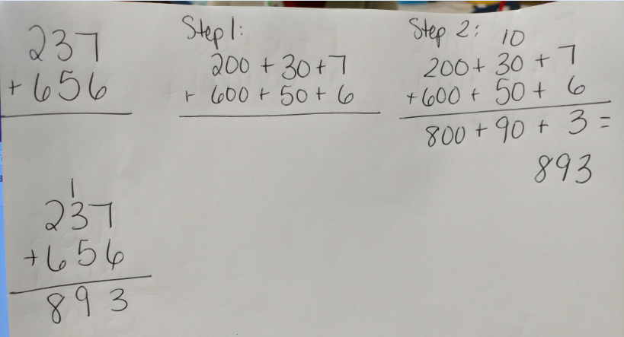

Do a few more problems together and then allow students to work on their own to solve the problems. Instruct students to display the expanded form of each number and then use the standard algorithm.
- 721 + 598 =
- 3,867 + 1,655=

Give students a few more problems to help them practice.
- 429 + 251 =
- 1,846 + 1,499 =
- 572 + 172 =
- 638 + 249 =

At the end of the lesson, discuss any challenges that students are having as they add the numbers. Return to the learning targets to summarize the lesson.

Evaluation of Student Understanding:
Informal Evaluation:
- Observe students to see how they are solving the addition problems. Consider: Can students solve an addition problem using various strategies? Do students have a range of strategies they can use to solve? Do students understand why the standard algorithm works? Can students use expanded form to help them better understand the standard algorithm?
Formal Evaluation/Exit Ticket:
- Use “My Favorite No” to close the lesson (My Favorite No: https://www.youtube.com/watch?v=srJWx7P6uLE). Give students the following problem: 768 + 479 = ______. Give students an index card and have them solve the problem using the standard algorithm. Collect the index cards and separate them into two piles: right and wrong. You might even want to rank your wrongs into really wrong and almost there. This will better help you select your favorite wrong answer. Choose your favorite wrong answer. Rewrite the wrong answer on the board. Begin by discussing what the student did correctly (celebrations). Next, have students analyze what the student did wrong and how they would fix it. Be sure to have students explain why. You can do multiple problems if you would like.

Meeting the Needs of the Range of Learners:
Interventions:
- If students are struggling with algorithm, continue to have them break apart into expanded form.
Extensions:
- Encourage students to attempt to use the standard algorithm with larger numbers.

Possible Misconceptions/Suggestions:
Possible Misconceptions | Suggestions
- Students are struggling with any addition strategy.  - Students are struggling with the standard algorithm. | - What have you learned in a previous grade that might be able to help you? Could you break apart or decompose the numbers? Think about place value.  - Continue to have students use expanded form. Don’t push them to use the algorithm until they are comfortable with expanded form. You might want to pull students into small groups to work on the standard algorithm. (The exit ticket will help you know who to pull.)

*Adapted from: Pearson’s Investigations in Number, Data, and Space - Unit 5: Landmarks and Large Numbers (second edition).

