Building 10,000
In this lesson, students will use base-ten blocks to build models of numbers including 10,000. The intention is to help students understand our base-ten place value system and explain that a digit in the ones place represents 10 times as much as it represents in the place to its right.

NC Mathematics Standards:
Number and Operations in Base Ten
NC.4.NBT.1 Explain that in a multi-digit whole number, a digit in the one place represents 10 times as much as it represents in the place to its right, up to 100,000.

Standards for Mathematical Practice:
2. Reason abstractly and quantitatively.
- Attend to precision.
- Look for and make use of structure.

Student Outcomes:
      - I can use models to reason about place value.
      - I can build numbers using place value.

Materials:
- Base ten blocks - enough to build ten 1000 cubes (If you don’t have enough, use square boxes (such as tissue boxes) or make tagboard 1000 cubes.)
- Paper copies of 100 flats to cover faces of the boxes (optional)

Advance Preparation:
      - Gather base ten blocks, enough for groups of 4 to have:
        - ten units (ones), ten rods (tens), ten flats (100), and one cube (1000)
- Gather at least ten 1000 cubes or materials to build 1000 cubes

Directions:
- Begin with a class discussion to review the base ten blocks.
Provide each student with a unit cube and have them discuss the value and shape of the block. Give students a ten rod and have students to discuss the shape and determine how many unit cubes it takes to make a rod. Record pictures as well as student responses on the board or on an anchor chart.
Possible responses: The unit cube has a value of 1 and is in the shape of a cube.
It takes 10 cubes to make a rod. The shape is a long rod. Ten unit cubes have been stacked to form the ten rod. 10 ones, 1 + 1 + 1 + 1 + 1 + 1 + 1 + 1 + 1 + 1 = 10, 10 × 1 = 10
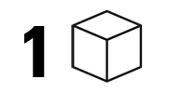
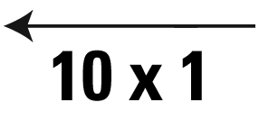
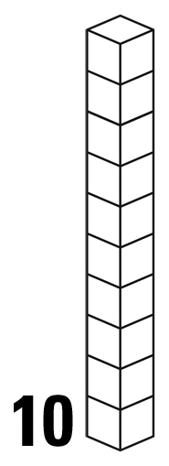

- Provide students with a 100 flat. Have students talk about the shape and value of the flat. Continue to record student responses. Possible responses: It forms a square. It takes ten rods to make a flat. 10 groups of 10 rods = 100 flat, 10 × 10 = 100
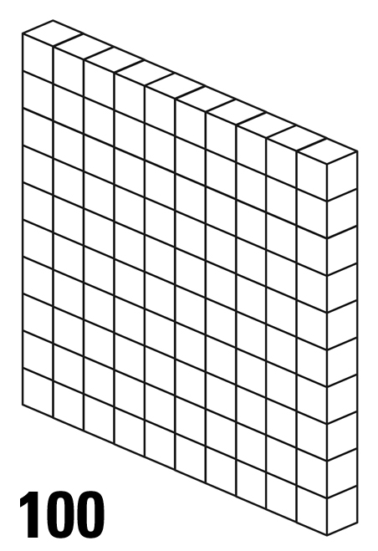
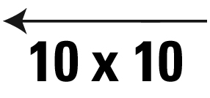
- Review the shapes (cube, long, square) and numbers (1, 10, 100). Instruct table groups to prove the relationships between the numbers and the shapes. For example, students may show that ten 1s is also one 10 by setting up ten 1s on top of a long or by placing ten 1s beside a tens rod. They may place ten longs on top of one flat to show that ten 10s equals 100 flat. Stress the use of the language - “ten 1s times 10 is one 10 or 10 x 1 = 10”, “ten 10s times 10 is one hundred or 10 x 10 = 100”.
- Ask students to predict what would come next. After students say 1000 or ten 100s, instruct them to build 1000 using the base ten blocks. Students may build ten 100s with ten flats by stacking them on top to make a cube or they may lay them out next to one another. Students may also try to build 1000 using rods or unit cubes.
- Once groups have made 1000, bring the class back to look at the structure and pattern of the numbers that have been written on the board. Use a student example of ten 100s stacked to make a cube. Introduce the 1000 cube base-ten block. Draw attention to the shape structure: cube, long, flat, cube. With every three places, the shapes repeat. Each cube represents a 1, and each long represents a 10, and each flat represents a 100.
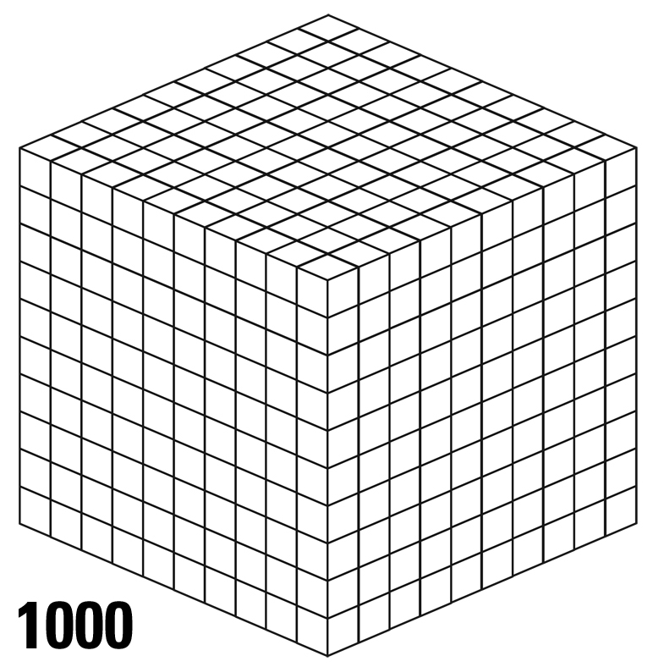
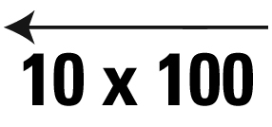
- Have students discuss what comes next. Emphasize the patterns they see. Once students agree that ten × 1000 comes next and it could be a long, have students discuss how the class could build 10,000.
  - Students could use ten 1000 cubes.
  - Students could use base-ten 1000 cubes along with thousand cubes made from 100 flats.
  - Students could make a 1000 cube model from a square tissue box, gluing a paper copy of a flat on each face of the cube. Then put 10 together.
  - Students could make a 1000 cube model from cutting poster board, gluing a paper copy of a flat on each face of the cube.
  - Students could use a combination of the techniques listed above.

- Once students have built 10,000, they arrange the cubes side by side to form a long strip of cubes or stack them on top of each other.
- Ask, “What comes next?” When students discover it is ten × 10,000 and the shape is a square, discuss how the class could build 100,000.
- Students could measure the length of the 10,000 model. Using string or something similar, students mark off a square that would represent the 100,000 model. (Building the 100,000 model is optional.)
- To conclude, the class will discuss connections to the size and magnitude of each model. See questions below.

Questions to Pose:
As students are working:
      - How does the long (10) relate to flat (100)?
      - What patterns or structure do you notice?
      - How would knowing the structure of number help you?
      - What is the relationship in size between the long (10,000) and the flat (100)?
      - What have you learned from building these numbers?

Extensions:
      - Students can build 1000s by making ten 100s charts and taping together. How many 1000 strips would be needed to make 10,000? How about 100,000? What would come next? How could we build the next number?
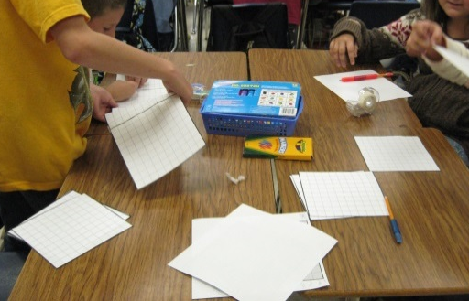

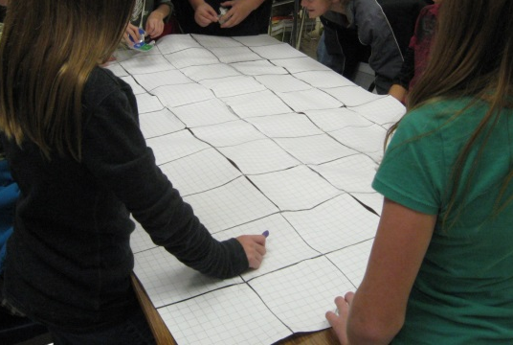

      - Make the connection between the models and the place value chart.
      - Use Arrow cards to build numbers:
http://www.educationworld.com/a_curr/Teaching-Place-Value-With-Arrow-Cards.shtml

Possible Misconceptions/Suggestions:
Possible Misconceptions | Suggestions
Students have difficulty understanding a digit in the ones place represents ten times what it represents in the place to its right. | Students work with models to build numbers.  Example: 20 = 2 x 10 Build a set of 2 and repeat it 10 times. Continue with 200. Build a set of 20 and repeat it 10 times.

Special Notes:
      - This lesson could go over two days.

Solutions: N/A

*Adapted from: Teaching Student-Centered Mathematics Grades 3-5 Van de Walle and Lovin (2006)

