North Carolina Rivers
In this lesson, students have the opportunity to apply their understanding of place value as they evaluate the lengths of North Carolina Rivers. This lesson focuses particularly on the understanding that “a digit in one place represents 10 times as much as it represents in the place to its right”.

NC Mathematics Standards:
Numbers and Operations in Base Ten
NC.4.NBT.1 Explain that in a multi-digit whole number, a digit in one place represents 10 times as much as it represents in the place to its right, up to 100,000.

Supporting Standard:
Numbers and Operations in Base Ten
NC.4.NBT.2 Read and write multi-digit numbers up to and including 100,000 using numerals,
number names, and expanded form.

Standards for Mathematical Practice:
1. Make sense of problems and persevere in solving them.
2. Reason abstractly and quantitatively.
3. Construct viable arguments and critique the reasoning of others.
7. Look for and make use of structure.
8. Look for and express regularity in repeated reasoning.

Student Outcomes:
- I can understand the value of digits in multi-digit whole numbers.
- I can prove that a digit in one place represents 10 times as much as it represents in the place to its right.

Math Language:
- ten times as much
- digit
- value
- equivalent
- place value

Materials:
- pictures of North Carolina rivers (Cape Fear River, New River, Pee Dee River, Dan River, Roanoke River, Neuse River)
- North Carolina Map
- student handouts
  - North Carolina Rivers (1 per student)
  - North Carolina Rivers – Exit Ticket (1 per student)

Advance Preparation:
- Collect pictures of North Carolina rivers to show students
- Make copies of the student handouts – North Carolina Rivers and Exit Ticket (1 per student)

Launch:
- Introduce Problem (5 minutes)
Ask students if they have ever been to a North Carolina river. What did they do on the river? (swimming, tubing, rafting, fishing, kayaking, boating, etc.) Show students different North Carolina Rivers and where they are located on a map of North Carolina.

Give each student a handout. Explain to students that the chart includes the lengths of six different rivers located in North Carolina. Instruct students to use the lengths of the rivers to complete the questions on the handout.

Explore:
- Solving the Problem (15 – 20 minutes)
Allow students time to work individually and then with partners in order to solve the task. As students work, observe students to see how they are solving the task. Encourage students to share their strategies with one another and describe how they are answering each question.
Observe:
  - How are students organizing and representing their thinking?
  - How do students make sense of the numbers?
  - How do students understand the value of each number?
  - How do students model their thinking?
Have students write the value of each number to show their thinking and understanding of the task.

Discuss:
- Discussion of Solutions (15 – 25 minutes)
Bring the group back together and have selected students share their strategies for solving the task. Have students identify what they notice about the numbers.
- How do you know one number is ten times as much as another?
- How do you know that those numbers will always be ten times as much?
- What about numbers that are 100 times as much?
- How do you know the numbers are that much more?
- What rule could you apply to these scenarios?
- Why is it important to understand that hundreds place is ten times more than the tens place?
- Does this rule always hold true? (Example: If there is a 2 in the tens place and a 4 in the hundreds place, is the hundreds place ten times more than the tens?)
- Why is it important to understand place value? How does understanding place value help with this task?

Close the lesson by having each student give a statement that tells one thing they’ve learned from today’s lesson. Give each student the North Carolina Rivers – Exit Ticket to complete.

Evaluation of Student Understanding:
Informal Evaluation:
- Observe and monitor students as they solve the problem. How are they making sense of the problems? Are they persevering in solving the problem? Are they reasoning abstractly and quantitatively about the problem? What do students understand about place value?
Formal Evaluation/Exit Ticket:
- At the end of the lesson, give students the North Carolina Rivers – Exit Ticket that includes multiple choice questions to assess their knowledge and understanding of the task.

Meeting the Needs of the Range of Learners:
Interventions:
- Suggest that students use models such as place value blocks to help them see the difference in lengths of the rivers.
- Create a class chart to help students understand each place and value.
- Have students write the numbers in expanded form to help them understand the concept of the place value.
Extensions:
- Have students write down the value for each river to show understanding.
- Have students create their own questions modeled after the tasks questions.

Possible Misconceptions/Suggestions:
Possible Misconceptions | Suggestions
- Student does not understand the problem.  - Student feels that ‘ten times as much’ means to add ten more to the current number; and vice versa with ten times less.  - Student does not understand that each individual number holds a separate value (ex: 231, the 2 is worth 200.) | - Have students model the problem with:  - Place value blocks  - Place value mats  - Expanded form  - Calculators

Possible Solutions:
See Answer Keys at the end.

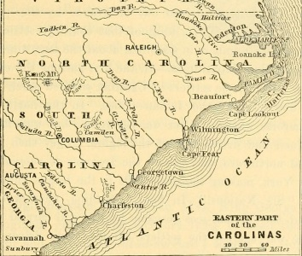
North Carolina Rivers
Name of River | Cape Fear River | New River | Pee Dee River | Dan River | Roanoke River | Neuse River
Length in Miles | 203 | 320 | 232 | 214 | 410 | 275
The chart includes the lengths of six different rivers in North Carolina. Use the lengths of the rivers to complete the questions below.

1. The value of the 2 in the Dan River’s length is ten times the value of the 2 in the _______________________’s length.
2. The value of the 3 in the _________________________’s length is ten times the value of the 3 in the Cape Fear’s length.
3. The value of the _____ in the Dan River’s length is hundred times the value of the same digit in the Roanoke’s length.
4. The value of the ____ in the Cape Fear’s river is ten times more than the value of the same digit in the New River.
5. The value of the 2 in the New River is ten times less than the value of the 2 in the ________________ River.
6. Which of the expressions below is equivalent to the value of the 4 in the length of the Roanoke River? Place a √ next to all that apply.

_____ 400 x 10 _____ 4,000 x 10 ____ 4 x 100
_____ 40 x 10 _____ 400 ÷ 10 _____ 4,000 ÷ 10

7. Circle each length that has a 7 that is worth ten times as much as the 7 in the Neuse River’s length.
26,175 miles 9,762 miles 67,582 miles 6,719 miles 40,678 miles

North Carolina Rivers – Exit Ticket
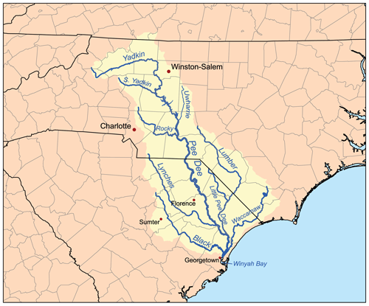
Solve the following multiple choice problems using the chart below.
River | Length in Kilometers
Catawba River | 350 km
Tar River | 346 km
Dan River | 344 km
French Broad River | 343 km
Roanoke River | 660 km

1. Which of the following rivers has a digit that has ten times the value of a digit in the Tar River?
A. Dan River
B. Roanoke River
C. Catawba River
D. French Broad River

2. Which of the following rivers has a digit that is ten times less than the same digit in the Tar River?
A. Catawba River
B. Dan River
C. Roanoke River
D. French Broad River

Answer Key:
North Carolina Rivers
Name of River | Cape Fear River | New River | Pee Dee River | Dan River | Roanoke River | Neuse River
Length in Miles | 203 | 320 | 232 | 214 | 410 | 275
The chart includes the lengths of six different rivers in North Carolina. Use the lengths of the rivers to complete the questions below.

1. The value of the 2 in the Dan River’s length is ten times the value of the 2 in the New River’s length.
2. The value of the 3 in the Pee Dee River’s length is ten times the value of the 3 in the Cape Fear’s length.
3. The value of the 4 in the Dan River’s length is hundred times the value of the same digit in the Roanoke’s length.
4. The value of the 2 in the Cape Fear’s river is ten times more than the value of the same digit in the New River.
5. The value of the 3 in the Pee Dee River is ten times less than the value of the 3 in the New River.
6. Which of the expressions below is equivalent to the value of the 4 in the length of the Roanoke River? Place a √ next to all that apply.

_____ 400 x 10 _____ 4,000 x 10 __√__ 4 x 100
__√___ 40 x 10 _____ 400 ÷ 10 __√___ 4,000 ÷ 10

7. Circle each length that has a 7 that is worth ten times as much as the 7 in the Neuse River’s length.
26,175 miles 9,762 miles 67,582 miles 6,719 miles 40,678 miles

Answer Key:
North Carolina Rivers – Exit Ticket
Solve the following multiple choice problems using the chart below.
River | Length in Kilometers
Catawba River | 350 km
Tar River | 346 km
Dan River | 344 km
French Broad River | 343 km
Roanoke River | 660 km

1. Which of the following rivers has a digit that has ten times the value of a digit in the Tar River?
A. Dan River
B. Roanoke River
C. Catawba River
D. French Broad River

2. Which of the following rivers has a digit that is ten times less than the same digit in the Tar River?
A. Catawba River
B. Dan River
C. Roanoke River
D. French Broad River

