Kindergarten Cluster 2
Additional Resources
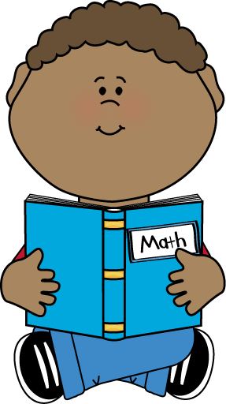

Videos to Share with Parents and Colleagues
- Speed is not Important by You Cubed
- The Progression of Early Number and Counting by Graham Fletcher

Videos to Share with Students
- Numeral Song by Dr. Jean
- Count to 20 by Pick Pride
- Number Rock by Greg and Steve
- Count to 20 and Workout by Jack Hartmann
- How many apples? bananas? by English Sing Sing
- Sorting Shapes by Sesame Street

Children’s Literature
- Chicka Chicka 1, 2, 3 by Bill Martin, Jr.
- Ten Little Fish by Audrey Wood
- Ten Black Dots by Donald Crews
- Ten Red Apples by Pat Hutchins
- Ten Apples Up on Top by Dr. Seuss
- Quack and Count by Keith Baker
- Fish Eyes: A Book You Can Count On by Lois Ehlert
- Counting Crocodiles by Judy Sierra

Additional Resources
- Shape sort by Star Fall
- Counting Games by ABCya

Clipart by My Cute Graphics

