Find the Difference
In this lesson students use the open number and various strategies to solve two-step story problems.

NC Mathematics Standard(s):
Represent and solve problems.
NC.2.OA.1 Represent and solve addition and subtraction word problems, within 100, with unknowns in all positions, by using representations and equations with a symbol for the unknown number to represent the problem, when solving:
  - One-Step problems:
    - Add to/Take from-Start Unknown
    - Compare-Bigger Unknown
    - Compare-Smaller Unknown
  - Two-Step problems involving single digits:
    - Add to/Take from- Change Unknown
    - Add to/Take From- Result Unknown

Use place value understanding and properties of operations.
NC.2.NBT.7 Add and subtract, within 1,000, relating the strategy to a written method, using:
- Concrete models or drawings
- Strategies based on place value
- Properties of operations
- Relationship between addition and subtraction

Additional/Supporting Standards:
Understand Place Value
NC.2.NBT.3 Read and write numbers, within 1,000, using base-ten numerals, number names, and expanded form.

Standards for Mathematical Practice:
- Make sense of problems and persevere in solving them.
3. Construct viable arguments and critique the reasoning of others
4. Model with mathematics
7. Look for and make use of structure.

Student Outcomes:
- I can apply place value understanding to add and subtract three-digit numbers.
- I can communicate my strategies to add and subtract three-digit numbers.

Math Language:
What words or phrases do I expect students to talk about during this lesson?
Addition, Count, Count On, Hundreds, Ones, Subtraction, Tens

Materials:
- Base Ten Blocks, Activity sheets

Advance Preparation:
- Gather materials

Launch:
Introducing Find the Difference (20-25 minutes)
Explain that today students will play a game that will give them practice finding the difference between 2 three-digit numbers. Demonstrate the game on the overhead or document camera. Directions for the game are at the end of this lesson.

Show the class the spinner. Spin the 3 spinners and record the 3-digit number. Spin the 3 spinners again and record the number.
Ask, “How can we use these two numbers in a subtraction equation?”

Have students share ideas.

Example:
If 782 and 439 were spun record, 782-439= __.
Ask, “What number story would match this equation? Turn to your partner and each of you share a story problem.” Give students 1-2 minutes to share stories. Bring the class back together and ask 2-3 students to share their story.

Ask, “Is there an addition equation we could use to solve this problem?” (439 + _____ = 782) Have both equations written on the board or overhead. Have students choose one of the equations (or both) and solve it on the paper or white boards
439 + ___ = 782 or 782-439 = ___
After most students have solved the equation have them turn to a partner and share their strategy. As the students are solving the equations and sharing with partners, walk around the class. Look for strategies you want shared with the entire class. Examples, strategies that:
- use place value
- are efficient
- generalizable strategies that will work in other problems
- two strategies that look different in appearance but mathematically are the same.

  - For example, 782 - 439
782 - 400 = 382
382 - 30 = 352
352 - 2 = 350
350 - 7 = 343
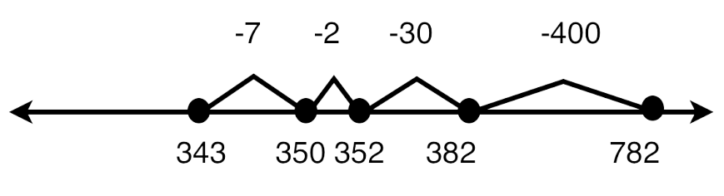
During the discussion make sure the use of place value to solve the problem is made explicit. When looking at two strategies, ask, “How are these strategies alike? How are they different?”

Explore
Play Find the Difference (17-20 minutes)
To model how to play the game Find the Difference, divide the class into two teams. Have a student from team 1 spin two, three-digit numbers.
Have a student from team 2 spin two, three-digit numbers.

Have every student record their numbers to represent the problem, and solve the problem. Students can solve the equation with a partner or independently. After solving the problem, share with another team member to see if each got the same answer and to compare strategies.

After most students have solved the problem, bring the class back together. Record the problems on the recording sheet and compare answers. The team with the largest difference receives a point. Continue to play several rounds.

Discuss
Discussion of the Game Find the Difference (10-12 minutes)
Bring the class back together to discuss the game and strategies that were used to solve the problem. During the discussion highlight strategies with a special focus on:
  - whether students subtracted or added up
  - how students broke numbers up by place value
  - mental math strategies that students used
Another point to emphasize is the relationship between addition and subtraction. Ask, “What two different equations to solve this problem?”
439 + = 782 or 782 - 439 = ___

Ask, “Why can I write 2 different equations for this one problem?”
Students should be able to discuss how a subtraction problem (782-439=_) is the same as a missing addend addition problem (439+_=782). This is introduced in First Grade in the Common Core Standards and should also be emphasized during the Second Grade.

Additional Activities (20-30 minutes)
Write a Story Problem
Give students 2 three-digit numbers. Students need to write:
- A subtraction or missing addend equation and a story problem

Students should then solve the task in two different ways. Collect this to evaluate students’ progress. As students work ask them to explain their strategies. Also, feel free to pull a small group of students to provide more support during this activity.

Beat the Calculator
Introduce the game, “Beat the Calculator.” The rules and cards are attached to this game.
Students solve the problems mentally and with a calculator. Play the game with the class. One side of the class can solve the problem mentally and the other side solves the problem with a calculator. Do this several times, switching sides for using the calculator and mentally solving the problems.

After several rounds ask, “What does this game help you do?” :
- Solve problems mentally.
- Practice using a calculator.
- Find easy numbers to solve first. Example in 8 + 6 + 2 the students may see that adding 8 + 2 first makes a 10 and then adding the 6 is easier.

Ask, “How do these problems relate to two-step story problems?”
After the class has worked together to solve the problems tell them that they will play the game with a partner tomorrow. This game should be played repeatedly during class time.

Building Three-Digit Numbers
Give students primary number cards and base ten blocks. Students pick two number cards and make a two-digit number: a 5, a 4, and a 3 could be 543, 534 or other possible numbers. Students then build those three-digit numbers with base ten blocks, record the number and a picture of the blocks. They continue to do this during the center.

Close to 100
Students need number cards. Each student starts with 7 number cards. Students select and 4 of their cards to make 2 2-digit numbers to get a sum that is as close to 100 as possible. Their score is the difference between their sum and 100. For example, if a student made the problem 54 + 48 they would have a sum of 102, which is 2 away from 100. So their score would be 2. The goal is to get the lowest score possible. After 5 rounds the one with the lowest score wins. The game can be repeated.

Moving on the Hundreds Board
Students need a hundreds board and number cards. Students pick a two-digit number. They then draw 2 number cards and make a 2-digit number. They have to determine how to move on the hundreds board to find the next 2-digit number.

Evaluation of Student Understanding
Informal: Make a chart (before the lesson) on observations.
Possible topics to place on the chart are:
  - Can a student accurately write an equation to represent a problem?
  - What strategies do student use to solve the problem?
  - What tools, models, or representations do students us to solve the problem? (cubes, drawing 100s, 10s, 1s, number line, numbers in a series of equations, other strategy)
  - Can you tell by looking at their work how the problem was solved? Make notes on the chart as you observe.
Formal: Examine student work for various strategies and correct answers.

Meeting the Needs of the Range of Learners
Intervention: Students who have difficulty working with 3-digit numbers can play the game using 2-digit numbers. Use the spinner board with tens and ones. Students can build numbers with base ten blocks and use them.

Extension: Write the scores of the two teams on the board and insert the correct sign ( <, >, = ) to show the relationship between the two numbers.
Example: 456 > 233. When pairs of students play, write the scores of the two players on the board and insert the correct sign ( <, >, = ) to show the relationship between the two numbers.
Example: 456 > 233. Use place value dice instead of the spinners to generate the numbers. Use the thousands cubes to generate 4-digit numbers. Have students solve each problem using two different strategies.

Possible Misconceptions/Suggestions:
Possible Misconceptions | Suggestions
Students may struggle subtracting. | Work with smaller numbers (50 or less) and provide them with base ten blocks or ten frame cards to support their work.
Students may struggle determining whether to add or subtract. | Students need concrete objects such as base ten blocks or ten strips. Use smaller numbers and have students discuss with classmates and you about the action of the problem to determine whether they should add or subtract.

Greatest Difference Wins

Materials

Spinner board—use transparent spinners placed over the paper spinners or place a brass fastener
through a ¼” length of drinking straw and a paperclip. Insert the brad and straw into the large end of the paperclip. Keep the straw and the paperclip on the brass fastener, insert it in the midpoint hole of the spinner. Then bend each side of the fastener flap against the underside of the board.
Recording sheet—students can record their equations and strategies on notebook paper, white boards or the recording sheet.

Directions

Partners can work together to solve these problems. This version of the game has no winner. They are just working together to solve problems.
Another version is that both players spin and generate 2, three-digit numbers and record their equations and strategies. The person with the larger difference is the winner of that round.
- One player spins the three spinners and records the number. For example, if 300, 40 and 2 were spun, record 342.
- The other player spins the three spinners again and records the number. For example, if 500, 30 and 1 were spun, record 531.
- Explain that their job is to find the difference between the two numbers, but first they have to record two different equations to show the problem. For example, the two equations students could record are 531 – 342 = ___ and 342 + ____ = 531.
- Players work to solve the problem two different ways. They could record their strategies using numbers, number lines, place value representations, etc.
- Use the recording sheet for documentation of student work. The students could also record the equations on notebook paper or white boards.

Extension: Choose one equation and write a story problem that matches the equation.

This game is adapted from The Math Learning Center, Bridges in Mathematics Grade 2 Supplement.

The Greatest Difference Wins Recording Sheet

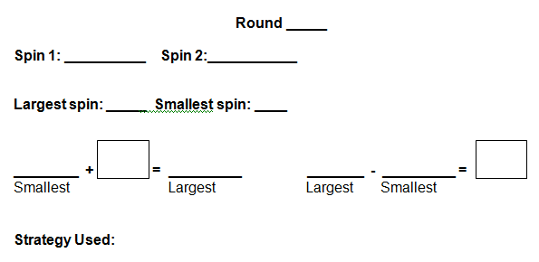

Spinners
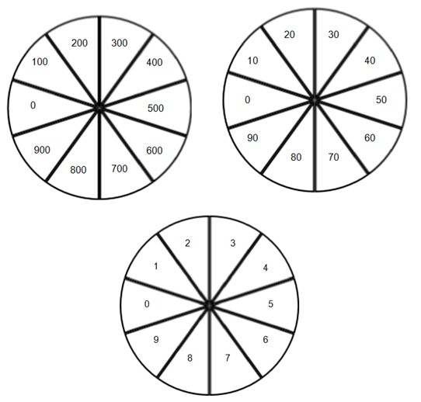

Hundreds Board
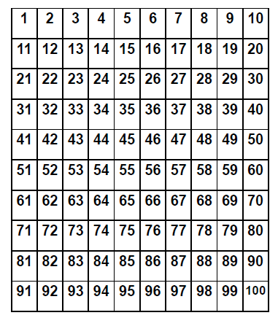

Glossary, Table 1. Common addition and subtraction situations.1
 | Result Unknown | Change Unknown | Start Unknown
 | Two bunnies sat on the grass. | Two bunnies were sitting on | Some bunnies were sitting on
 | Three more bunnies hopped | the grass. Some more | the grass. Three more
 | there. How many bunnies are | bunnies hopped there. Then | bunnies hopped there. Then
Add to | on the grass now? | there were five bunnies. | there were five bunnies. How
 | 2 + 3 = ? | How many bunnies hopped | many bunnies were on the
 |  | over to the first two? | grass before?
 |  | 2 + ? = 5 | ? + 3 = 5
 | Five apples were on the table. | Five apples were on the | Some apples were on the
 | I ate two apples. How many | table. I ate some apples. | table. I ate two apples. Then
Take from | apples are on the table now? 5 – 2 = ? | Then there were three apples. How many apples did | there were three apples. How many apples were on
 |  | I eat? | the table before?
 |  | 5 – ? = 3 | ? – 2 = 3
 | Total Unknown | Addend Unknown | Both Addends Unknown2
 | Three red apples and two | Five apples are on the table. | Grandma has five flowers.
 | green apples are on the table. | Three are red and the rest | How many can she put in her
Put Together/ Take Apart3 | How many apples are on the table?  3 + 2 = ? | are green. How many apples are green?  3 + ? = 5, 5 – 3 = ? | red vase and how many in her blue vase?  5 = 0 + 5, 5 = 5 + 0
 |  |  | 5 = 1 + 4, 5 = 4 + 1
 |  |  | 5 = 2 + 3, 5 = 3 + 2
 | Difference Unknown | Bigger Unknown | Smaller Unknown
 | (“How many more?” version): | (Version with “more”): | (Version with “more”):
 | Lucy has two apples. Julie has | Julie has three more apples | Julie has three more apples
 | five apples. How many more | than Lucy. Lucy has two | than Lucy. Julie has five
 | apples does Julie have than | apples. How many apples | apples. How many apples
 | Lucy? | does Julie have? | does Lucy have?
Compare4 | (“How many fewer?” version): | (Version with “fewer”): | (Version with “fewer”):
 | Lucy has two apples. Julie has | Lucy has 3 fewer apples than | Lucy has 3 fewer apples than
 | five apples. How many fewer | Julie. Lucy has two apples. | Julie. Julie has five apples.
 | apples does Lucy have than | How many apples does Julie | How many apples does Lucy
 | Julie? | have? | have?
 | 2 + ? = 5, 5 – 2 = ? | 2 + 3 = ?, 3 + 2 = ? | 5 – 3 = ?, ? + 3 = 5

2These take apart situations can be used to show all the decompositions of a given number. The associated
equations, which have the total on the left of the equal sign, help children understand that the = sign does not always mean makes or results in but always does mean is the same number as.
3Either addend can be unknown, so there are three variations of these problem situations. Both Addends Unknown
is a productive extension of this basic situation, especially for small numbers less than or equal to 10.
4For the Bigger Unknown or Smaller Unknown situations, one version directs the correct operation (the version
using more for the bigger unknown and using less for the smaller unknown). The other versions are more difficult.

1Adapted from Box 2-­‐4 of Mathematics Learning in Early Childhood, National Research Council (2009, pp. 32, 33).

Primary Number Cards

0 | 1 | 2 | 0 | 1 | 2
3 | 4 | 5 | 3 | 4 | 5
6 | 7 | 8 | 6 | 7 | 8
9 | 0 | 1 | 9 | 0 | 1
2 | 3 | 4 | 2 | 3 | 4

5 | 6 | 7 | 5 | 6 | 7
8 | 9 | 0 | 8 | 9 | 0
1 | 2 | 3 | 1 | 2 | 3
4 | 5 | 6 | 4 | 5 | 6
7 | 8 | 9 | 7 | 8 | 9

Beat the Calculator

Materials
- Calculator for each pair of students
- Deck of Beat the Calculator cards

Directions
- Partners play together.

- Turn over the top card in the deck.

- Player 1 solves the problem on the calculator and records the answer. Player 2 solves the problem mentally and records the answer.

- Players compare answers.

- Keep turning over the top card in the deck. Take turns using the calculator to solve the problem on the card.

Beat the Calculator Cards, Set 1

5 + 4 + 1 | 3 + 3 + 3 + 1
10 + 5 + 10 | 4 + 10 + 4 + 2
9 + 9 + 1 | 7 + 8 + 7
10 + 4 + 6 | 10 + 9 + 1 + 10
6 + 6 + 12 | 8 + 8 + 6 + 4

Beat the Calculator Cards, Set 2

6 + 4 + 1 | 4 + 4 + 4 + 4
13 + 2 + 10 | 12 + 12 + 1
8 + 7 + 5 | 18 + 2 + 10
10 + 5 + 6 | 10 + 8 + 1 + 10
3 + 3 + 12 | 7 + 8 + 3 + 4

Beat the Calculator Cards, Set 3

5 + 5 + 1 + 1 | 8 + 4 + 2 + 1
14 + 6 + 10 | 5 + 10 + 5 + 2
19 + 9 + 1 | 17 + 3 + 7
11 + 9 + 6 | 9 + 1 + 10
16 + 4 + 12 | 18 + 18 + 2 + 2

Beat the Calculator Cards, Set 4

10 - 4 + 1 | 3 - 3 + 3 + 1
10 - 5 + 10 | 4 + 10 - 4 + 2
9 - 9 + 1 | 7 + 8 - 7
8 + 4 - 6 | 10 + 9 - 1 + 10
6 - 6 + 12 | 18 - 8 + 6 + 4

