NC.4.NBT.7
Candy Warehouse
Domain | Number and Operations in Base Ten
Cluster | Generalize place value understanding for multi-digit whole numbers.
Standard(s) | NC.4.NBT.7 Compare two multi-digit numbers up to and including 100,000 based on the values of the digits in each place, using >, =, and < symbols to record the results of comparisons.
Materials | pencil, activity sheet
Task | Candy Warehouse  Jay and Bella visited a candy warehouse. Candy is sold in crates of 1000, boxes of 100, packages of 10, and single pieces of candy.  Jay purchased 9 crates, 2 boxes, 7 packages, and 4 single pieces of candy.  Bella purchased 8 crates, 9 boxes, 9 packages, and 1 single piece of candy.  Part 1:  - How many pieces of candy did Jay purchase? (9,274)  - How many pieces of candy did Bella purchase? (8,991)  Part 2:  - Compare the amounts each child purchased. Use >, =, or <. (9,274 > 8,991)  - Tell how you know which child purchased the most candy. (Jay purchased more candy.)

Rubric
Level I  Not Yet | - Level II  - Progressing | Level III  Meets Expectation
Student is unable to:  - Tell how many pieces of candy each child purchased.  - Compare the amount of candy using < or >.  - Explain who purchased the most candy using information based on the value of the digits in each number. | Student can do 1-2 of the following:  - Tell how many pieces of candy each child purchased.  - Compare the amount of candy using < or >.  - Explain who purchased the most candy using information based on the value of the digits in each number. | Student can do all of the following:  - Tell how many pieces of candy each child purchased.  - Compare the amount of candy using < or >.  - Explain who purchased the most candy using information based on the value of the digits in each number.

Standards for Mathematical Practice
1. Makes sense and perseveres in solving problems.
2. Reasons abstractly and quantitatively.
3. Constructs viable arguments and critiques the reasoning of others.
4. Models with mathematics.
5. Uses appropriate tools strategically.
6. Attends to precision.
7. Looks for and makes use of structure.
8. Looks for and expresses regularity in repeated reasoning.
Candy Warehouse

Jay and Bella visited a candy warehouse.
Candy is sold in crates of 1000, boxes of 100, packages of 10, and single pieces of candy.

Jay purchased 9 crates, 2 boxes, 7 packages, and 4 single pieces of candy. Bella purchased 8 crates, 9 boxes, 9 packages, and 1 single piece of candy.

Part 1:
- How many pieces of candy did Jay purchase?

- How many pieces of candy did Bella purchase?

Part 2:
- Compare the amounts each child purchased. Use >, =, or <.
- Tell how you know which child purchased the most candy.

Scoring Examples

Not Yet: The student did not answer any aspect of the task correctly.
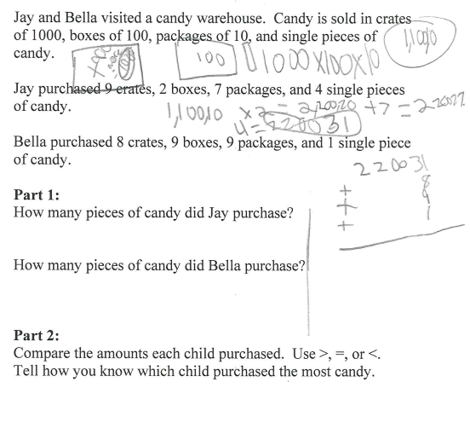

Progressing: The student did not correctly identify the correct amount of candy for each child, but was able to compare the amounts. The student did not correctly explain how the numbers were compared.
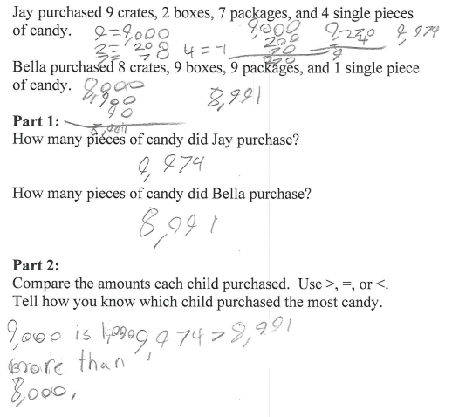

Meets Expectation: The student correctly identified the amount of candy for each child, compared the amounts, and explained the comparison. To move forward, this student needs to understand the difference in spelling between thousands and thousandths.
