NC.4.NBT.2
Carolina Panthers Game Attendance
Domain | Number and Operations in Base Ten
Cluster | Generalize place value understanding for multi-digit whole numbers.
Standard(s) | NC.4.NBT.2 Read and write multi-digit whole numbers up to and including 100,000 using numerals, number names, and expanded form.
Materials | activity sheet, pencil
Task | Carolina Panthers Game Attendance  At last Sunday’s football game, the stadium was full. There were seventy-five thousand, four hundred twelve people at the game.  Part 1:  Write each amount in standard form if it isn’t already written in standard form.  Standard Form  7 ten thousands, 5 thousands, 4 hundreds, 1 ten, 9 ones 75,419  4,000 + 500 + 70,000 + 2 + 30 74,532  754,012  70,000 + 5,000 + 400 + 10 + 2 75,412  7 ten thousands, 45 hundreds, 2 ones 74,502  Part 2:  Circle the number in the table above that represents the number of people at the game.  (75,412)

Rubric
Level I  Not Yet | - Level II  - Progressing | Level III  Meets Expectation
Student does not write all four amounts correctly and does not circle the correct number of people at the game. | Student writes all four amounts correctly but does not circle the correct number of people at the game. OR Student does not write all four amounts correctly but does circle the correct number of people at the game. | Student writes each amount correctly in standard form and circles the correct number of people at the game.

Standards for Mathematical Practice
1. Makes sense and perseveres in solving problems.
2. Reasons abstractly and quantitatively.
3. Constructs viable arguments and critiques the reasoning of others.
4. Models with mathematics.
5. Uses appropriate tools strategically.
6. Attends to precision.
7. Looks for and makes use of structure.
8. Looks for and expresses regularity in repeated reasoning.

Carolina Panthers Game Attendance

At last Sunday’s football game, the Carolina Panthers’ stadium was full. There were seventy-five thousand, four hundred twelve people at the game.

Part 1:
Write each amount in standard form if it isn’t already written in standard form.
Standard Form
7 ten thousands, 5 thousands,
4 hundreds, 1 ten, 9 ones

4,000 + 500 + 70,000 + 2 + 30

754,012

70,000 + 5,000 + 400 + 10 + 2

7 ten thousands, 45 hundreds, 2 ones

Part 2:
Circle the number in the table above that represents the number of people at the game.

Scoring Examples

Not Yet: The student does not write the numbers correctly in standard form and does not choose the correct number of people at the game.
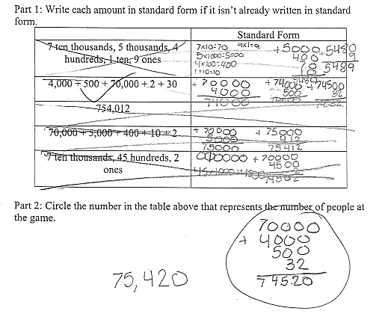

Progressing: The student inconsistently writes the numbers correctly in standard form and circles the correct number of people at the game.
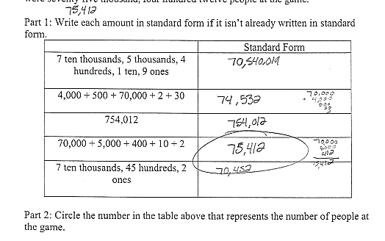

Meets Expectation: The student writes the numbers correctly in standard form and chooses the correct number of people at the game.

