NC.4.NBT.1
Coin Collection
Domain | Number and Operations in Base Ten
Cluster | Generalize place value understanding for multi-digit whole numbers.
Standard(s) | NC.4.NBT.1 Explain that in a multi-digit whole number, a digit in one place represents 10 times as much as it represents in the place to its right, up to 100,000.
Materials | paper and pencil, activity sheet
Task | Coin Collection  Part 1:  You have a collection of 826 coins.  - If the coins are pennies, what would be the value of your collection?  - If the coins are dimes, what would be the value of your collection?  - If they were dollars instead of coins, what would be the value of your collection?  - If they were ten dollar bills, what would be the value of your collection?  Part 2:  Look at the four values that you wrote for Part 1.  - What do you notice about the value of your collections?  - What pattern do you notice about the value of your collections?  - Explain your thinking in words, pictures, or numbers.  Solutions presented in rubric below.

Rubric
 | Level I  Not Yet | Level II  Progressing | Level III  Meets Expectation
Part 1 | Student correctly identifies values for 0-1 coins. | Student correctly identifies values for 2-3 coins. | Student correctly identifies values for each coin.  Value in pennies: $8.26  Value in dimes: $82.60  Value in dollars: $826.00  Value in ten dollars: $8,260.00
Part 2 | Explanation does not show consistent understanding of place value patterns. | Explanation shows a developing understanding of place value patterns. | Explanation demonstrates conceptual understanding of place value patterns.

Standards for Mathematical Practice
1. Makes sense and perseveres in solving problems.
2. Reasons abstractly and quantitatively.
3. Constructs viable arguments and critiques the reasoning of others.
4. Models with mathematics.
5. Uses appropriate tools strategically.
6. Attends to precision.
7. Looks for and makes use of structure.
8. Looks for and expresses regularity in repeated reasoning.
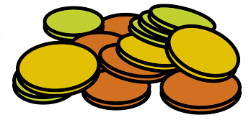
Coin Collection

Part 1:
You have a collection of 826 coins.
- If the coins are pennies, what would be the value of your collection?

- If the coins are dimes, what would be the value of your collection?

- If they were dollars instead of coins, what would be the value of your collection?

- If they were ten dollar bills what would be the value of your collection?

Part 2:
Look at the four values that you wrote for Part 1.
- What do you notice about the value of your collections?

- What pattern do you notice about the value of your collections?

- Explain your thinking in words, pictures, or numbers.

Scoring Examples
Part 1
Not Yet: The student identified the value for one coin.
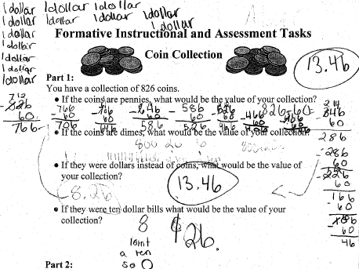

Progressing: The student found the value for three coins.
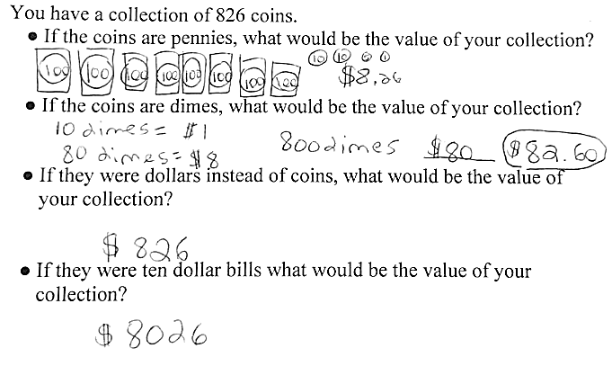

Meets Expectation: The student identified correct values for each coin.

Part 2
Not Yet: The student does not demonstrate an understanding of place value patterns and does not consider the value of each coin when describing their relative size (“the biggest in value goes first”).
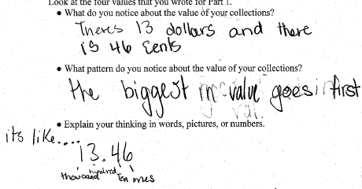

Progressing: The student shows a developing understanding of place value patterns. The student can describe the patterns, but does not explain why those patterns exist.
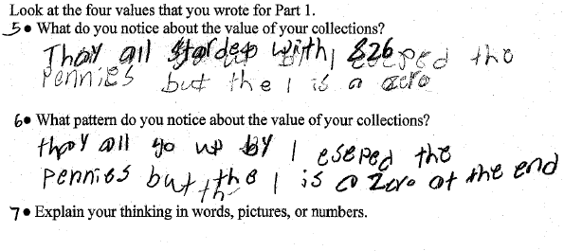

Meets Expectation: The student demonstrates a conceptual understanding of place value patterns by describing the relationship between ones and pennies, tens and dimes, and hundreds and dollars.
