NC.4.NBT.4
Filling the Auditorium
Domain | Number and Operations in Base Ten
Cluster | Use place value understanding and properties of operations to perform multi-digit arithmetic.
Standard(s) | NC.4.NBT.4 Add and subtract multi-digit whole numbers up to and including 100,000 using the standard algorithm with place value understanding.
Materials | pencil, activity sheet
Task | Filling the Auditorium  On a field trip, three different schools send their fourth graders across town to the high school auditorium for a math competition. Each school sends between 120 and 170 students each. There are 417 students total.  Part 1:  How many students could have come from each school? Show your thinking.  Part 2:  Find another possible solution to this task. Show your thinking.  Part 3:  If the number of students from each school was the same, how many students came from each school? Explain how you found your solution.

Rubric
Level I  Not Yet | Level II  Progressing | Level III  Meets Expectation
The student is unable to use strategies to find correct answers to any aspect of the task. | The student correctly and completely answers 1-2 parts of the task. | The answers are to all parts are complete and correct.  Part 1: All three numbers add up to 417.  Part 2: All three numbers add up to 417.  Part 3: Each school had 139 fourth graders. The explanation is clear and accurate.

Standards for Mathematical Practice
1. Makes sense and perseveres in solving problems.
2. Reasons abstractly and quantitatively.
3. Constructs viable arguments and critiques the reasoning of others.
4. Models with mathematics.
5. Uses appropriate tools strategically.
6. Attends to precision.
7. Looks for and makes use of structure.
8. Looks for and expresses regularity in repeated reasoning

Filling the Auditorium

On a field trip, three different schools send their fourth graders across town to the high school auditorium for a math competition. Each school sends between 120 and 170 students each. There are 417 students total.

Part 1:
How many students could have come from each school? Show your thinking.

Part 2:
Find another possible solution to this task. Show your thinking.

Part 3:
If the number of students from each school was the same, how many students came from each school? Explain how you found your solution.

Scoring Examples

Not Yet: The student was unable to answer any part of the task correctly.
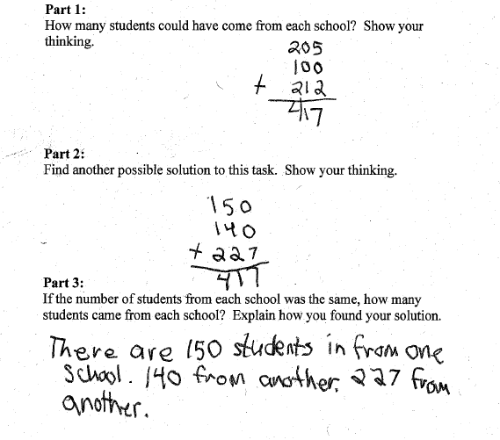

Progressing: The student is able to find two different solutions for the number of students who attended from each school in Part 1 and Part 2. However, the student is unable to find the correct answer for Part 3.
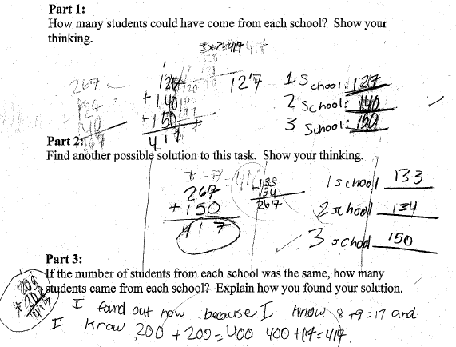
Meets Expectation: The student was able to find correct answers to all three parts of the task and explain the solution for Part 3.
