NC.4.NBT.2
Manuel’s Error
Domain | Number and Operations in Base Ten
Cluster | Generalize place value understanding for multi-digit whole numbers.
Standard(s) | NC.4.NBT.2 Read and write multi-digit whole numbers up to and including 100,000 using numerals, number names, and expanded form.
Materials | activity sheet, pencil
Task | Manuel’s Error  Ms. Smith asked Manuel to write this number in standard form:  ninety-seven thousand, three hundred two.  Manuel wrote:  97,3002  - What was Manuel’s mistake?  Possible responses:  - An extra zero was added.  - Manuel’s number represents three-thousand rather than three-hundred.  - The extra zero changes the place value of the number.  - Manuel’s number represents nine-hundred seventy-three thousand, two rather than ninety-seven thousand, three hundred two.  - What should he have written instead? (97,302)  - How would Ms. Smith’s number be written in expanded form? (90,000 + 7,000 + 300 + 2)

Rubric
Level I  Not Yet | - Level II  - Progressing | Level III  Meets Expectation
Student is unable to answer any part of the problem correctly. | Student answers 1-2 parts of the problem completely and correctly. | Student answers each part of the question correctly.

Standards for Mathematical Practice
1. Makes sense and perseveres in solving problems.
2. Reasons abstractly and quantitatively.
3. Constructs viable arguments and critiques the reasoning of others.
4. Models with mathematics.
5. Uses appropriate tools strategically.
6. Attends to precision.
7. Looks for and makes use of structure.
8. Looks for and expresses regularity in repeated reasoning.

Manuel’s Error

Ms. Smith asked Manuel to write this number in standard form:
ninety-seven thousand, three hundred two.

Manuel wrote:
97,3002

- What was Manuel’s mistake?

- What should he have written instead?

- How would Ms. Smith’s number be written in expanded form?

Scoring Examples

Not Yet: The student was unable to answer any aspect of the task correctly.
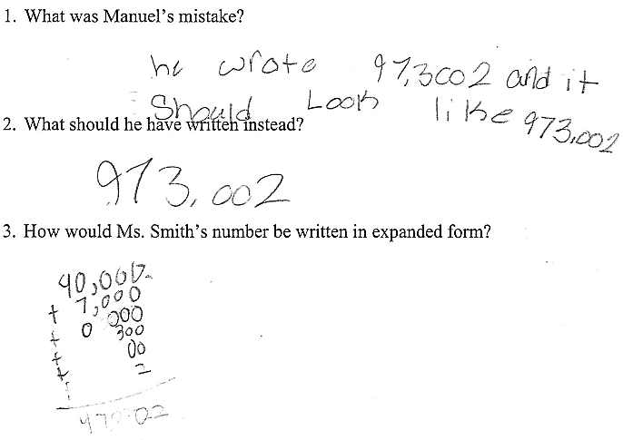

Progressing: The student answered questions 1 and 2 correctly, but did not expand the ten thousands and thousands place with writing the number in expanded form.
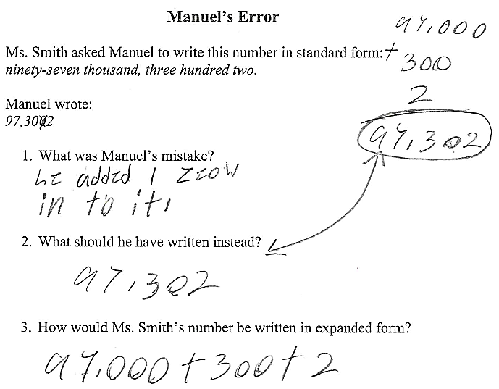

Meets Expectation: The student answered all aspects of the task correctly.
