NC.4.OA.3
Movie Theater Seats
Domain | Operations and Algebraic Thinking
Cluster | Use the four operations with whole numbers to solve problems.
Standard(s) | NC.4.OA.3 Solve two-step word problems involving the four operations with whole numbers.  - Use estimation strategies to assess reasonableness of answers.  - Interpret remainders in word problems.  - Represent problems using equations with a letter standing for the unknown quantity.
Materials | pencil, activity sheet
Task | Movie Theater Seats  The Royal Movie Theater has 199 seats. The theater has sold 23 child tickets and 78 adult tickets for the seven o’clock show.  - About how many tickets have been sold? (Accept reasonable estimates between 90 – 110 tickets.)  - Write an equation to represent the problem. Use a letter to stand for the unknown quantity. (199 – (23 + 78) = t)  - How many more tickets would the theater need to sell to fill every seat? (98 tickets)

Rubric
Level I  Not Yet | Level II  Progressing | Level III  Meets Expectation
The student cannot answer any part of the problem correctly. | The student answers 1 part of the problem completely and correctly. | The student answers each part of the problem correctly.

Standards for Mathematical Practice
1. Makes sense and perseveres in solving problems.
2. Reasons abstractly and quantitatively.
3. Constructs viable arguments and critiques the reasoning of others.
4. Models with mathematics.
5. Uses appropriate tools strategically.
6. Attends to precision.
7. Looks for and makes use of structure.
8. Looks for and expresses regularity in repeated reasoning.

Movie Theater Seats

The Royal Movie Theater has 199 seats. The theater has sold 23 child tickets and 78 adult tickets for the seven o’clock show.

- About how many tickets have been sold for the seven o’clock show?

- Write an equation to represent the problem. Use a letter to stand for the unknown quantity.

- How many more tickets would the theater need to sell to fill every seat?

Scoring Examples

Not Yet: The student did not answer any part of the task correctly.

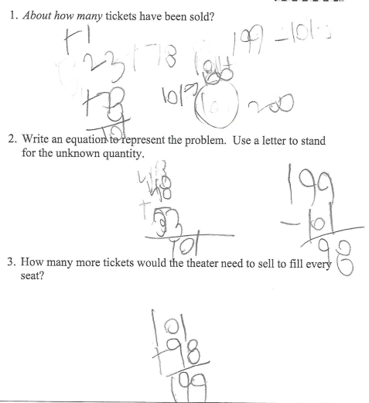

Progressing: The student was able to make a reasonable estimate, but was not able to write an equation with an unknown and was not able to solve the two-step word problem.

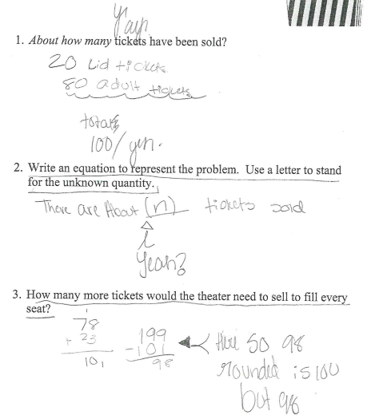

Meets Expectation: The student answered all questions correctly. In order to progress further, the student should be able to represent a two-step problem using an equation with a symbol for the unknown.
