NC.4.NBT.7
Up and Away
Domain | Number and Operations in Base Ten
Cluster | Generalize place value understanding for multi-digit whole numbers.
Standard(s) | NC.4.NBT.7 Compare two multi-digit numbers up to and including 100,000 based on the values of the digits in each place, using >, =, and < symbols to record the results of comparisons.
Materials | pencil, activity sheet
Task | Up and Away  The chart below shows the flying heights of different types of aircrafts.  Type of Aircraft Height (in meters)  jet 37,650  rotorcraft 12,440  electrically powered aircraft 29,524  propeller aeroplane 67,028  helicopter 10,820  single engine airplane 7,000  - Which type of aircraft flew higher, the jet or the propeller aeroplane? Use <, >, or = to compare the heights. (propeller aeroplane; 37,650 < 67,028)  - Which type of aircraft flew higher, the Rotorcraft or the helicopter? Use <, >, or = to compare the heights. (rotorcraft; 12,440 > 10,820)  - Which type of aircraft flew higher, the electrically powered aircraft or the single engine airplane? Use <, >, or = to compare the heights. (electronically powered aircraft; 29,524 > 7,000)

Rubric
Level I  Not Yet | - Level II  - Progressing | Level III  Meets Expectation
0-1 questions are answered completely and correctly. | 2 questions are answered completely and correctly. | All 3 questions are answered completely and correctly.

Standards for Mathematical Practice
1. Makes sense and perseveres in solving problems.
2. Reasons abstractly and quantitatively.
3. Constructs viable arguments and critiques the reasoning of others.
4. Models with mathematics.
5. Uses appropriate tools strategically.
6. Attends to precision.
7. Looks for and makes use of structure.
8. Looks for and expresses regularity in repeated reasoning.

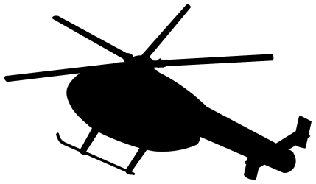

Up and Away

The chart below shows the flying heights of different types of aircrafts.
Type of Aircraft | Height (in meters)
jet | 37,650
rotorcraft | 12,440
electrically-powered aircraft | 29,524
propeller aeroplane | 67,028
helicopter | 10,820
single engine airplane | 7,000

- Which type of aircraft flew higher, the jet or the propeller aeroplane? Use <, >, or = to compare the heights.

- Which type of aircraft flew higher, the Rotorcraft or the helicopter? Use <, >, or = to compare the heights.

- Which type of aircraft flew higher, the electrically powered aircraft or the single engine airplane? Use <, >, or = to compare the heights.

Scoring Examples

Not Yet: The student answered one of the questions correctly. The student was inconsistent in the ability to use the correct symbol to compare the amounts.
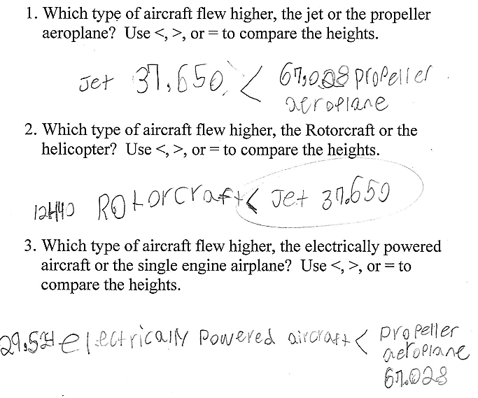

Progressing: The student was able to use the correct symbol to compare the amounts in two of the questions.
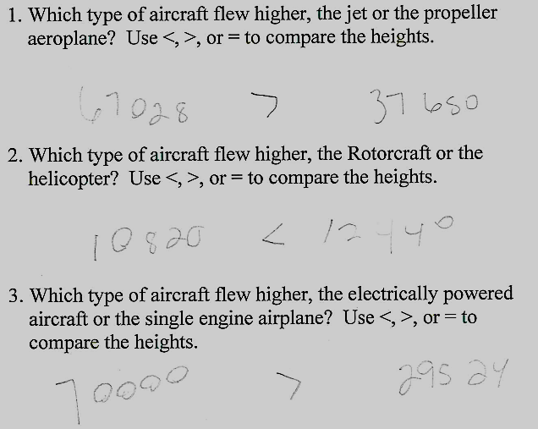

Meets Expectation: The student was able to use the correct symbol to compare the amounts in all three questions.
