NC.4.NBT.1
Value of the Bills
Domain | Number and Operations in Base Ten
Cluster | Generalize place value understanding for multi-digit whole numbers.
Standard(s) | NC.4.NBT.1 Explain that in a multi-digit whole number, a digit in one place represents 10 times as much as it represents in the place to its right, up to 100,000.
Materials | paper and pencil, activity sheet
Task | Value of the Bills  Part 1:  Gary said, “In my pocket I have 25 of the same amount of dollar bills.” What is the value of Gary’s money if he has:  - 25 one dollar bills?  - 25 ten dollar bills?  - 25 hundred dollar bills?  Part 2:  Gary reasoned, “The value of the 2 when I have ten dollar bills is 200, but the value of the 2 when I have one dollar bills is only 20.” Is Gary correct? Why or why not?  Part 3:  Consider Parts A, B, and C above. If you had 260 of the same amount of dollar bills, what would the value of the bills be? Explain how you found your answer.

Rubric
Level I  Not Yet | Level II  Progressing | Level III  Meets Expectation
Student answers all parts of the task incorrectly. | Student is successful in 1 to 2 parts of the task. | Student correctly answers all parts of the task.  Answers:  - Part 1: 25; 250; 2,500  - Part 2: Gary is correct. The explanation should include connections to place value such as there are 25 groups of 1, 25 groups of 10, or 25 groups of 100.  - Part 3: 260; 2,600; 26,000. Explanation discusses the idea that the value of each digit is multiplied by 10 when the value of the dollar bills increases by 10.

Standards for Mathematical Practice
1. Makes sense and perseveres in solving problems.
2. Reasons abstractly and quantitatively.
3. Constructs viable arguments and critiques the reasoning of others.
4. Models with mathematics.
5. Uses appropriate tools strategically.
6. Attends to precision.
7. Looks for and makes use of structure.
8. Looks for and expresses regularity in repeated reasoning.
Value of the Bills

Part 1:
Gary said, “In my pocket I have 25 of the same amount of dollar bills.” What is the value of Gary’s money if he has:
- 25 one dollar bills?

- 25 ten dollar bills?

- 25 hundred dollar bills?

Part 2:
Look back at your answers for Part 1. If Gary reasoned, “The value of the 2 when I have ten dollar bills is 200, but the value of the 2 when I have one dollar bills is only 20.” Is Gary correct? Why or why not?

Part 3:
Consider Parts A, B, and C above. If you had 260 of the same amount of dollar bills, what would the value of the bills be?
- 260 one dollar bills?

- 260 ten dollar bills?

- 260 hundred dollar bills?

Explain how you found your answer.

Scoring Examples
Not Yet: The student is able to partially answer Part 1 correctly, although he does not write the dollar amounts in standard form. The student does not demonstrate an understanding of place value patterns.
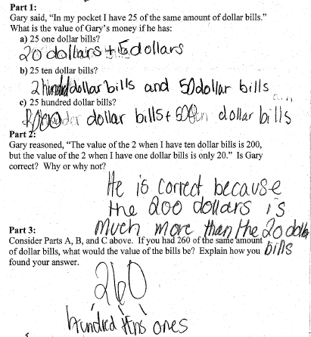

Progressing: The student demonstrates an understanding of place value patterns, but does not correctly explain why those patterns exist in Part 2.
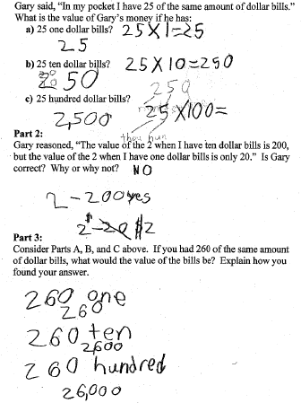

Meets Expectation: The student correctly answered all parts of the task. The student’s work and explanations demonstrate an understanding of place value patterns.
