Kindergarten Cluster 2 Centers
Cluster 2 stations develop students as both counters and producers. Students are counters when they count a given set to find “how many”. Students are producers when they produce/count out a set to match a given numeral.

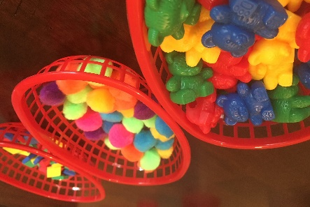 | Count it Out  Pick a numeral card 0-5, or other number range. Produce (count out) a set to match.  Optional: Draw a picture of the set. Record the matching numeral.
Counting Cups
Pick a cup. Count the objects in the cup to find “How many?”.

Optional: Draw a picture of the set. Use a numeral card to represent the set.
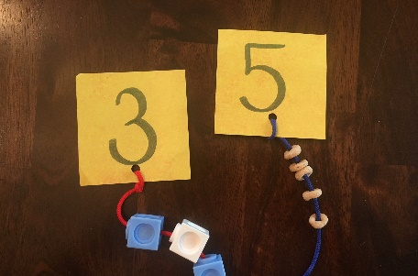 | Stringing Sets  Pick a string with a numeral card attached. Produce (count out) a set to match. Place the set on the string.
Count and Match
Count the quantity on each card. Place the card under the matching number.

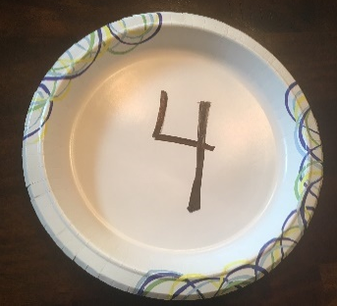 | Clip It  Pick a number 0-5, or other number range. Produce (count out) a set of clothes pins to match. Clip clothes pins to the plate.
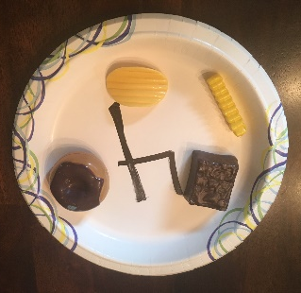 | Order’s Up!  Pick a number 0-5, or other number range. Produce (count out) a set of food items (or pictures) to match.  Optional: Draw a picture of the set. Record the matching numeral.

