Fourth Grade Exit Tickets
Cluster 4 – NC.4.NBT.5

Solve each problem.
1. 264 x 4

2. 482 x 7

3. 796 x 5

4. 24 x 12

5. The school store sold 453 packs of erasers this week. Each pack of erasers cost $6. How much money did the school store make this week?

6. Write an equation that would allow someone to find the value of P and solve.
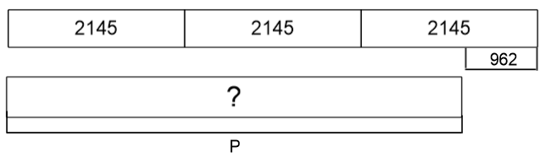

Solve each problem.
1. 264 x 4

2. 482 x 7

3. 796 x 5

4. 24 x 12

5. The school store sold 453 packs of erasers this week. Each pack of erasers cost $6. How much money did the school store make this week?

6. Write an equation that would allow someone to find the value of P and solve.

Answer Key

1. 1,056
2. 3,374
3. 3,980
4. 288
5. $2,718
6. (2,145 x 3) – 962 = 5,473

